A day in the life of a Church – Early Morning
Hi! My name is Julie, and I am the Vicar in a parish in London. I work for the Church of England. I have been here for 18 months. Before that I was a curate in a small town in southwest Somerset and before that I was at college, studying so I could be a vicar. And before that I was an actress!
Days in the life of a vicar are rarely the same though they usually start in the same way. Every morning at 7.30 I take my dog out for a walk. We walk to the church where I say my prayers, offering the day to God and asking him to guide me and be with me in everything I do as he has promised he will. Sometimes it is just me and my dog (Bella) but often I am joined by my colleagues and people from the parish. I like it when other people from the church join me in prayer, but I know early morning can be tricky if they need to get to work.
I usually travel around the parish on my bike. It helps me to keep fit. I enjoy the fresh air and exercise and it's easier to see people and for them to see me. People wave at me and call out 'Good morning'. My bike is good because I can get around quite quickly on it but I can also stop quickly if I want and walk along with someone if it seems the right thing to do.
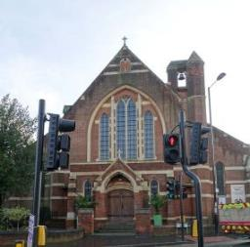
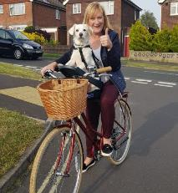

Our church Bella and me on the bike!

A Day in the Life ... of a Vicar
Morning – A day in the life of a church
Sometimes after breakfast I am joined by some volunteers from our church to visit our local primary school and lead the collective worship. At other times different classes come into the church for assemblies and other services.
Sometimes the phone will ring and there is someone speaking to me in tears because their mum or dad or child has died or been taken seriously ill suddenly and unexpectedly. They want to talk or a shoulder to cry on. Often they just don't know what to do and simply want someone to help them. In the event of a death I will help them make the arrangements for the funeral and will visit them a number of times both before and after.
We have a mid-morning midweek communion service which I often lead. Usually the people who come to it are retired so they have the time. We say prayers together for the world and for the sick and celebrate Jesus' life by breaking bread and sharing wine.
Our church has a church hall and on Tuesday mornings we hold a group for parents and carers to come with their babies and toddlers. There are toys to play with, refreshments, singing and a Bible story. Other groups hire our church hall too. People come and go all day long. It's a busy church.
On Wednesdays our church puts on a lunch group for retired people.
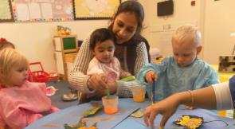
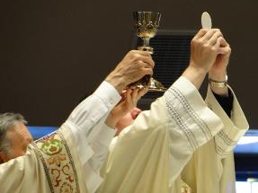
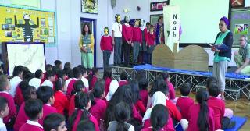

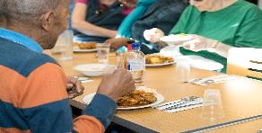

Collective worship at our local school

Afternoon – A day in the life of the church
In the afternoons volunteers from our church try to phone or visit people in their homes and once a week we go to the hospital and spend time with people from the parish who are there. We chat with them and offer to pray with them.
I sometimes use time in the afternoon to prepare my sermon for Sunday.
Our food stop is also open on Tuesdays and Fridays. It is a community food sharing scheme where people in our area can buy reasonably priced food. Our local supermarket helps us with food from their store. People can also donate food and toiletries too.
After school has finished for the day we run Messy Church. This is an opportunity for children and adults to get together at our church, hear a Bible story, get messy with some craft and then sit down and eat a meal together. Lots of families and households come from our local school. It can be noisy and messy but it is good fun. I would never be able to run this on my own but we have a great team of volunteers who help me with this.
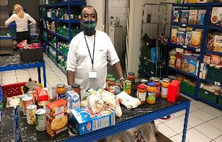
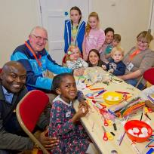
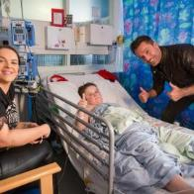

A visit to our local hospital One of our volunteers at the Food Stop Fun at Messy Church

Evening – A day in the life of a church
Most evenings I have meetings or appointments, speaking with people who want to get married in church, church council meetings, preparing couples who want to have their children baptised and many other different things. At the moment I am leading a group of people from our church in an Alpha course. It is for people who want to know more about the Christian message. We meet together once a week and there is a talk, discussion and some food that we eat together.
In our church we have a young people’s group called Rock Solid. They meet on a Friday night at the church. They have a chill-out night or games and activities and there is usually a spot during the evening when we think about faith in Jesus. Last year some of them wanted to become Christians and so I led confirmation classes with them and they were confirmed by a Bishop.
We also work with other churches in our area to provide a Floating Shelter during the winter months. This is a safe space that we set up in our church hall for guests to stay who are homeless. We provide a bed, evening meal, breakfast and a take-away packed lunch.
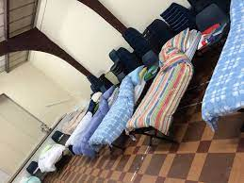

Alpha course Youth Group
Beds in the church hall

