Using talking tubs
Talking tubs:

A talking tub is a collection of materials that are designed to stimulate talking and thinking about a concept. They can also be used to:
- assess prior knowledge and understanding;
- assess pupil knowledge and understanding part way through a teaching sequence or at the end of a unit of learning.

Possible content of a talking tub to explore the question:
What did the Buddha teach his followers about life?

- Prince Siddhartha
- Palace
- Buddha under the Bodi tree
- Four sightings
- Truth seeker – Holy man
- Key words associated with the teachings of the Buddha

How to use the talking tub:
The activity works best when the pictures/words are presented in a box to create the element of mystery and exploration.

Step 1:
- Pupils are given the opportunity to talk about each photo/word in the box. What can they remember from the unit of learning? Pupils are encouraged throughout to use religious vocabulary in their talk and conversation.

Step 2:
- On strips of paper, Pupils write down what they believe the key knowledge associated with each picture/word is using appropriate religious vocabulary.

Step 3:
- On a different coloured strip of paper, pupils write down any links/connections they can make/see between the items. Eg: What is the link between the Buddha sitting under the tree and the word enlightenment? What is the link between Prince Siddhartha and the palace? What is link between the word Buddha and Prince Siddhartha?

Step 4:
- On speech bubbles, pupils write down any questions they still have related to the big question?

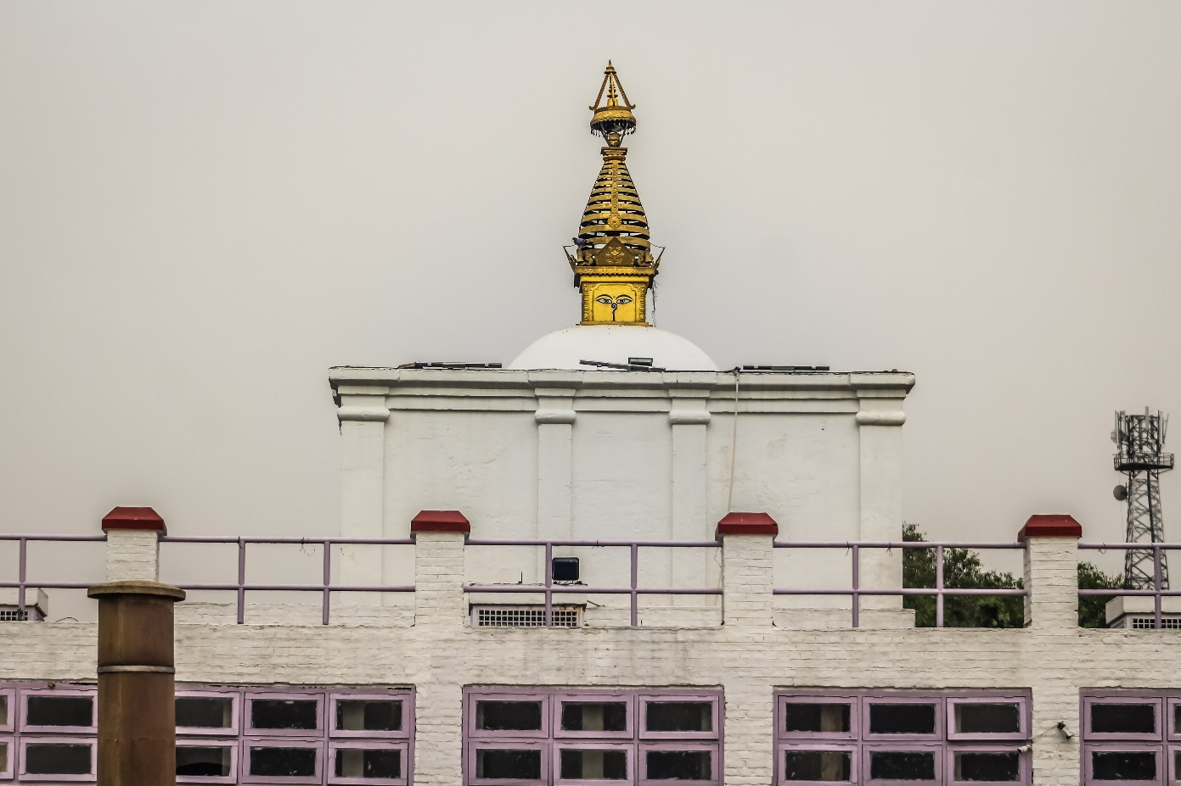

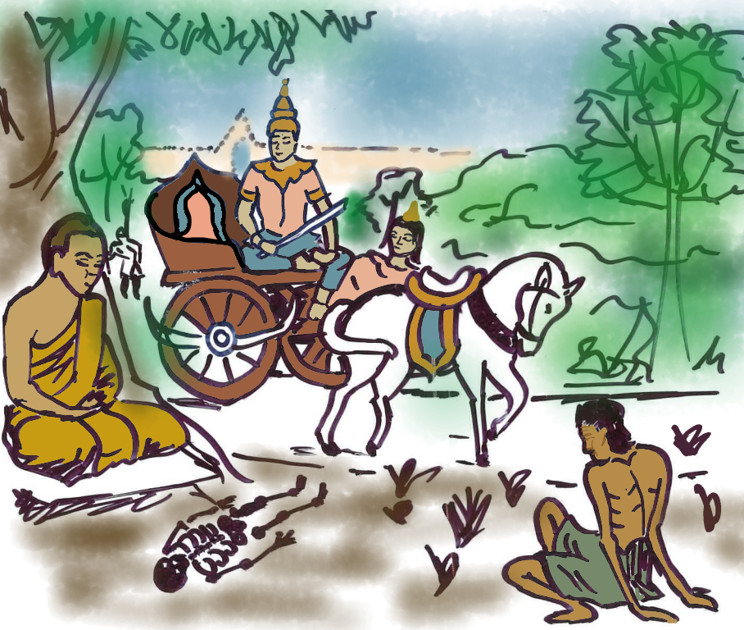
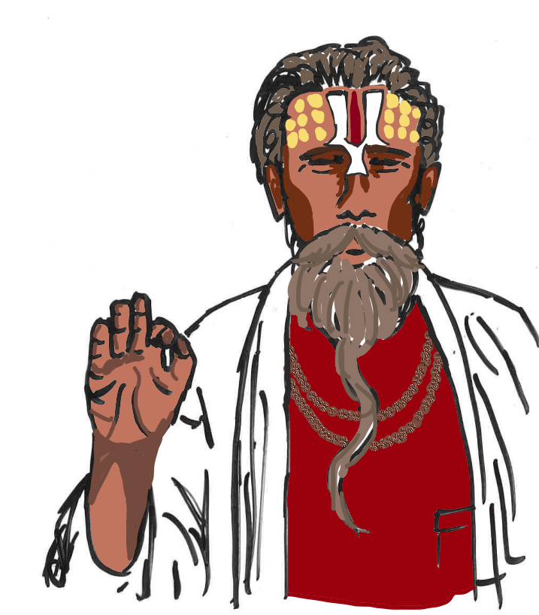

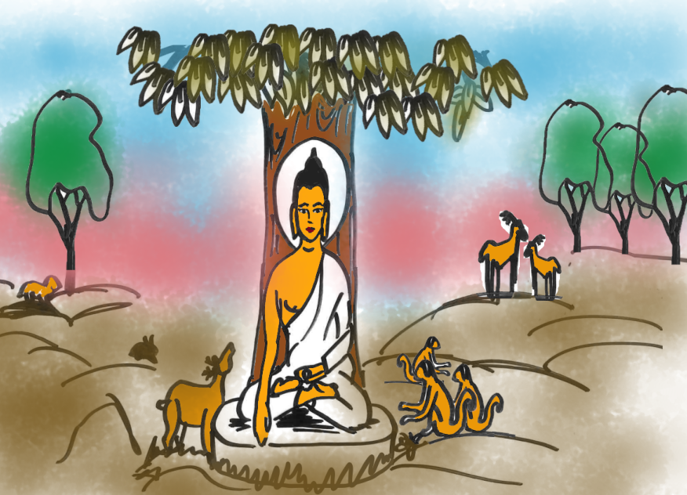

Prince Siddhartha

Buddha

Enlightenment

Four noble truths

Kindness

Compassion

Happiness

Unhappiness

Suffering

Wants

Greed

Hatred

Ignorance

Everything changes

Nothing is permanent

Things are interconnected

