Appendix Lesson 6: Using talking tubs
Talking tubs:

A talking tub is a collection of materials that are designed to stimulate talking and thinking about a concept. They can also be used to:
- assess prior knowledge and understanding;
- assess pupil knowledge and understanding part way through a teaching sequence or at the end of a unit of learning.

Possible content of a talking tub to explore the question: Who does Jesus say he is?

How to use the talking tub:

The activity works best when the photos/objects are presented in a box to create the element of mystery and exploration.

- I am statements.
- Images of bread, light, shepherd, vine, resurrection and life, raising of Lazarus.
- Words: nourishment, sustain, caring, protecting, danger, bear fruit, eternal life, sin, salvation, hope.
Step 1:
- Children are given the opportunity to talk about each object/photo in the box. What can they remember from the unit of learning? Children are encouraged throughout to use religious vocabulary in their talk and conversation.
Step 2:
- On strips of paper, children write down what they believe the key knowledge is for each item, using appropriate religious vocabulary.
Step 3:
- On a different coloured strip of paper, children write down any links/connections they can make/see between the images and words.
Step 4:
- On speech bubbles, children write down any questions they still have related to the big question?

‘I am the bread of life.’

‘I am the light of the world.’

‘I am the good shepherd.’

‘I am the true vine.’

‘I am the resurrection and the life.’

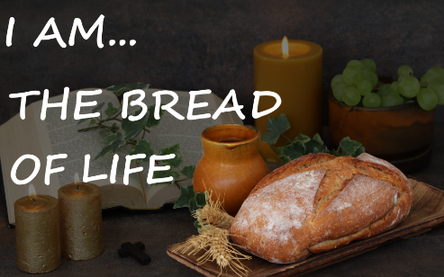

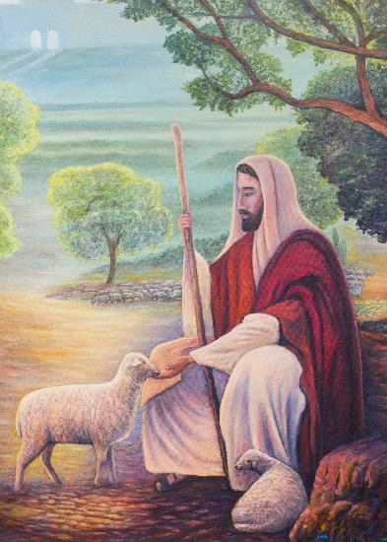
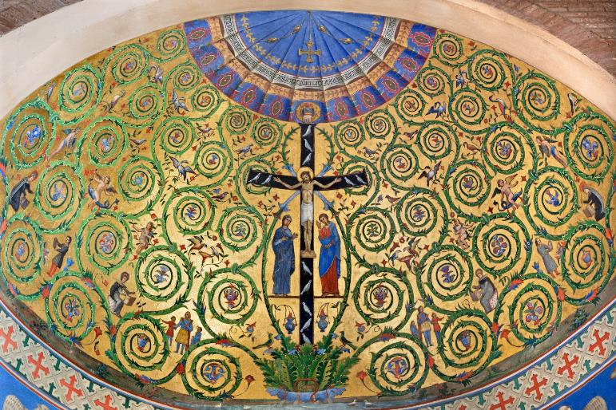

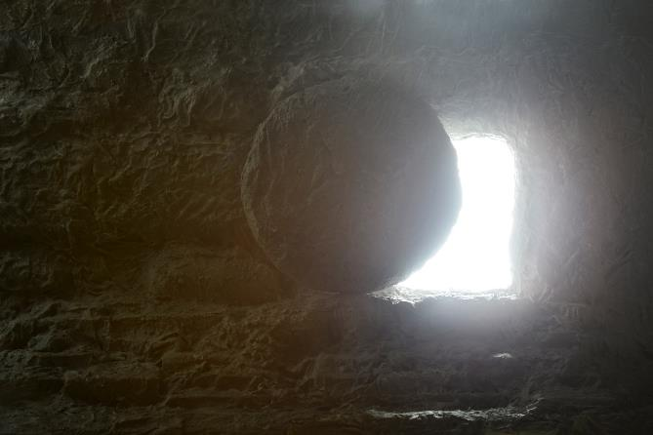

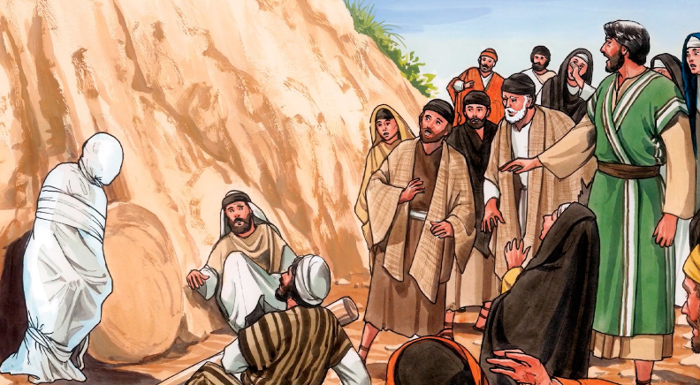

nourishment

sustain

caring

protecting

danger

bear fruit

eternal life

sin

salvation

hope

