Appendix Lesson 6: Using talking tubs
Talking tubs:

A talking tub is a collection of materials that are designed to stimulate talking and thinking about a concept. They can also be used to:
- assess prior knowledge and understanding;
- assess pupil knowledge and understanding part way through a teaching sequence or at the end of a unit of learning.

Possible content of a talking tub to explore the question: Why do Christians make and keep promises before God?

How to use the talking tub:

- Church
- Font
- Baptistry
- Godparents
- Parents
- Water
- Scallop shell
- Candle
- Oil
- Promises
- Priest
- Ring
- Christening gown
- Wedding dress
- Congregation
- God
- John the Baptist
- Jesus
- Baptism
- Marriage
- Christian
The activity works best when the photos/objects are presented in a box to create the element of mystery and exploration.

Step 1:
- Children are given the opportunity to talk about each object/photo in the box. What can they remember from the unit of learning? Children are encouraged throughout to use religious vocabulary in their talk and conversation.
Step 2:
- On strips of paper, children write down what they believe the key knowledge is for each item, using appropriate religious vocabulary.
Step 3:
- On a different coloured strip of paper, children write down any links/connections they can make/see between the items. Eg: Water, oil, candle = symbols of baptism. John the Baptist and Jesus = John baptised Jesus. Vows and exchange of rings = promises they make to each other. Congregation, baptism and marriage = both rites of passage require witnesses to be present.
Step 4:
- On speech bubbles, children write down any questions they still have related to the big question?

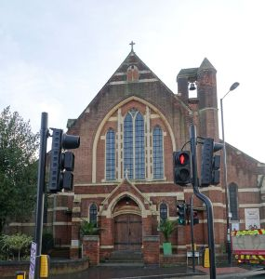

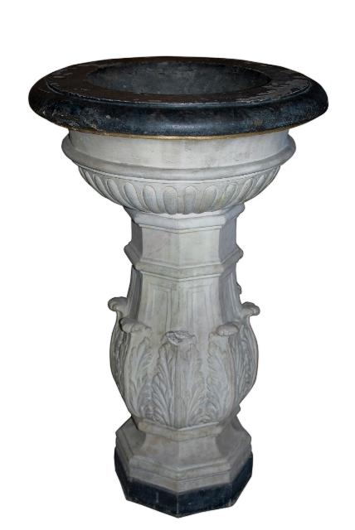

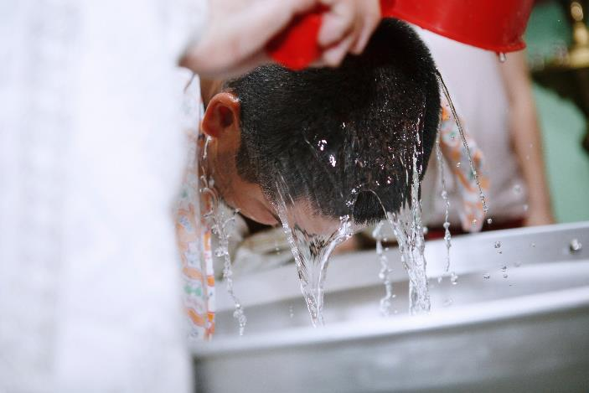

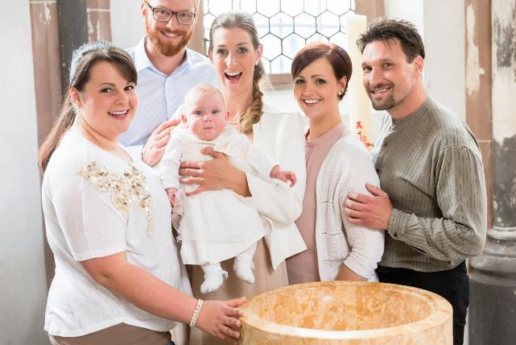

Parents and Godparents

Baptism Water

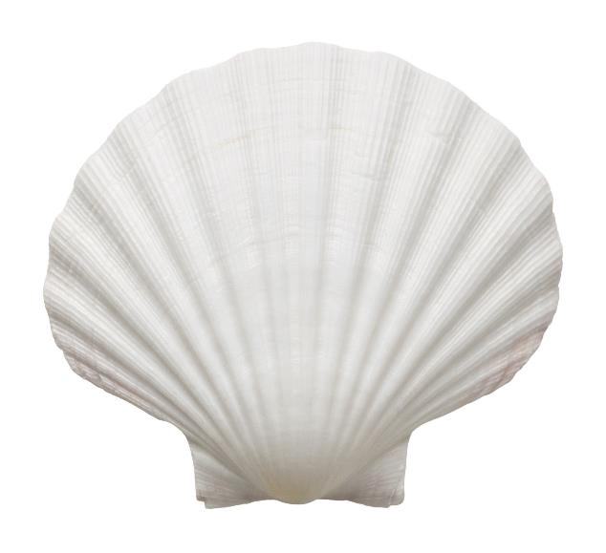

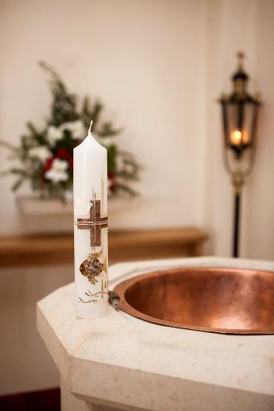

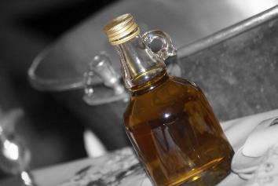

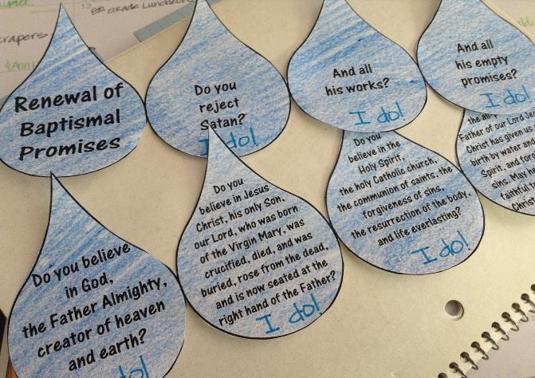

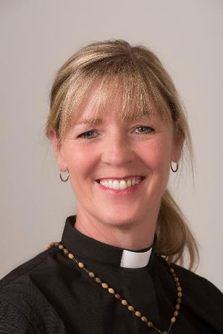

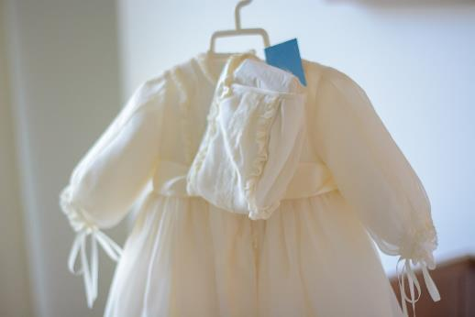

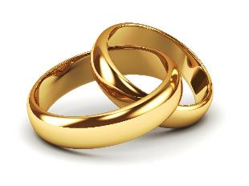

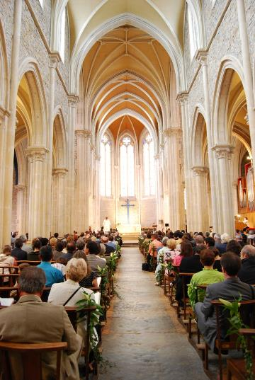

God

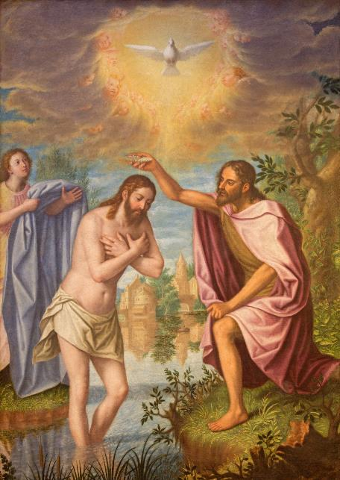

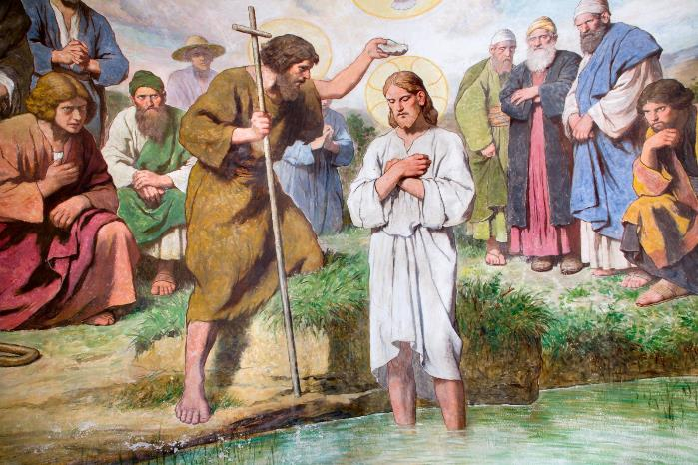

Baptism
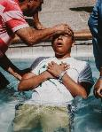
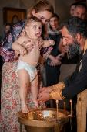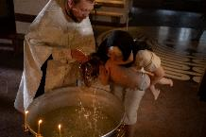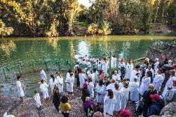

Marriage
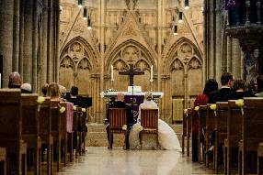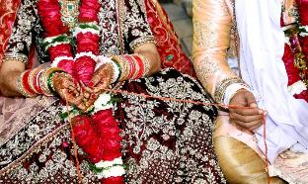

Christian

