**When can a Muslim eat during Ramadan?**

**Tick = Yes. Cross = No**

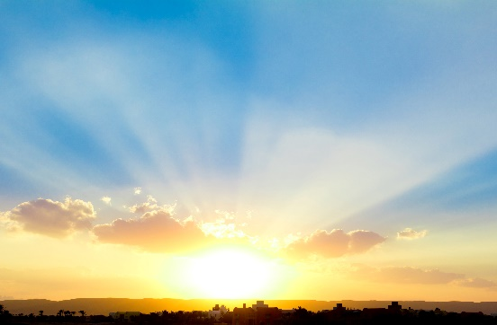 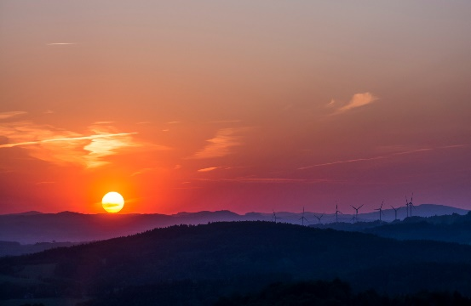

Can a Muslim eat now?

Can a Muslim eat now?

tick or cross

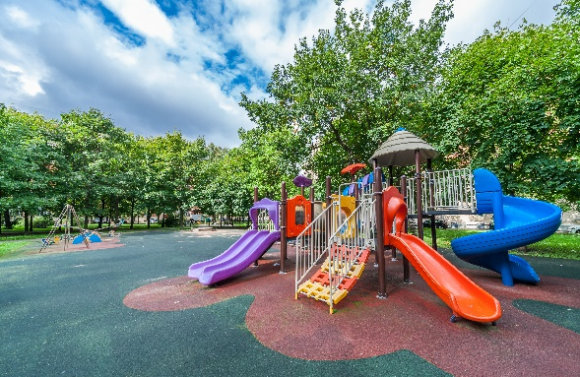

Can a Muslim eat now?

Can a Muslim eat now?

 

Can a Muslim eat now?

Can a Muslim eat now?