Two options:
Option one:
- Pupils complete the diagram.

Option two:
- Pupils sequence the pictures.

Appendix Lesson 4: Complete the diagram.

Step 4
Step 3
Step 2
Step 1

How many times does each part of the body have to be washed?
Step 10
Step 9
Step 8
Step 7
Step 6
Step 5
Cut these out and place them in the right order on the diagram.

hands
face
left arm
right foot
left foot
ears
hair
right arm
nose
mouth
Teacher notes:

Wudu process:
- Hands – 3 times – always start in the name of God.
- Mouth - is cleaned 3 times.
- Nose – water is breathed in gently through the nose 3 times.
- Face – the whole of the face must be washed at least once and is often done 3 times.
- Right arm – the arm is washed right up until the elbow and is done 3 times.
- Left arm – same as the right.
- Hair – water is passed through the air – this is done only once but is compulsory.
- Ears – the back and inside of the ears are wiped.
- Right foot – washed up to ankle – 3 times – compulsory
- Left foot – washed up to ankle – 3 times

Cut out the pictures for children to sequence. (The written words are for the teacher only.)

Hands
The Prophet, peace be upon him, said 'cleanliness is half of faith'. Wudhu is the ritual washing performed by Muslims before prayer. Muslims must be clean and wear good clothes before they present themselves before God.
Muslims start in the name of God, and begin by washing the right, and then the left hand three times.
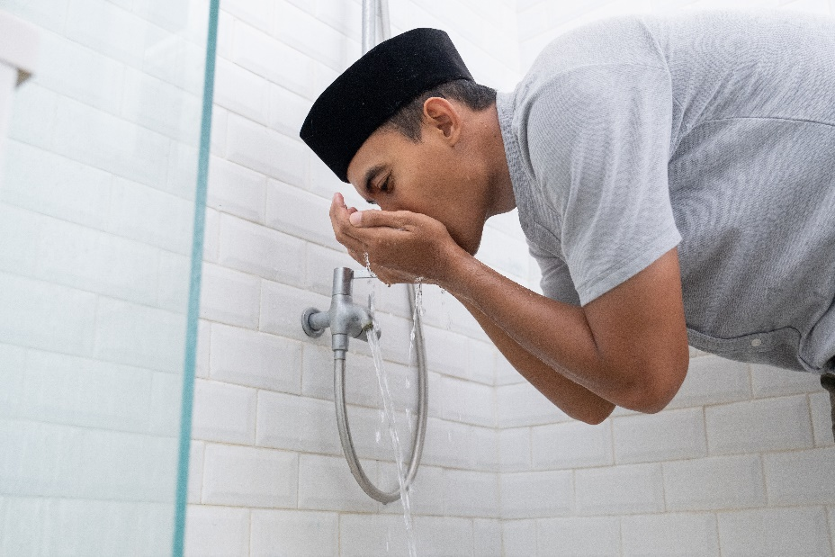

Mouth
The mouth is then cleaned three times.

Nose
Water is breathed in gently through the nose three times.

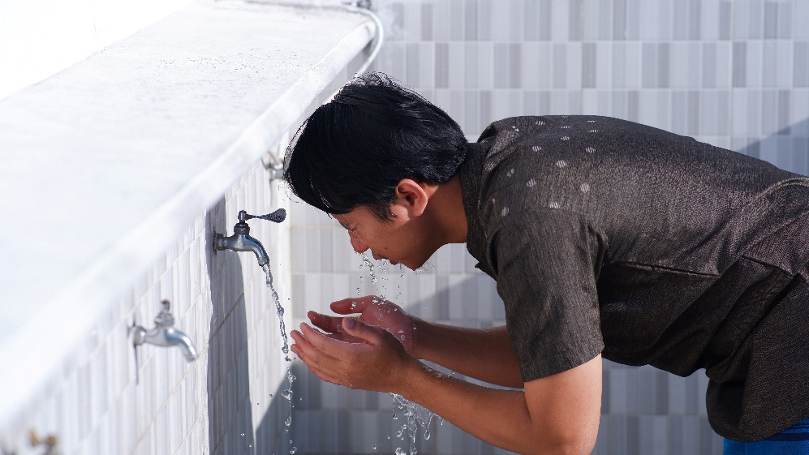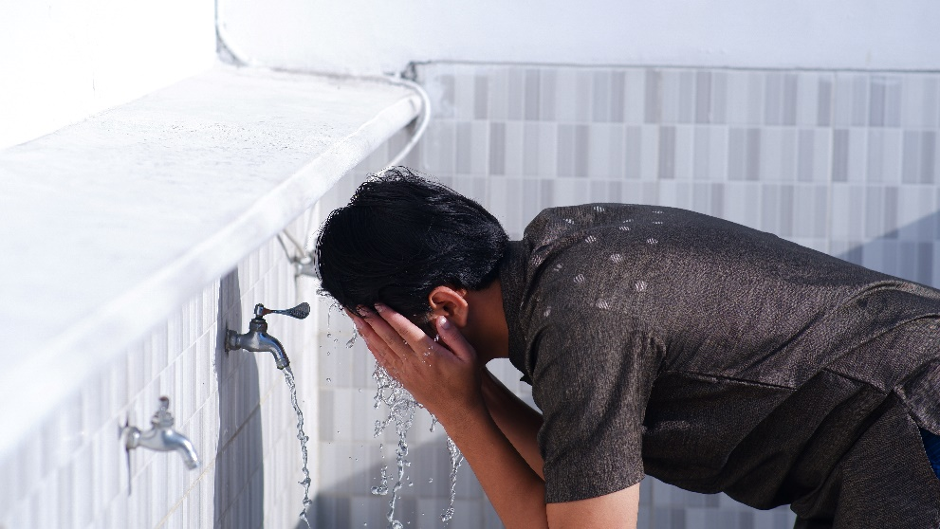

Face
The face includes everything from the top of the forehead to the chin, and up to both ears. The face is one of the essentials in wudhu, and must be washed at least once, or the wudhu is incomplete. However, it is usually washed three times.

Right arm
The arms up to the elbow, and including the hands, are one of the four essential areas that need to be washed. The right arm is washed three times first.

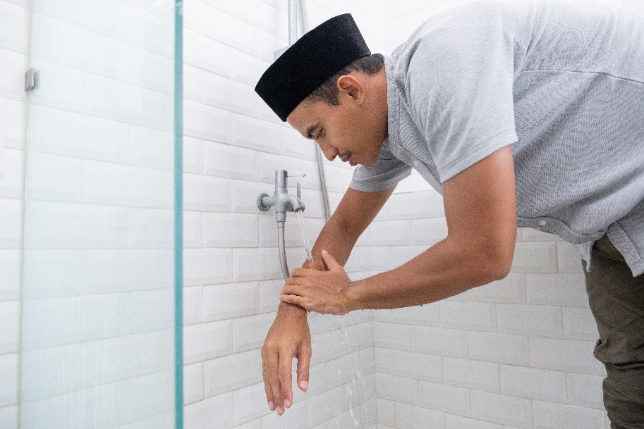

Left arm
Then the left three times.

There is a certain ritual order in which wudhu is normally performed, but as long as Muslims wash the four essentials at least once, by taking a shower for example, it counts.

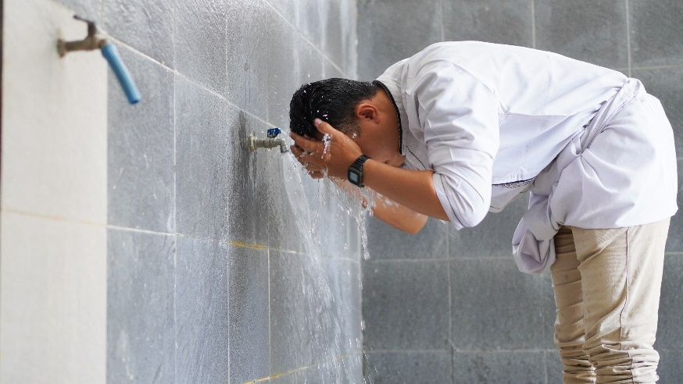

Hair
Water from wet hands is passed from the beginning of the hairline and over the head. This is only done once. The wiping of the hair is the third of the four compulsory acts.

Ears
Using damp hands, the back and inside of the ears are wiped.
The Prophet also said "If there was a river at the door of anyone of you and he took a bath in it five times a day would you notice any dirt on him?" His companions said, "Not a trace of dirt would be left." The Prophet added, "That is the example of the five prayers with which Allah blots out evil deeds." (Bukhari)

Right foot
The feet represent the last of the four compulsory areas of washing. The right foot is washed up to the ankles three times.
Although there are only four compulsory acts of washing, and each has to be washed only once, Muslims follow the example of the Prophet. He usually extended the washing ritual to ensure cleanliness before prayer, and even used to brush his teeth before each prayer.

Left foot
Then the left foot up to the ankles three times.
Wudhu does not need to be performed before every prayer, although this is recommended. Each wudhu lasts for up to a day when not travelling but must be performed again after going to the toilet, passing wind, bleeding heavily, contact with excrement, vomiting, falling asleep, and taking intoxicating substances.

