Incredible Creeds
The Apostles’ Creed.

Fascinating Fact:
The word ‘creed’
comes from the Latin word ‘credo’ which means ‘I believe’

Throughout the New Testament there are examples of Christians making statements regarding their beliefs about Jesus. These statements are called confessions of faith. One of the earliest confessions was “Jesus is Lord!”

Creed History
From the beginning of the Christian church
people were baptised to show others they had become Christians. It was the entrance
ceremony into the Christian community. Church leaders wanted to make sure that new Christians really understood the beliefs of the church and that they were really Christians before they
baptised them. In order to do this, they devised a set of questions and answers to ask new
converts. These questions were usually about
Jesus.
What do you believe about Jesus’ death?

I believe he was crucified and died.

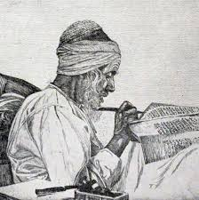
Gradually, over time, Christians started to write down what they believed. The Apostles’ Creed developed from baptism questions and answers. It was not only used in Church services but also to make sure that people were believing the right things.

Date Fact:
It is thought that the Apostles’ Creed was written in about 400CE. This makes it too old to have been written by the Apostles themselves. (The Apostles were some of the original followers of Jesus). Although the Apostles did not write this creed down it is still an early creed in church history.

What’s in the Apostles’ Creed?

The Apostles’ Creed contains all the beliefs that the early church thought was
important for other people to know. It contains beliefs about God the Father,
Jesus, the Son and the Holy Spirit. It also contains information about the church, teaching about forgiveness and life after death.

What do we know about Mary?

- God, the Father, is the maker of heaven and earth.
Key Beliefs:

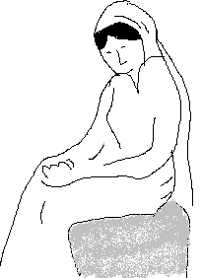
2. Jesus is the Son of God and Lord. Jesus was conceived by the Holy Ghost and born of the Virgin Mary.

Mary (the mother of Jesus was engaged to Joseph when she was visited by the angel Gabriel. She would have been somewhere between thirteen and eighteen years old (marrying age, at the time). The angel brought her
Disturbing news:

“You will become pregnant and give birth to a son, and you will name him Jesus.” (Luke 1:31)

Mary’s faith was so strong that she was able humbly to accept the news, despite the disgrace it would bring to her as an unmarried pregnant girl.

In Luke 1:30-35 and Matthew 1:18-25 Jesus is said to have been conceived without a human father, through the work of the Holy Spirit. Jesus was, therefore (as one early writer put it) ‘the Son of Mary and the Son of God’

He was Procurator of Judea
(a Province of the
Roman Empire)-Judea was a
violent and difficult place to govern, and Pilate often used his powers to have rebels put to death.
THE CRUCIFIXION
Pilate is best known to history as the man who sentenced Jesus to death. In the Gospels he comes across as a weak character, easily swayed. He believed in Jesus’ innocence, but he didn’t want a riot. He agreed Jesus’ death when the crowd shouted:
If you let this man go, you are no friend of Caesar!
He didn’t want bad reports getting back to Rome. But he had his revenge on the Jews by putting these words on Jesus’ cross

Pontius Pilate-
Who was he?

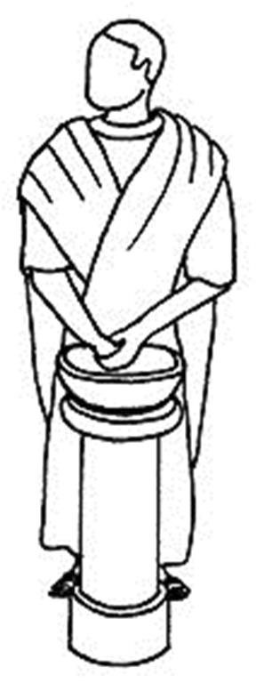

3. Jesus died on the cross and was buried.

HEAVEN

HELL
4. Jesus descended to hell before he rose from the dead and went to heaven, where he sits at God ‘s right hand.

Information:
If you were sitting down, it meant that you had
finished your work. To sit at someone’s right hand was a place of honour and showed you were an
important person

King of the Jews

6. The Holy Ghost is the third person of the Trinity.

5. Jesus is coming back again as Judge.

7. The Church made up of all its people is important.
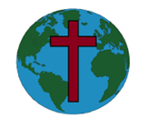

8. Belief about forgiveness of the things people do wrong is important.

9. After death there is resurrection of the body and everlasting life.
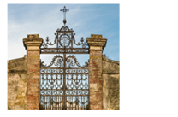

The Apostles' Creed
I believe in God, the Father almighty,
creator of heaven and earth.
I believe in Jesus Christ, his only Son, our Lord,
who was conceived by the Holy Spirit,
born of the Virgin Mary,
suffered under Pontius Pilate,
was crucified, died, and was buried;
he descended to the dead.
On the third day he rose again;
he ascended into heaven,
he is seated at the right hand of the Father,
and he will come to judge the living and the dead.
I believe in the Holy Spirit,
the holy catholic Church,
the communion of saints,
the forgiveness of sins,
the resurrection of the body,
and the life everlasting.
Amen.

