Appendix Lesson 1: Using talking tubs
Talking tubs:

A talking tub is a collection of materials that are designed to stimulate talking and thinking about a concept. They can also be used to:
- assess prior knowledge and understanding;
- assess pupil knowledge and understanding part way through a teaching sequence or at the end of a unit of learning.

Possible content of a talking tub:

- Picture of Muslims praying
- Picture/artefact of the Qur’an placed on a stand
- Picture/object of a compass
- Picture/artefact – prayer mat
- Picture of the five pillars of Islam
- Picture of a new born baby having the adhaan whispered into their right ear
- The Arabic word for God – Allah
- The name of the prophet Muhammed (pbuh)
How to use the talking tub:

The activity works best when the photos/objects are presented in a box to create the element of mystery and exploration.

Step 1:
- Children are given the opportunity to talk about each object/photo in the box. What can they remember from the unit of learning? Children are encouraged throughout to use religious vocabulary in their talk and conversation.
Step 2:
- On strips of paper, children write down what they believe the key knowledge is for each item, using appropriate religious vocabulary.
Step 3:
- On a different coloured strip of paper, children write down any links/connections they can make/see between the items. Eg: Link between the Qur’an and the prophet Muhammed (pbuh). Link between the picture of Muslims praying, the prayer mat and the compass. The link between the baby having the words of the adhaan whispered in their right ear and the word Allah and the prophet Muhammad (pbuh).
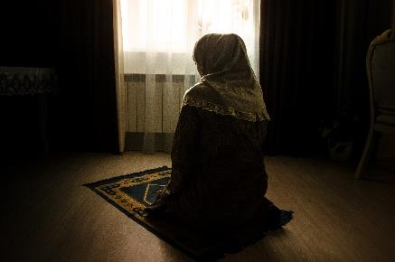

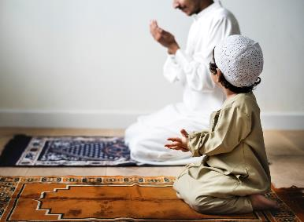
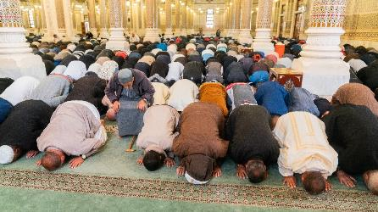

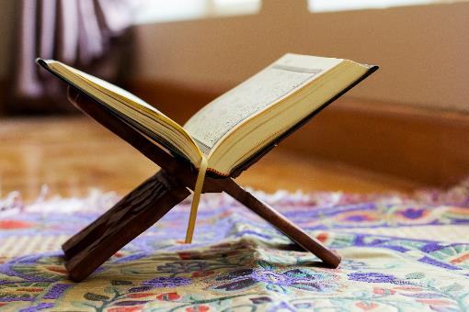

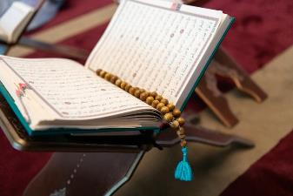

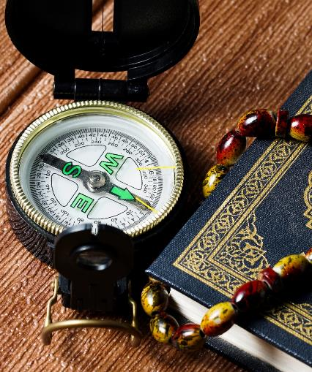

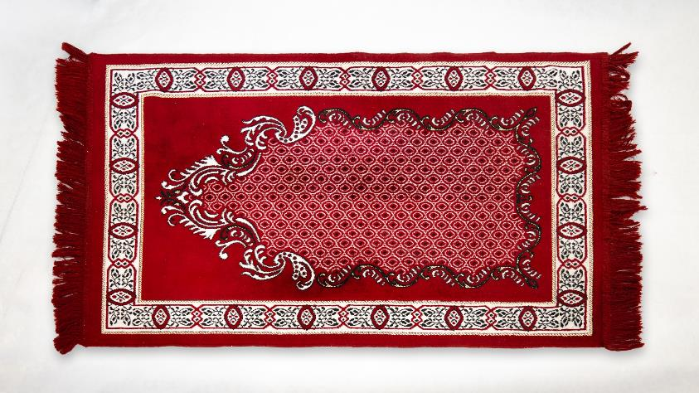

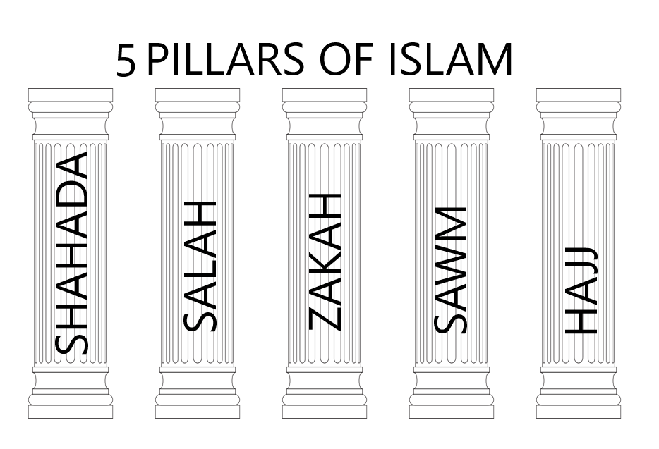

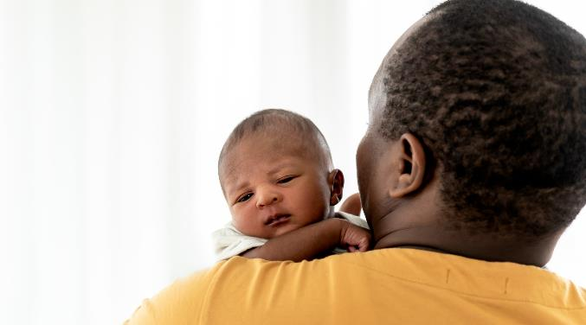

Allah

The Prophet Muhammed
(pbuh)

