Appendix Lesson 1:

Key question: Why do some people choose to belong to a Christian community?

Decide why you think this person has decided to belong to the Christian community – the church.

Person | What they attend at the church | Why do you think this person they belong to the Christian community?
 | Maria lives on her own in the neighbourhood. She goes to the church every Wednesday to have lunch with other members of the community.
 | Chris attends the church’s parent and toddler group with his son every Tuesday.
 | Max attends the Christian youth group on a Friday evening.
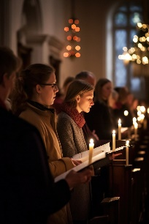 | Jasmine goes to the church every Thursday evening to sing in the community choir.
 | Jody, Peter and their children attend church every Sunday.

What group do you belong to? Why do you belong to the group? How does belonging to the group make you feel?

