Guru Gobind Singh and Baisakhi

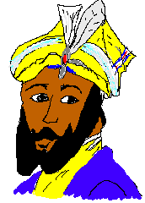

Guru Gobind Singh was the tenth Sikh Guru (teacher, leader). He lived at a time when the Sikhs were being

Then Guru Gobind Singh went back into the tent and brought out the five Sikhs – alive. They were dressed in new clothes and fine weapons so they looked like the Guru.

In 1699, at the spring festival of Baisakhi, Guru Gobind Singh called all the Sikhs together for a special meeting.

persecuted and killed for what they believed. It was not only the Sikhs who were being attacked. The Emperor at the time disliked anyone who challenged him or who had different beliefs.

Guru Gobind Singh was a skilled soldier, very clever and also concerned about the rights of all people. He wanted to unite the Sikhs, teach them to be brave and courageous, to look after and defend the rights of others and to not look at the differences of race or colour of skin.

# Fascinating Fact

Guru Gobind Rai (later known as Singh) was born in India on 22 December 1666 (the same year as the Great Fire of London).

He was the only son of Guru Tegh Bahadur, who had been martyred (killed) for defending the beliefs of others.

How do you think it might have made Guru Gobind feel to know his dad had died defending the beliefs of others?

On that day a large crowd

gathered to listen to theGuru.

I want the heads of five Sikhs, willing to die for what they believe.

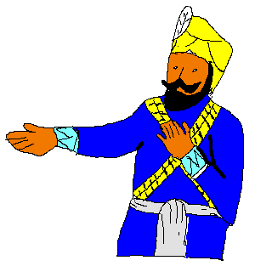

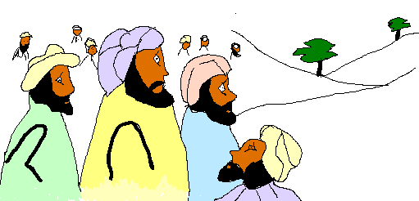

Everyone who heard the Guru was afraid. Then a young man got up and said, “I’ll give my head for you my Guru.”

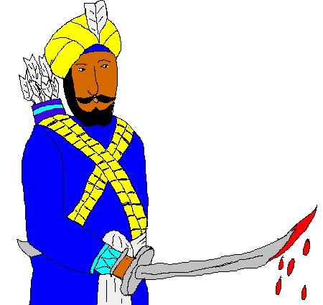

The same happened with the four other Sikhs who offered their lives.

The Guru took the Sikh into his tent When the Guru reappeared he was alone and his sword wasdripping with blood!

These are my beloved five – my panj piare. They are the beginning of a new community – the Khalsa.

I want four more heads!

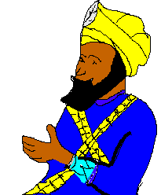

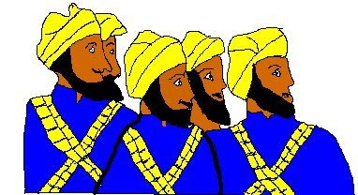

They are all alive! Where did the blood come from?

The Guru was testing us

Later on Guru Gobind Singh asked for a steel bowl, which he filled with water and his wife added some sugar crystals. The Guru said prayers and stirred the mixture with a double-edged sword, called a khanda. Then the Panj Piare were given this mixture, calledamrit.

From now on each of you men will be called Singh (lion). You will grow your hair and beard (kesh), carry a khanga (comb), and a kirpan (sword) and wear a kara (bracelet) and kachha (shorts).

Guru Gobind Singh told the Khalsa that they must never harm the weak and should think of all people as equal.

Many others took amrit that day. The name Kaur (princess) was given to women and girls.

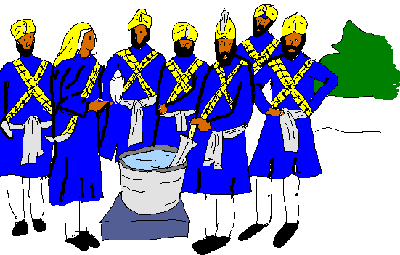

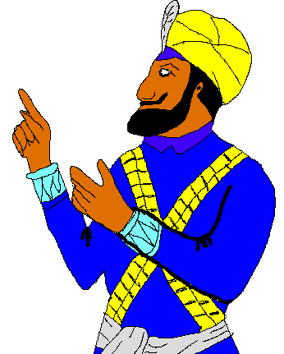

Fascinating Fact

It is thought that Guru Tegh Bahadur had not been the only Sikh martyr during the rule of Emperor Aurangzeb. However, nobody was sure just how many Sikhs had given their lives rather than give up their beliefs. This was because Sikhs wore the exact same clothing as everyone else, which meant that they could not be easily identified as Sikhs.

**Think of two reasons why Guru Gobind Singh may have asked the Khalsa Sikhs to take on the names Singh and Kaur and to wear certain items and not cut their hair.**

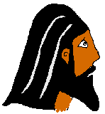

**Kesh** – a symbol of dedication to God. Sikhs believe God has given them their hair they do not cut it show their trust in God







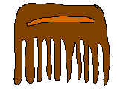

**Kirpan** – a symbol of a willingness to defend truth and justice. It reminds Sikhs to look out for the rights of others and to look to God for freedom.

**Kachera** – a symbol of modesty and readiness for action. Guru Gobind Singh wanted members of the Khalsa to be disciplined and ready to defend others.

**Kara** – a symbol of God’s eternity, strength and unity. It can also be used to defend oneself.

**Kangha** – a symbol of cleanliness and discipline. As well as keeping their hair clean and tidy the Kangha reminds Sikhs to keep their souls clean and honest