The Death of Guru Tegh Bahadur (1621-1675CE)
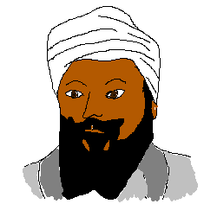
What was he like?
Who was Guru Tegh Bahadur?
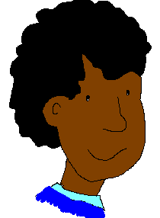


Fascinating Fact
Guru Tegh Bahadur name means “Brave Sword” because of his skills as a soldier. However the Guru liked to be known as Degh Bahadur which means “Brave cooking pot” Do you think it tells us anything about his character?

Guru Tegh Bahadur was the 9th of the 10 Sikh Gurus. He liked to
travel around the Punjab area of India and encourage other
Sikhs in their faith. He took his wife and his mother on his trips
to show how important family was. Living in peace and feeding
the poor and hungry were also important to him. However, at the
time he became Guru, 1664CE, Emperor Aurangzeb was ruling
India. He was persecuting followers of the Sikh and Hindu religions.
Both Sikhs and Hindus were being asked to give up their religion.
I wonder what I would have done?
If they refused they were forced to pay large
taxes, many Sikh and Hindu schools and
places of worship were also closed by the
Emperor. When the Emperor threatened to kill
Hindu Brahmins (priestly families), the Hindus
turned to Guru Tegh Bahadur for protection.
Although Guru Tegh Bahadur was not a Hindu he

believed that everyone should be free to worship God in
whatever way they believed to be right.

What did Guru Tegh Bahadur do next?

Guru Tegh Bahadur encouraged Sikhs and Hindus to stick to their faith. He decided that he would go and speak to the Emperor. However, the Emperor had Guru Tegh Bahadur arrested and taken to Delhi. He was offered all sorts
of presents and rewards if he would change his religion but
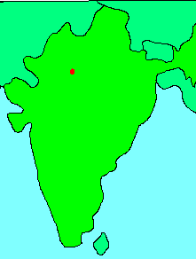
he would not accept any of them. Then, to try to persuade
him, three of his friends were tortured to death while he was
made to watch. Even the death of his friends would not make
Guru Tegh Bahadur change his mind. The Emperor ordered
that the Guru’s head should be cut off. One Sikh managed to
smuggle Guru Tegh Bahadur’s head back to his family,
where it was placed before his young son, the new Guru. Another Sikh rescued Guru Tegh Bahadur’s body but could only take it as far as his home village as the Emperor’s soldiers were chasing after him. There was no time to set up a proper funeral and so the man set fire to his own home and cremated Guru Tegh Bahadur’s body.

Today Sikhs remember Guru Tegh Bahadur for his death as a martyr. A Gurdwara has been built at the place where he was beheaded and a gurpurb (anniversary day) is held each year in his honour.

- Imagine you could travel back in time
- What questions would you like to ask….

Guru Tegh Bahadur
The Emperor
The Guru’s wife
The Sikh who took the Guru’s head back to his family.

