Year 5 unit of learning:
Big question: What happens in churches during Lent, Holy week, and Easter Sunday?

Event | Ritual today: What do many Christians do today? | What significance and impact do you think the ritual has on a believer’s life?  How do you think participating in a ritual creates a sense of belonging?
Ash Wednesday

Palm Sunday

Maundy Thursday

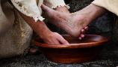
Event | Ritual today: What do Christians do today? | The significance and impact the ritual has on a believer’s life.  How do you think participating in a ritual creates a sense of belonging?
Good Friday

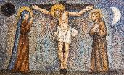
Holy Saturday

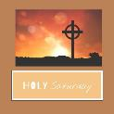
Easter Sunday

