Using talking tubs

Talking tubs:

A talking tub is a collection of materials that are designed to stimulate talking and thinking about a concept. They can also be used to:
- assess prior knowledge and understanding;
- assess pupil knowledge and understanding part way through a teaching sequence or at the end of a unit of learning.

Possible content of a talking tub to explore the question: How did the first five Sikh Gurus shape Sikhism?

- Guru Nanak
- Guru Arjun Dev
- Guru Amar Das
- A picture of a Sikh naming ceremony
- A picture of the Guru Granth Sahib
- A picture of a langar kitchen
- A picture of a Sikh wedding

How to use the talking tub:

The activity works best when the photos/objects are presented in a box to create the element of mystery and exploration.

Step 1:
- Children are given the opportunity to talk about each object/photo in the box. What can they remember from the unit of learning? Children are encouraged throughout to use religious vocabulary in their talk and conversation.

Step 2:
- On strips of paper, children write down what they believe the key knowledge is for each item, using appropriate religious vocabulary.

Step 3:
- On a different coloured strip of paper, children write down any links/connections they can make/see between the items. Eg: What is the link between the Guru Granth Sahib and the naming ceremony? What is the link between the word equality, Guru Amar Das, and the langar kitchen? Is there a link between the word equality and marriage?

Step 4:
- On speech bubbles, children write down any questions they still have related to the big question?

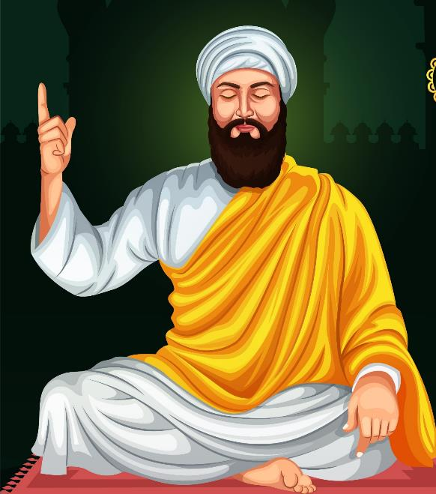

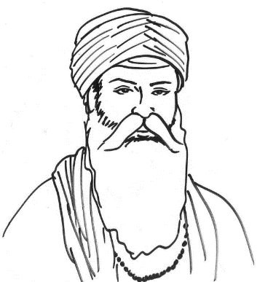

Sikh naming ceremony - Bing images See for naming ceremony
Naam Karan : The Sikh Naming Ceremony / Naming Rites - YouTube

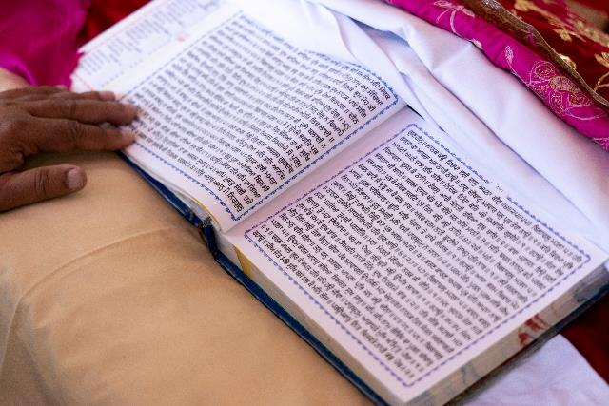

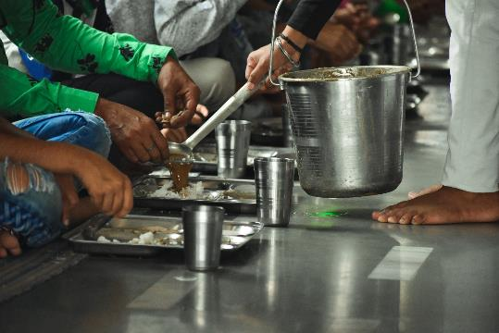

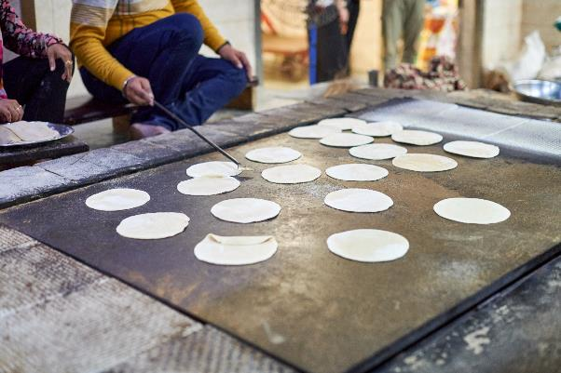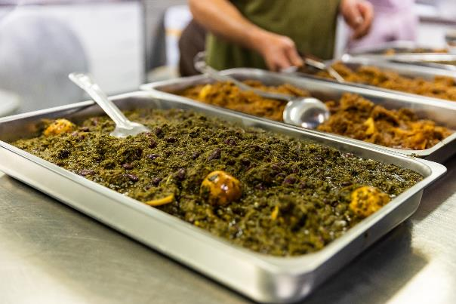

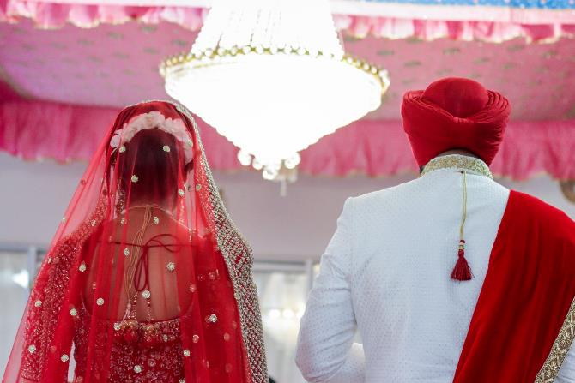

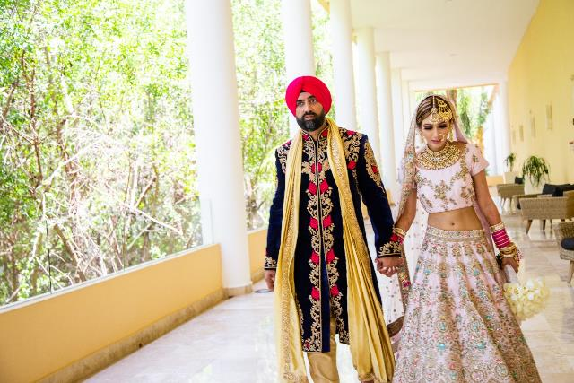

Equality

