Festivals | What is the festival all about and how does the Jewish community celebrate it? | How is it similar or different?
Rosh Hashanah  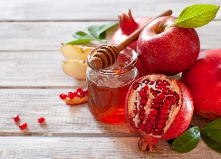 |  | This reminds me of….
Yom Kippur  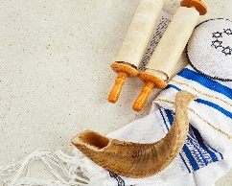 |  | This reminds me of….
Sukkot  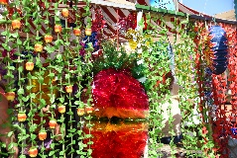 |  | This reminds me of….
Hannukah  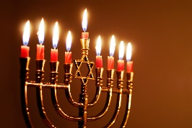 |  | This reminds me of….

