Core concepts and the ‘big story’ of the Bible
Core concept | Definition | Icon
God | Christian understanding of God as Father, Son and Holy Spirit. | 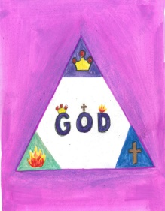
Creation | The natural world and human life are all part of God’s creation. Humanity is made in the image of God. | 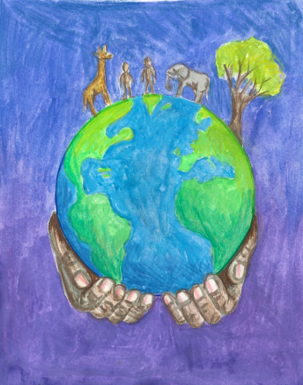
Fall | The fall as described in the book of Genesis 3 is an account of the separation between God and humanity and His creation because sin has entered the world. Humans have decided to go their own way. | 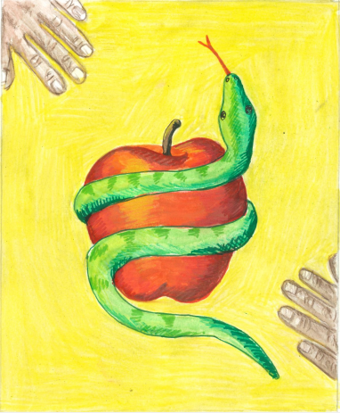
People of God | The Old Testament is the story of God’s plan to save humanity and to restore the relationship between God and His people. There are many accounts in the Old Testament that demonstrate the ebs and flows of the plan. The message of many of the prophets was to try and encourage people to remain with God’s plan. However this plan ends with the people of God exiled and then returning and waiting the coming of the Messiah – the anointed one. | 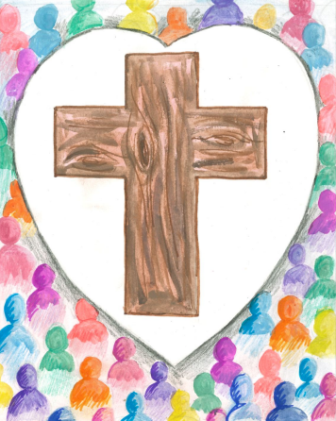
Incarnation | God comes to live amongst His creation in the form of Jesus. Jesus is both human and devine. Incarnation means that Jesus is God in the flesh. | 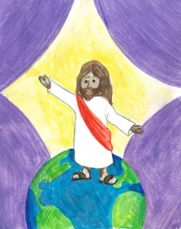
Gospel | Gospel means good news. Jesus comes to live amongst His creation so that humanity can see what it means to live in relationship with the Creator. In Jesus’ teaching and ministry, it is evident that He calls all to love one another and to reach out to the poor and marginalised. | 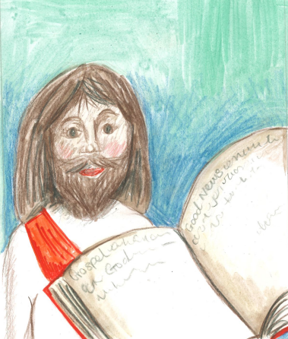
Salvation | It is through the death and resurrection of Jesus that the relationship between God and humanity is restored. In the death of Christ, forgiveness is offered for the sins of all people. | 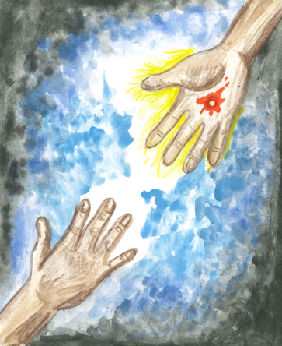
Kingdom of God | Kingdom of God is understood to be that ideal where all are living as God intended them to live. Jesus provides a clear example of what it means to live in the Kingdom of God. Christians long for the time when all is restored. They look to Jesus as the example of how to live a life that is pleasing to God. | 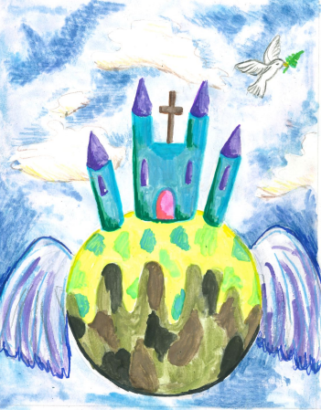

Images created by St Mary’s C.E Primary School - Twickenham.

