Using talking tubs:

Talking tubs:
A talking tub is a collection of materials that are designed to stimulate talking and thinking about a concept.
They can also be used to:
- assess prior knowledge and understanding;
- assess pupil knowledge and understanding part way through a teaching sequence or at the end of a unit of learning.

Possible content of a talking tub to explore the question: How did belief in God affect the actions of people in the Old Testament?
- Painting of each person being explored.
- Images associated with the story.
- Words associated with each story.

How to use the talking tub:
The activity works best when the photos/objects are presented in a box to create the element of mystery and exploration.

Pupils are encouraged to complete the following steps: You may wish to simplify these tasks or just do one of the steps.
- Step 1:
Pupils are given the opportunity to talk about each item/painting in the tub. What can they remember from the unit of learning? What things would they link together? Pupils are encouraged throughout to use religious vocabulary in their talk and conversation.
- Step 2:
On strips of paper, pupils write down what they believe the key knowledge is for each item, using appropriate religious vocabulary. (Key events that took place for each person, what actions did each person take, how did they respond to what God was requiring of them? What can believers learn from each person?)
- Step 3:
On a different coloured strip of paper, pupils write down any links/connections they can make/see between the different paintings/images and words (Trust, obedience, faith, commitment to God, leaders.) E.g., Do some of the words belong to more than one story?
- Step 4:
On speech bubbles, pupils write down any questions they still have related to the decisions each person made and or the big question being explored.

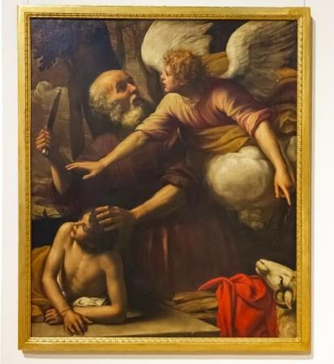
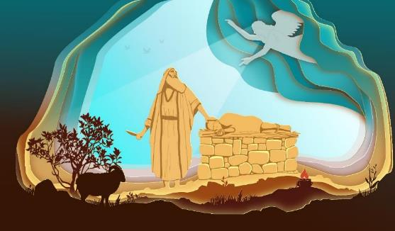

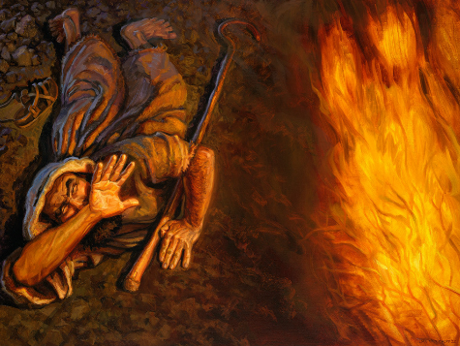

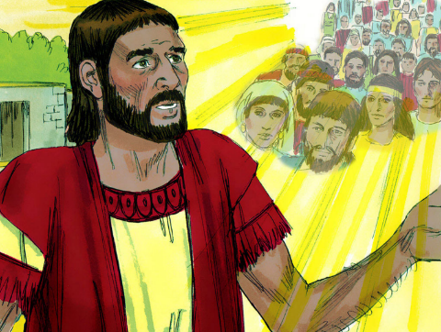
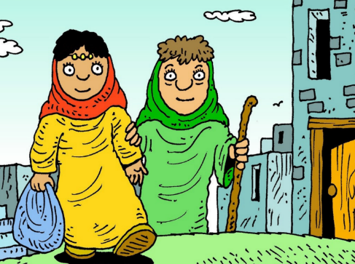
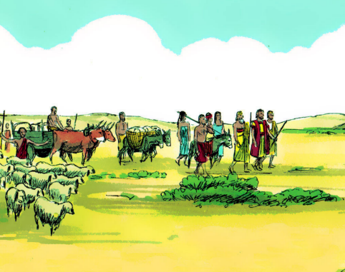
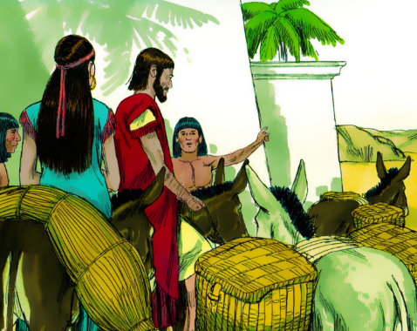

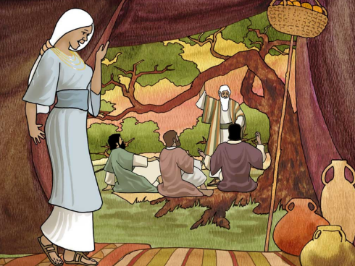
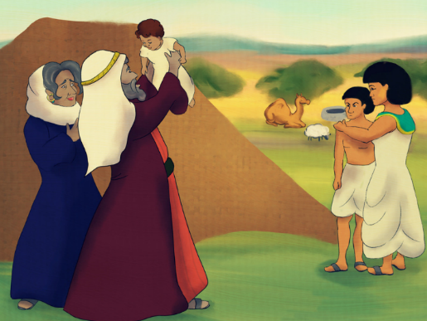
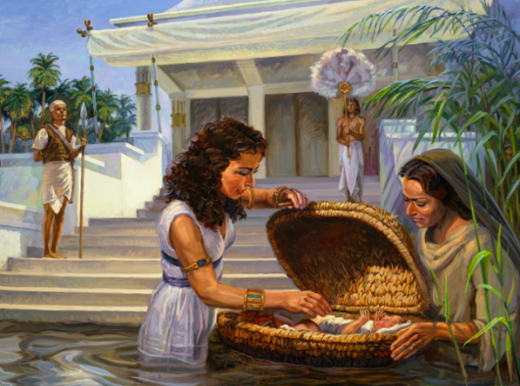
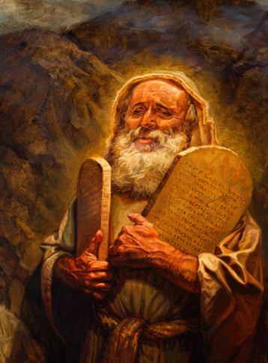

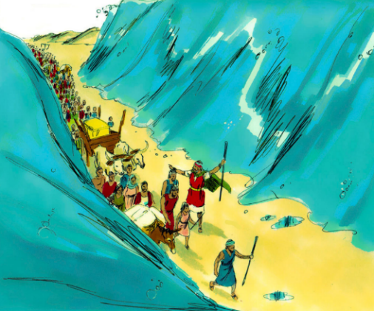
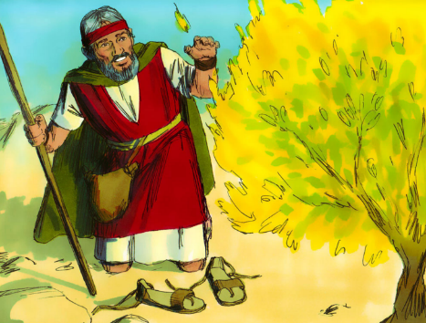
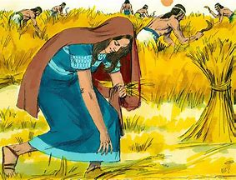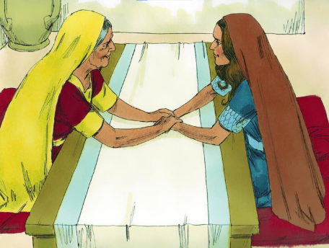

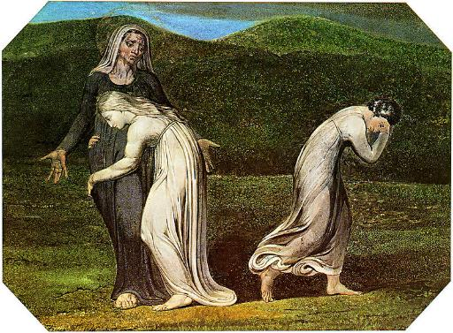
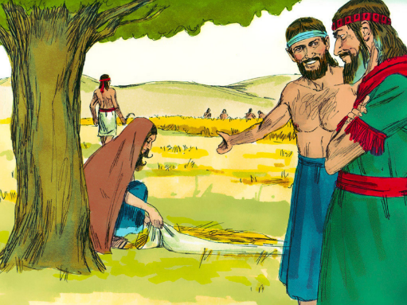

Julius Schnorr von Carolsfeld | Ruth in Boaz's Field | NG6570 | National Gallery, London

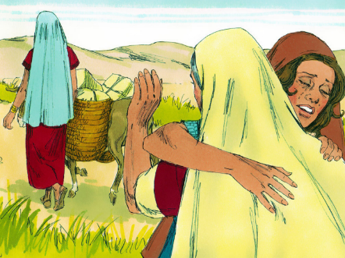

Faith

Vocation

Calling

Obedience

Trust

Love

Selflessness

Sacrifice

Commitment

Leaders

Patience

God

Doubt

