Possible paintings you may choose to use:

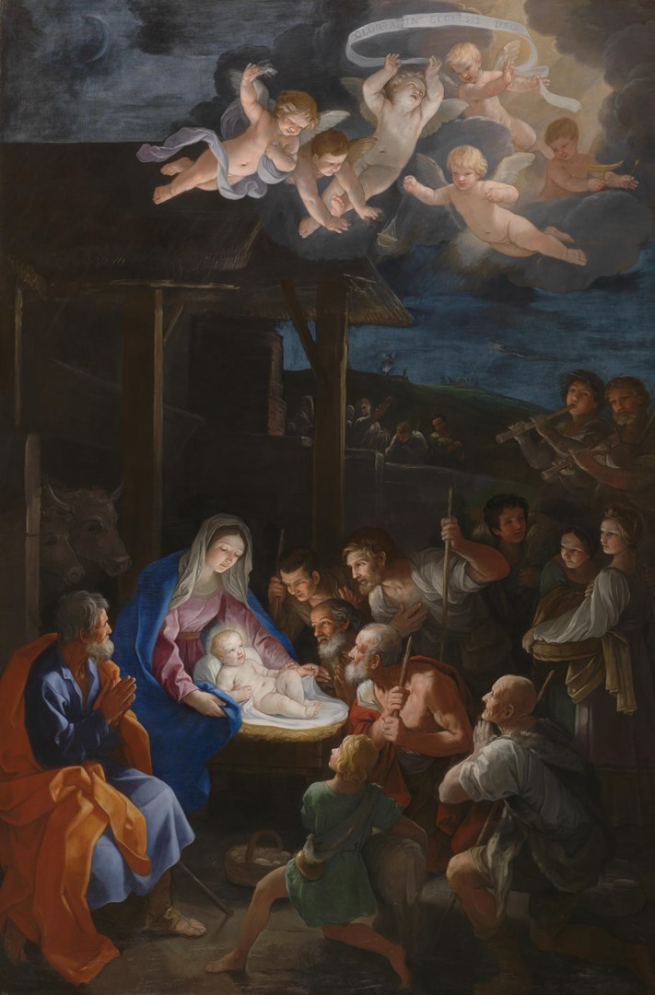

'The Adoration of the Shepherds' Guido Reni about 1642
See here for higher quality: Guido Reni | The Adoration of the Shepherds | NG6270 | National Gallery, London

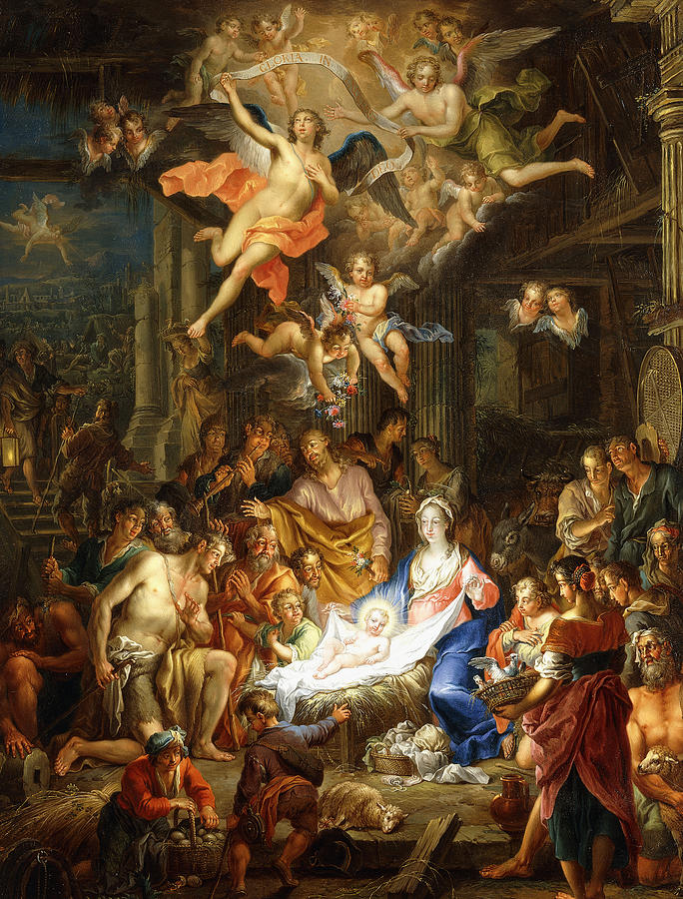

The Nativity Painting by Franz Christopher Janneck 1703-1761
Franz Christoph Janneck (1703-1761) (christies.com)
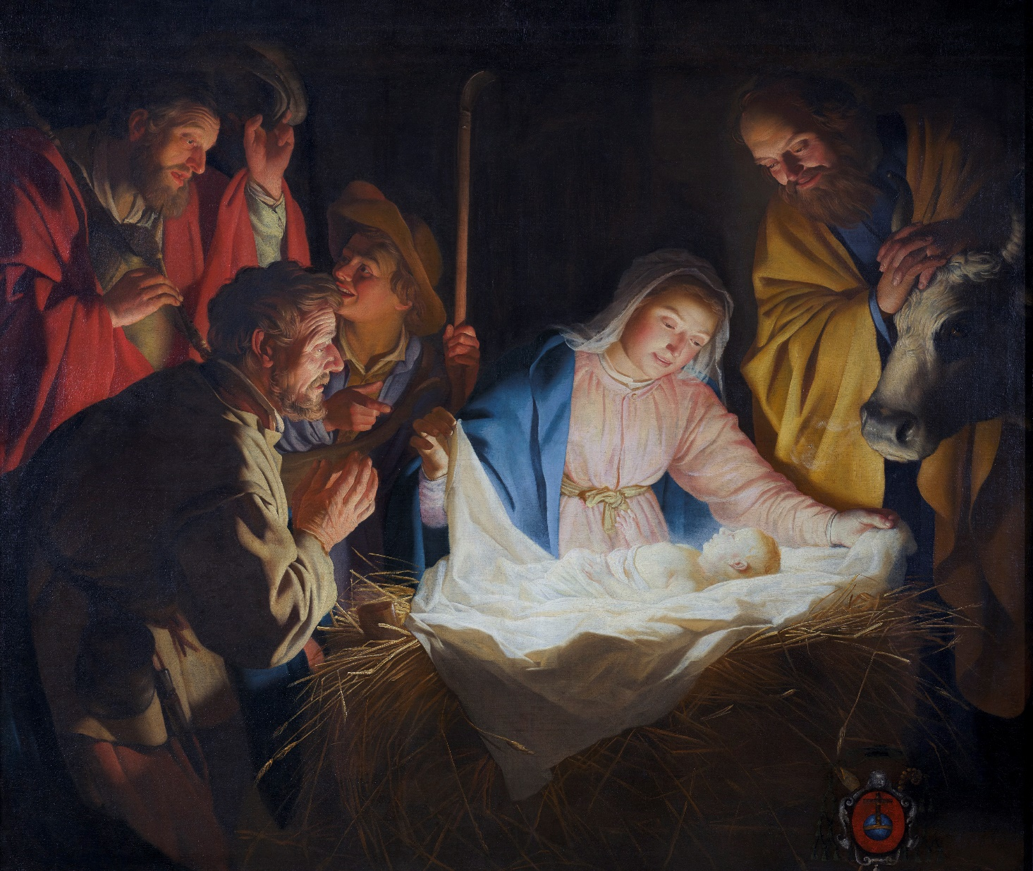

The Adoration of the Shepherds, 1622 (oil on canvas), Honthorst, Gerrit van (1590-1656)

Another option here:
Black Nativity: African American Christmas Card (Box Set of 15) – The Black Art Depot

See Here for lots of great possible paintings from around the world:
Around the World « ORTHODOX CHRISTIAN FAITH AND LIFE (orthodoxcityhermit.com)

ACAA - Asian Christian Art Association – this is a great resource for Asian art works.

