True or false
Cut up the statements. Pupils in groups decide which ones they think are true and which ones they think are false.

The Bible was written by many different authors.

The Bible is a story.

The Bible is one book.

The Bible is made up of 66 books.

The Bible is the Holy Book for Christians.

The Old Testament was originally written in Hebrew and is shared with the Jewish community.

The New Testament was written in Hebrew.

You can find many different genres in the Bible.

The Bible was written by God.

The Bible was written in one go.

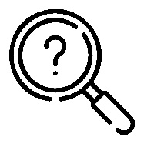

The Bible was written by many different authors. | The Bible is a story.
The Bible is one book. | The Bible is made up of 66 books.
The Bible is the Holy Book for Christians. | The Old Testament was originally written in Hebrew and is shared with the Jewish community.
The New Testament was written in Hebrew. | You can find many different genres in the Bible.
The Bible was written by God. | The Bible was written in one go.

