The Light of the World

See link below for an explanation of the painting.
The Light of the World by William Holman Hunt | St Paul's Cathedral (stpauls.co.uk)
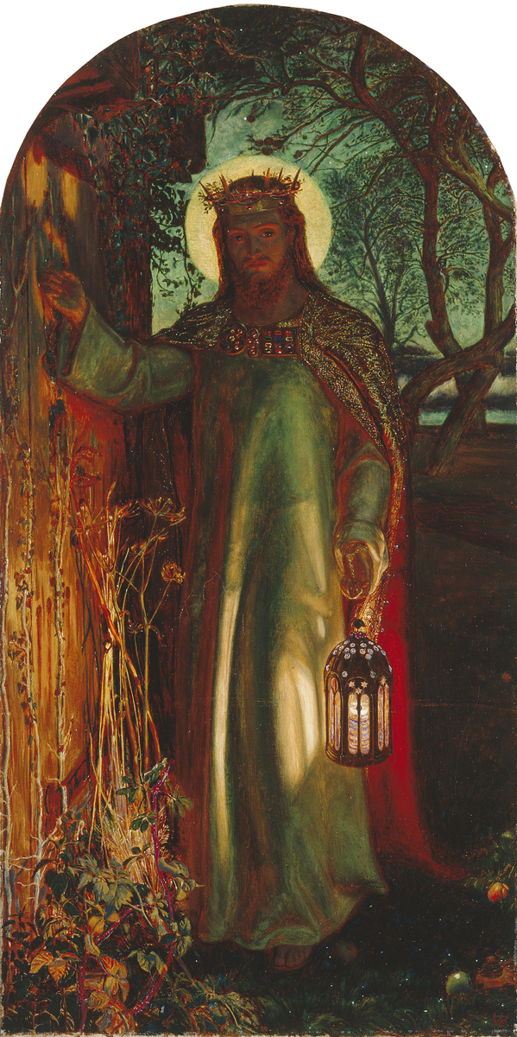
(The Light of the World - Keble College (ox.ac.uk))- extra info found here.
YEAR TWO - LESSON 1
© Copyright London Diocesan Board for Schools 2023

