London Diocesan Board for Schools
Religious Education

In conversation…. is a training resource to support the continued professional development of primary RE leads and classroom practitioners working in Church Schools across the Diocese of London.

Introduction:
The core purpose of the resource is to provide practitioners with live examples of how a class teacher adapts planning to meet the needs of all, how to teach Biblical text analysis effectively and how listening to the pupils’ voice is essential if we are to really understand a child’s learning journey in RE.
A sincere thank you goes to All Souls Church of England Primary School in Westminster who have provided the material for this resource.

The videos and supporting material have been written by the following people:

Mary Thorne:
Primary adviser with responsibility for Religious Education for the London Diocesan Board for Schools.

Hannah Legg:
RE lead and an experienced class teacher at All Souls Church of England Primary School in Westminster.

All Souls Church of England Primary School:
All Souls is a very diverse school situated in the West End of London. The school currently has a higher than average percentage of pupils from a disadvantaged background as well as a higher than average percentage of pupils with special educational needs. There are approximately 30 different languages spoken across the school with the most common home languages being Bengali, Arabic and English.

The school has children from many different faith backgrounds as well as those with no identified faith. The highest percentage of children are of the Islamic Faith.

Academic standards across the school are high. Results at the end of Key Stage Two are significantly above the national in terms of outcomes and progress.

The resource consists of the following:

- Video 1: Adapting the learning to meet the needs of all.
Topics covered:
How to plan a unit of learning
Planning for pupils with SEND
Planning for higher attainers
The importance of questioning
- Video 2: How to teach Biblical text analysis effectively.
Chapter 1: Mary and Hannah discuss the preparation that Hannah has undertaken prior to teaching the lesson.
Chapters 2 - 7: Live lesson.
Chapter 8: Mary and Hannah reflect together on the lesson.
Topics covered:
Recapping prior knowledge.
Introducing the big question.
Teaching religious vocabulary.
Modelling and scaffolding.
Teaching children the skills of text analysis.
The importance of asking questions in the RE classroom.
Using questioning to move the learning on.
Religious literacy – what does it look like?
The role of talk in the classroom.
Collaborative learning.

- Video 3: Children from All Souls Church of England Primary School talking with their class teacher about their RE learning.
Topics covered:
How to listen to children.
The role the child’s book plays when children talk about their RE.
Why the voice of the child is essential in the assessment process.
- Training pack:
Examples of children’s work from the lesson featured in Video 2.
An example of a child’s written outcomes for the whole unit.
Group discussion questions. Please feel very free to adapt and change these to ensure the training meets the needs of your context. The questions have been written to prompt reflective discussion, challenge current thinking and practice, affirm where there is good practice and facilitate change and improvement where required.
How the resource can be used:
CPD for RE leads:
- Knowing the curriculum.
- Curriculum design.
- How to effectively monitor and evaluate RE.
- Writing an action plan linked to whole school improvement priorities.

CPD for class teachers:
- A one-off session using an extract from one of the videos supported by the group discussion questions.
- A year-long CPD programme covering a different topic each half term.
- To support whole school training
- To support K.S team training
- To support individual teachers who might like to dip into the videos to see what quality teaching of RE looks like.
- To support the training of RE leads across the diocese.

Pupil progress in RE:
Pupils make progress in RE as a result of a rich and engaging RE curriculum. When we talk about whether a pupil is making progress in RE, we are asking two questions. The first question being – is there evidence that the learning is going into the long-term memory? The second question being – is the pupil becoming religiously literate appropriate for their age? In order to answer these two questions, it is essential that teachers draw on a wide evidence base which includes the following: Pupil participation and engagement in lessons, pupil voice, teacher voice and evidence produced in a pupil’s book. By looking at a broad range of evidence, teachers are able to formatively assess and make a fair and accurate judgement with regards to a pupil’s progress within the subject.

Learning: A change in the long-term memory. “If nothing has changed nothing has been learned.”
Definition of religious literacy: To enable children and young people to hold balanced and well-informed conversations about religion and worldviews. Dr Kathryn Wright.

In conversation with: Mary Thorne - London Diocesan Board for Schools Primary Adviser with responsibility for RE
and
Hannah Legg - RE lead at All Souls Church of England Primary School.
Video 1: Adapting a unit of learning to meet the needs of all.
Mary and Hannah in conversation….
Part 1: From a teacher’s perspective.
Chapter 1: As a class teacher can you talk through the things you consider before you begin teaching the unit to ensure the planning is appropriately adapted to meet the needs of your class?
0:00 to 0:59

Key things Hannah spoke about
- Where the unit fits in the whole school plan.
- Strengths and weaknesses of her class.
- Having in mind the end point – where is the unit going?

Group discussion:

- How do you as a class teacher currently approach each unit of learning, taking into account the whole-school curriculum map?
- Reflecting on Hannah’s approach, consider what you might need to do before you begin teaching a unit of learning?
- What are the strengths and weaknesses of your class in RE? What do you need to adapt in the planning to ensure your teaching meets the needs of your pupils?

Chapter 2: How do you ensure the lessons you teach, are accessible and offer an ambitious curriculum for a child with SEND?
2:08 to 3:41

Key things Hannah spoke about
- Think about what the entry point of the lesson will be.
- Think about task design – does it have an RE focus?
- Consider carefully the importance of scaffolding literacy skills so that they do not detract pupils from excelling in RE.

Group discussion:

- Talk about your current classroom context. What are the needs within your class? What are the potential barriers for some children in the RE classroom? What is currently working well?
- How do you currently begin your RE lessons? Is there anything you might do differently in the light of what you have heard?
- Consider strategies you use in other curriculum areas to help pupils with SEND access the curriculum. How could these be transferred to the RE classroom.
- Taking a lesson of your choice, what do you need to do to the suggested activity to ensure all pupils can access it and succeed in terms of RE knowledge and skills.
Chapter 3: Is there anything you do specifically to the planning to ensure your higher attainers are challenged?

3:41 to 5:15

Key things Hannah spoke about
- Quality of questioning.
- Task design.
- Enabling pupils to ‘go deeper’ with their learning.
Group discussion:

- How do you ensure the quality of questioning in your classroom is offering challenge? Can you give an example of when the questioning has led to deep thinking? (Look at previous lesson plans / in children’s books if you need prompting.) What was it about the question that enabled the pupils to respond at that level?
- How does your task design offer opportunity for depth? Give examples from an RE lesson you have recently taught where pupils have taken this opportunity.
- Taking a lesson of your choice, identify the questions that you think allow for deep thinking.
- Taking a lesson of your choice, review the task design. Is it allowing for challenge, if not, what could you do to ensure pupils in your class are appropriately challenged?
- How might you prepare to respond to a child who has begun to go deeper, without shutting them down, even though you will not know in advance what a child might say?
Chapter 4: If you had to give teachers three top tips of things to consider before they start teaching a unit of learning, what would they be?

12:25 to 14:45

Key things Hannah spoke about
- Read through the whole plan – have the end point in mind.
- Know where the children have been beforehand.
- Think about the big question yourself and how you would answer it.

Group discussion:

Take a unit of learning and discuss the following points:
- What is the end point of this unit?
- What prior learning will the children bring to this lesson and how will you find out if prior learning is secure?
- What is the big question and how would you answer it?
- What adaptations do you need to make to the plan to ensure all pupils achieve the end point?
Part 2: From the perspective of the RE leader

Chapter 5: Tell us a little bit about how and why you created the knowledge organisers. How do they support the pupils to make progress in RE? Have you seen a difference in the quality of outcomes and pupil engagement since you started using them? If yes, why do you think this is?

5:15 to 9:55

Key things Hannah spoke about
- Creating knowledge organisers has helped Hannah, as the RE lead, to get to know the curriculum overview.
- Giving teachers a one-page overview of what the main focus of the unit is about with some clear pointers of previous learning that teachers need to draw on.
- Ensuring the knowledge organiser supports the children in recalling learning, vocabulary, stories, questioning, including a Bible timeline on the Christianity units and key Bible passages.
- Use of images to prompt learning.
- How to use the knowledge organisers in the classroom.
- The impact the knowledge organiser has had on pupil progress.

Group discussion:

- Consider what you might need to do as a RE lead to strengthen your own understanding of the curriculum and your teachers understanding of the curriculum.
- What do you do in your role as RE lead to help teachers gain a real understanding of the units of learning?
- As a school, do you have a consistent approach to the teaching of RE that enables pupils to know more and remember more?
- How do you support your pupils to recall and use their prior learning and then make connections to help them with their current learning? Consider how you do this from one lesson to the next, as well as across the whole curriculum map.
- As an RE lead, how do you build a consistent and coherent approach across the school to help pupils recall their prior learning and apply it to their current learning?

Chapter 6: In your role as RE lead at your school, is there anything you do at a strategic level related to the planning, for all classes? What difference do you think this has made to the teaching of RE?

9:55 to 12:25

Key things Hannah spoke about.
- Knowing the units of learning for the whole school really well, particularly knowing the sequence in which the units appear in the curriculum map (knowing what comes before and what comes next).
- Identifying the key priorities for your school and delivering CPD to support teachers in developing their own skills in the areas you have identified.

Group discussion:

- What are your school improvement priorities for the year?
- What are your RE improvement priorities for the year?
- Consider how you could align RE priorities with school priorities?
When writing your action plan, consider the following:
- Leadership and management
- Quality of Education
- Key priorities for the academic year
- Long term goals for the next 2-3 years
In conversation with: Mary Thorne - London Diocesan Board for Schools Primary Adviser with responsibility for RE
and
Hannah Legg - RE lead at All Souls Church of England Primary School.

Video 2: How to teach Biblical text analysis effectively.
This video is a live lesson. It is the first lesson of the Easter unit taught in Year 6 entitled: How does the Christian festival of Easter offer hope?
The question for the lesson is: How do Christians believe the Easter story helps people to understand the meaning of forgiveness?

Background information of the class in the context of their RE learning:
This is a class that enjoy RE lessons. A variety of religions and world views are represented within the class and this contributes to the children's confidence in discussing their own views and experiences, as well as their desire to learn about those of others. Prior to this lesson, the class had done very little biblical text analysis in as much depth as they do here; this is why the lesson was so heavily scaffolded at the beginning. Once biblical text analysis has been more embedded in the school's RE teaching, it would be expected that by Year 6 the majority of children should have the skills to approach such an activity independently from the start.

Mary and Hannah in conversation
Chapter 1: Can you just talk us through how you are intending on teaching this in terms of your input as the teacher, the tasks you intend to set the pupils and what you are hoping the pupils will learn both in terms of knowledge and skills.

0:00 to 2:51

Also see:
Page 5 video 1 part 1: Adapting a unit of learning to meet the needs for all. From a teacher’s perspective. Chapter 3.

Key things Hannah spoke about.
- Her desire for children to have a deeper understanding of how Christians understand forgiveness.
- For pupils to use the Biblical text to help them to gain that understanding.
- The importance of modelling how to read the text and the thought processes that takes place.
- The importance of thinking through the questions she is going to ask the children to think about to help them answer the big question from the lesson.
- The importance of putting in the scaffolds and steps in place to help children really understand the Biblical text.

Group discussion:

- What do you currently do as part of the preparation process, before you start teaching a unit of learning?
- Before you start to teach Biblical text analysis to your children, what adaptations do you need to make to the planning to ensure your teaching meets the needs of your class?

Chapter 2: Recapping prior learning and introducing the big question for the unit of learning and the small question for the lesson.

2:55 to 9:01

Also see:
Page 5 video 1 part 2: Adapting a unit of learning to meet the needs for all. From the perspective of the RE leader. Chapter 5.

Key things Hannah has does in her teaching.
- Recapping prior knowledge using the knowledge organiser as the key tool kit.
- Making reference to children’s prior learning of the curriculum.
- Reference the Bible timeline.
- Reference to the big question and small question.
- Using the Bible as the tool to helping children explore the question of the lesson.

Group discussion:

- How do you currently introduce children to a new unit of learning?
- How do you help children to recall prior learning? Do you have a good understanding of what the children have learnt in previous lessons?
- In the light of what you have heard from Hannah, what might you do differently or consider doing next time you are introducing a new unit of learning?

Chapter 3: Teaching religious vocabulary.

9:03 to 13:05

Key things Hannah does in her teaching
- Highlights key vocabulary.
- Gives children time to discuss their own thoughts and opinions.
- Provides children with a range of questions to consider during their conversations – providing challenge for pupils.
- Listens to children’s responses but also pushes their thinking on through skilled questioning.

Group discussion:

- What made Hannah’s teaching of religious vocabulary effective?
- How do you teach religious vocabulary? Is what you do effective?
- What might you do differently in your own teaching from what you have seen?

Chapter 4: Introducing the four key ideas children will need to consider as they read the Biblical text analysis.

13:35 to 21:11

Key things Hannah does in her teaching
- Allows time for the children to consider their views and ideas.
- Encourages children to build on each other’s answers and responses.
- Gives children key knowledge they require.
- Gives time in the lesson to explore the key ideas.

Group discussion:

- What is Hannah doing during this part of the lesson and why is it relevant?
- Expectations – what is Hannah expecting from her pupils?
- What does Hannah do when a pupil’s response isn’t quite accurate?
- Talk about how Hannah introduces the key four ideas – is it effective?

Chapter 5: Teaching Biblical text analysis – teacher modelling and scaffolding.

21:29 to 24:53
28:04 to 38:33

Key things Hannah does in her teaching
- Provides children with the strategies they need to apply when reading the text.
- Provides children with the questions before they begin reading so they know what to look out for.
- Tells the children how to navigate their way around the Bible.
- Models and scaffolds.

Group discussion:

- What does Hannah do really well?
- Talk about the quality of Hannah’s questioning – how does it support the learning for the children?
- Talk about the modelling and scaffolding – how does this support the learning for the children?
- How does Hannah make links to the four key ideas previously taught earlier in the lesson?
- What might you do differently in your own teaching from what you have seen?

Chapter 6: Pupils’ religious literacy – pupils working collaboratively together.

41:22 to 48:55

Group discussion:

- Thoughts and reflections.
- From listening to the pupils, what can you say about the quality of discussion?
- Reflecting on the children you teach, how religiously literate are they? Do they talk with confidence in the RE classroom? What could you do to enable your children to become more religiously literate?
- How do you think the teaching has impacted on the pupils’ independent learning?
- Are the pupils appropriately challenged? If yes, how and how do you know?
- Thinking about your own classroom – do you think your children are appropriately challenged? If yes, how and if you not, what could you do to offer that challenge?
Chapter 7: Plenary – summing up the learning.

53:01 to 59:05

Key things Hannah does in her teaching
- Sums up the learning through skillful and well thought out questioning.
- Brings the learning back to the pupil’s own thoughts and reflections.
- Returns back to the question for the lesson and the small step questions that were used to help answer the question and explores with the children their responses now in the light of their learning.

Group discussion:

- From what you have observed, have the pupils made progress and if yes, what evidence are you basing your answer on?
- In your own teaching, what strategies do you use within a lesson to assess pupil progress?

Chapter 8: Reflecting on the lesson.

As the RE lead….

59:12 to 1:06:47

Group discussion:

- Consider how Mary asks and phrases the questions. What does she do to help Hannah reflect on the pupils’ learning?
- Mary consciously plays back what Hannah has reflected on and in some cases extends her responses and adds to them. Why do you think Mary does this?
- Do you think the structured conversation was helpful for Hannah as the teacher?
- From observing the structured conversation, what can you take away from it as an RE lead and use when you are giving feedback to classroom teachers?

In conversation with: Mary Thorne - London Diocesan Board for Schools Primary Adviser with responsibility for RE
and
Hannah Legg - RE lead at All Souls Church of England Primary School.

Video 3: Hannah in conversation with children from her class.

Background information on the pupils:
- Two pupils are working at expected in RE.
- Two pupils are working at greater depth in RE.
- Three pupils are EAL.
- One pupil is pupil premium.

Chapter 1: Enjoyment in RE

Hannah’s question:
- What do you enjoy about RE and can you tell us about a lesson this year that you have particularly enjoyed?

0:00 to 1:46

Group discussion:

- What do you notice about the children’s responses?
- Do you get a sense from what you have heard that the children enjoy RE? If so, what is it that they are saying that gives you that sense?
- What do you think the purpose of asking the question is in terms of addressing children’s progress in RE?

Point to note:
- It is essential that the teacher knows and has a copy of the RE curriculum when asking the question in order to gain a real understanding of whether what the children are remembering links with their prior learning.

Chapter 2: How children use the knowledge organiser.

Hannah’s questions:
- Can I ask you to talk through the knowledge organiser?
- Can you explain how these knowledge organisers help you with your RE learning?

1:45 to 3:57

Group discussion:

- From what you have just heard, discuss what you think the impact of the knowledge organiser is having on the following:
- Children’s engagement in the RE lesson
- Children’s ownership of their own learning
- Children’s progress in RE
- Children’s ability to remember and make links with prior learning

Also see:
Page 6 video 1 part 2: Adapting a unit of learning to meet the needs of all. From the perspective of the RE leader. Chapter 5.
Page 9 video 2: How to teach Biblical text analysis effectively Chapter 2.

Chapter 3: The lesson

Hannah’s question:
- What did you learn in today’s lesson?

4:00 to 5:46

Group discussion:

- What do you notice about the children’s responses? What does it tell you about the learning that has taken place for all the children?
- What does Hannah do in this part of the conversation that enables the children to go deeper with their answers?
- What do you do in your classroom as a teacher to check that children have learnt?
- What do you do as a RE lead to check that children are making progress in their RE learning?
- What might you do next, in the light of what you have just heard?

Chapter 4: Challenge

Hannah’s question:
- How were you challenged in today’s lesson?

5:47 to 8:21

See also:
Page 5 video 1 Part 1: Adapting a unit of learning to meet the needs of all. From a teacher’s perspective. Chapter 3.

Group discussion:

- What do you notice about the children’s responses?
- Discuss the children’s ability to reflect on their own learning. Thoughts/reflections.
- What can you say about the children’s religious literacy? What evidence are you basing your opinion on?

Point to note: Hannah has the expectation that all learners should experience challenge within a lesson.
- What does challenge look like in your classroom?
- As the RE leader what does challenge look like in RE across the school?
- What might you do differently in the light of what you have heard?

Chapter 5: Future learning

8:24 to 10:17

Hannah’s question:
- What are you looking forward to in the rest of this unit?

Group discussion:

- What strategies and tools have the children been exposed to that has enabled them to have a desire and interest in wanting to know more? Do think this will make a difference in how they engage in the unit and if so why and how?
- What might you do to ensure your children have a desire at the start of the unit to want to know more and to be engaged in the learning?

Group task
Examples of children’s work produced in the lesson featured in video 2

Here are three examples of children’s work from the video lesson. They represent a range of responses, from very strong to less so.

Bearing in mind the key question and learning objective for this lesson -

How do Christians believe the Easter story helps people to understand the meaning of forgiveness?
LI: To use biblical texts to explain the Christian concept of forgiveness?

- for each piece of work, consider these three questions:
- What are the strengths of this piece of work?
- Where has this child struggled?
- What would your next steps be for this child?

Discuss your answers, then compare them to the reflections from the class teacher.

Class teacher’s reflections

Child A

- What are the strengths of this piece of work?
- The child has accurately picked out details from each text that help him to answer each question.
- For each text, the child has given a slightly different answer to “What does this passage teach Christians about forgiveness?” This shows me that he is thinking deeply about that question and building his understanding of forgiveness from his analysis of the biblical text.
- He has accurately used some religious vocabulary, such as “sinners” and “redeem”.

- Where has this child struggled?
- He has misused the word ‘merciful’: in “if they are merciful they will be forgiven”, merciful should be repentant.
- You can see that he has struggled to work out who Jesus forgives in Luke 23:26-34 - he writes one answer, then changes it to another that is not completely correct. He has, however, understood that the people being forgiven do not realise this, but has not acknowledged the significance of this when explaining what this passage teaches about forgiveness.
- His answer to “How does the forgiven person react?” for Luke 15:11-32 does not speak about the forgiven person, but the one who is forgiving. It is, however, an insightful comment about the father.

- What would your next steps be for this child?
- This child shows a willingness to use religious vocabulary. This is to be encouraged and he now needs support to ensure he always uses these words accurately in context.
- Next time he does some biblical text analysis, he needs reminding to stay within the verses he has been given and look for insight there, particularly when the answers are not immediately obvious, rather than reading around the given passage - this will help him to find deeper insights than those he already has.

Child B

- What are the strengths of this piece of work?
- Child B’s answer to “How do the other people react?” for Luke 19:1-10 was very insightful as it showed understanding that Jesus’ response was so shocking because he claimed to be God. The fact that he uses the term God is interesting as it indicates a possible understanding of Jesus showing his divinity by forgiving sins. His use of God in the final question for each text also shows his understanding that, for Christians, Jesus is considered to be God.
- Like Child A, he has offered different answers to “What does this passage teach Christians about forgiveness?” for each of the passages. This shows that he is working hard to take his understanding of forgiveness directly from the Bible text and not from his own knowledge.
- When analysing Luke 23:36-34, Child B has thought in detail about all of the characters present in that passage and the following verses: the soldiers, the mockers in the crowd, and the women following Jesus. This shows that he is reading the text deeply and using what he reads to develop his understanding of forgiveness.

- Where has this child struggled?
- This is a very strong piece of work that shows a secure understanding of how to use Biblical texts to deepen understanding of a Christian concept.
- There are some small grammatical issues with his use of religious vocabulary to pick up on, such as forgived.

- What would your next steps be for this child?
- This child is ready to attempt more independent Biblical text analysis. The next lesson in the unit on Biblical text analysis focuses on the concept of hope (see sample work dated Monday 28 March 2022). This child is ready to access that without much teacher scaffolding or support.

Child C

- What are the strengths of this piece of work?
- For the first two texts, both of which have been analysed with support, Child C has successfully picked out the details from the biblical texts which answer the initial observation questions.
- She has shown some understanding of what these passages teach about the Christian concept of forgiveness - she has written “he will always forgive you” twice.

- Where has this child struggled?
- Overall, this response shows a simpler level of understanding of forgiveness but one that is still mostly rooted in the Biblical texts.
- Twice, she has written that “he” forgives you and it is unclear who she means by this. This could be followed up with a conversation and an expectation to be more specific in responses next time.
- For the last two texts, both of which were done without teacher support, note that she has not offered a response to “why” the forgiven person reacted as he did. For the third passage, she has struggled to unpick exactly who Jesus forgives and how they respond to being forgiven.
- When analysing the final text, she has lost sight of the concept of forgiveness and instead commented on jealousy and not judging people at first sight.

- What would your next steps be for this child?
- Although Child C has mostly observed details from the texts correctly and worked out what is going on in each text, she has struggled to understand what the passages teach about forgiveness. As the scaffolding became less and she moved through each text, her difficulty with this became increasingly obvious. Next time, this child would require more teacher support to deepen her reading and find meaning in the text.

Example of children’s work completed in the lesson that is featured in video 2
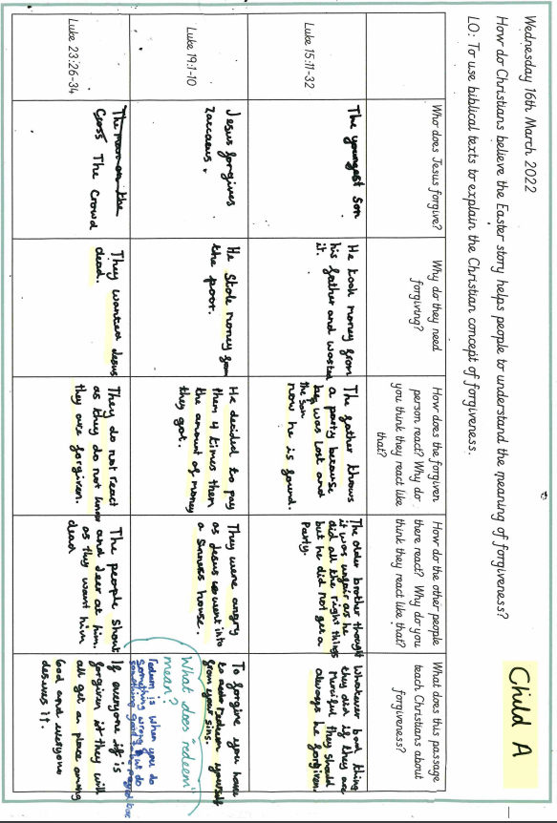

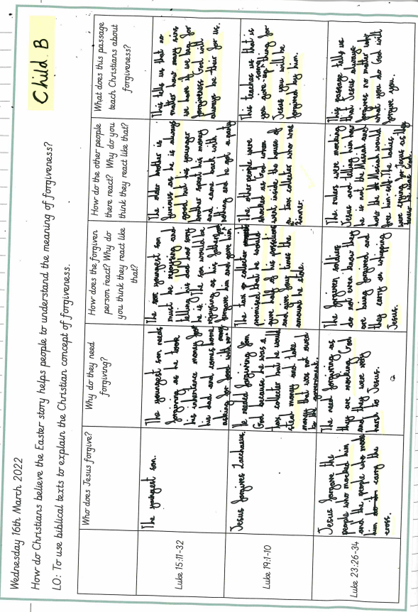
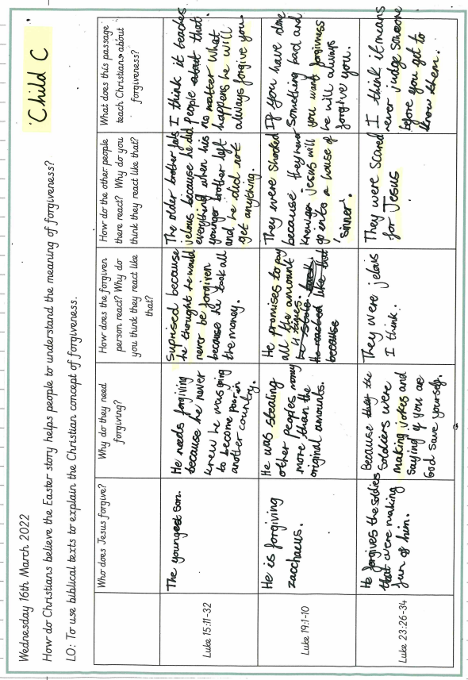

An example of a child’s written outcomes from the whole unit
How does the Christian festival of Easter offer hope?

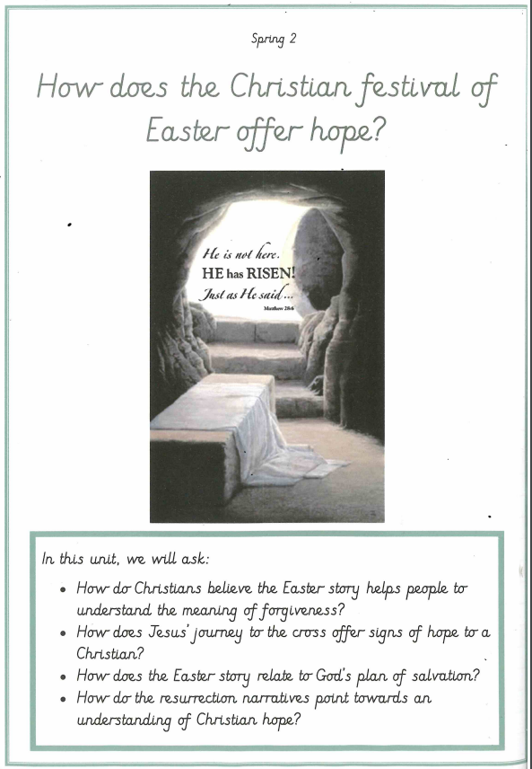

dd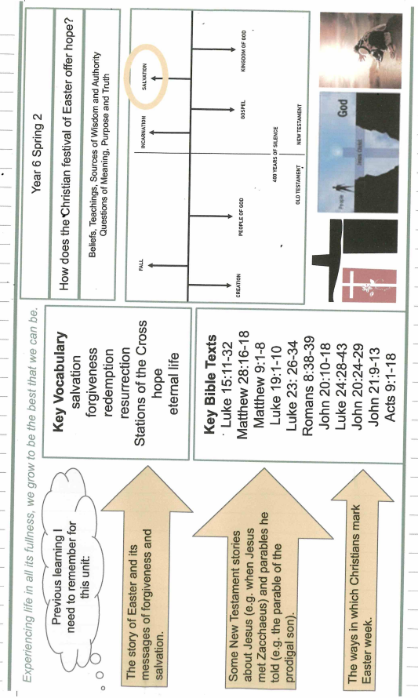

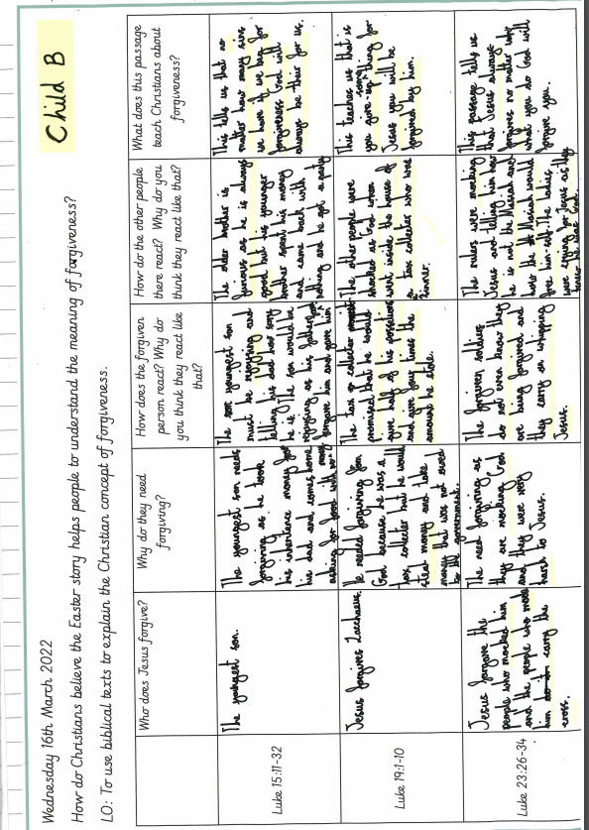

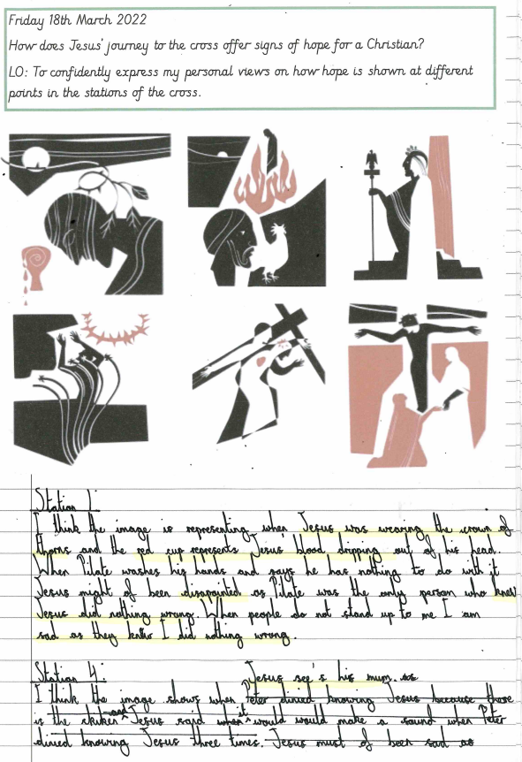

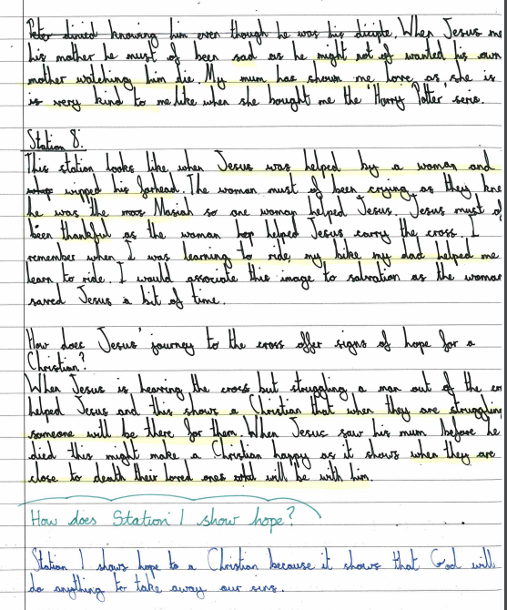

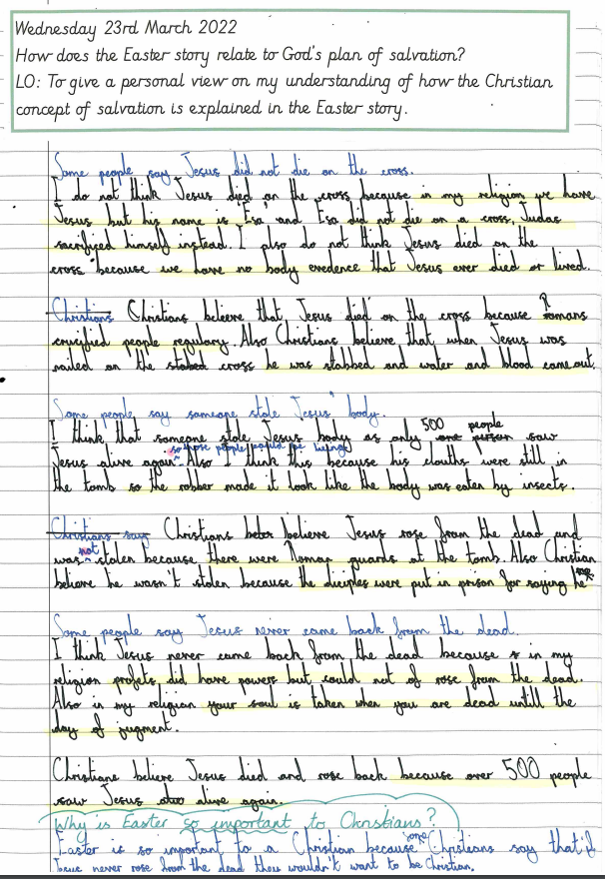

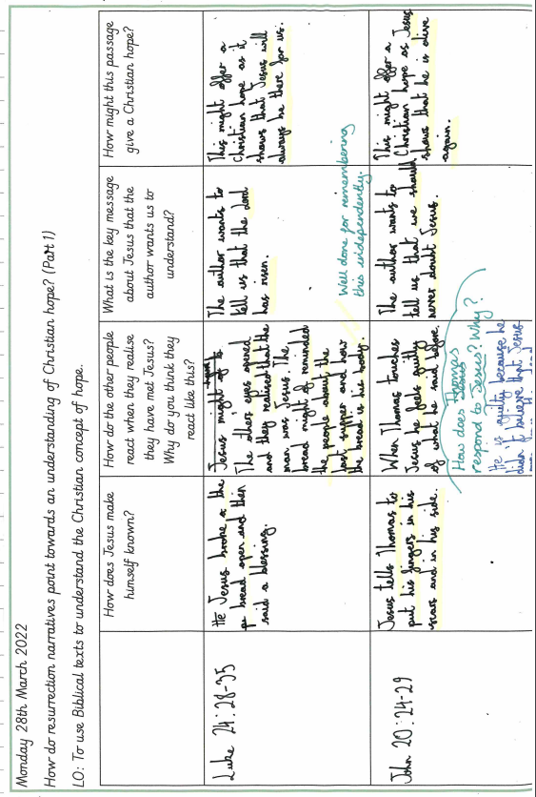g

