Could you be our next Deputy Headteacher?

Do you want to be part of our story?
The Aldgate School is an exceptional school in a unique environment and we are looking for a dynamic, forward-thinking leader whose track record proves they can help lead our school into the next chapter of its exciting story.
We want the very best for our children and families.
We’re looking for an inspirational leader to join our team and support our Headteacher to achieve our aim of an exceptional education for every child.

You will be a creative and talented leader with a determination to help lead our outstanding primary school and Children’s Centre to the next stage of its development.
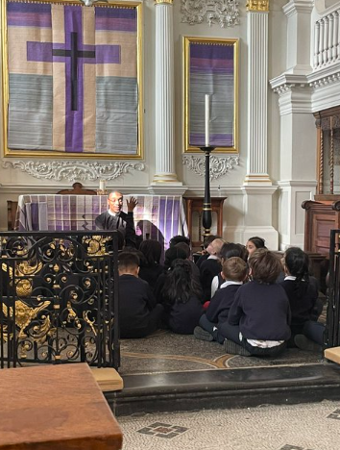
We can offer you the chance to work in a unique Church of England Primary School - the only maintained school in the City of London. We run an integrated Children’s Centre on our site so you will have the opportunity to develop provision for children aged 3 months to eleven years. Because of our special setting you will have access to unrivalled resources, including the wealth of cultural, educational and artistic institutions on the doorstep.
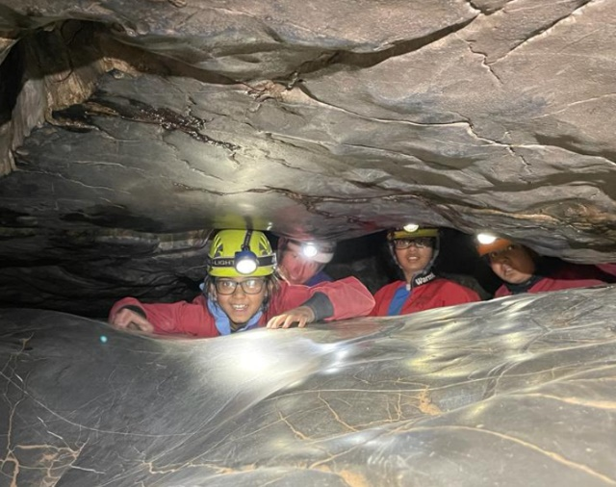
You will have significant experience and knowledge of education and demonstrate a good understanding of how to achieve the best outcomes for all children at EYFS, KS1 and/or KS2. You’ll be an outstanding practitioner with high expectations of young children. You will be able to demonstrate your consistent focus on developing an exceptional provision for every child.
The successful candidate will be supported by a dedicated Headteacher, leadership and teaching team. The school is a close-knit community, where the Christian ethos of the school is lived out in all relationships. If applicable, we will support the successful candidate to achieve a master’s level qualification or with other professional development on a path to Headship.
We’d love to talk more with you about this role and we welcome visits to the school at any time.

On behalf of the Governors, thank you for your interest in our school.
Dear Applicant,
Thank you for your interest in the role of Deputy Headteacher of our school.
We are a unique single-form entry Church of England school, the only state-funded primary school in the City of London. Our children are drawn from the City and neighbouring Tower Hamlets, resulting in an incredible ethnic, cultural and socio-economic diversity. The school has a strong Christian culture of inclusivity, where children of all backgrounds are welcomed and enabled to flourish. Our ambition is that every child receives the very highest levels of educational practice.
As a Governing Board we are immensely proud of our hardworking pupils and our committed staff. We are looking for an exceptional Deputy Headteacher to work collaboratively with our Headteacher, Alex Allan, to develop the school further.
The uniqueness of our location, and the longstanding support of the City of London Corporation the Portal Trust bring many benefits to our school, offering our children resources and opportunities that are not available elsewhere. Aldgate is currently undergoing significant change: thousands of new homes are being built in the vicinity of the school and a new pedestrianised square is on our doorstep, the largest such public space in the City and the focal point for art and cultural events. This is an exciting time for our school and one of great opportunity.
We are looking for an experienced practitioner with the skills and passion to deliver outstanding outcomes for our children and to further develop our special culture of care and support for one another. You can be assured of Alex’s support and that of the whole Governing Board, both in your role and in your future professional development.
We very much look forward to receiving your application.
Yours faithfully,
Matt Piper
Chair of Governors
Our Vision
Every member of our school community will develop a questioning approach to faith, grounded in the principles of Christian hope, which prompts everyone to seize every opportunity for growth, to look beyond themselves and lovingly serve their community and the wider world.
Faith, hope and love abide, these three: and the greatest of these is love.
We provide:
- A stimulating, broad and balanced curriculum for every child.
- A religious education according to the principles and practices of the Church of England in a context where everyone is valued and respected.
- Excellent teaching and carefully targeted support to ensure every child is challenged to excel and achievements are celebrated.
- Staff development to ensure our staff are well trained.
- A safe, disciplined environment where all members of our school community are expected to treat each other with courtesy and respect.

About our school
Every child at our school makes excellent progress and achieves highly.

At our school, education is much more than fluency in reading, writing and arithmetic. It’s about a rounded experience which enables each child to be independent, self-confident and creative. We want every child to flourish and be well-prepared for their future.

Our school pioneered a whole class strings teaching programme in the 1960’s and to this day every child still learns to play a stringed instrument, free of charge. We’re also proud of our choir and performing arts group who have performed for major dignitaries - the Queen and President Bill Clinton and at major events at the Royal Albert Hall and the O2 arena. We also provide specialist art, French and sports teaching each week.

The governing body is responsible for running an integrated Children’s Centre, offering childcare, family support and information.

We want the very best for our children. And we’re looking for a Deputy Headteacher who will share our vision for an exceptional education for all.

Beating of the Bounds- Find out more about our history on our School website https://www.thealdgateschool.org/about-us-2/our-trustees-and-history

Our Deputy Headteacher
Professional duties are to be carried out in accordance with the terms and conditions of the current School Teachers’ Pay and Conditions Document issued by the DfE and this job description should be read alongside the range of duties and responsibilities of Deputy Headteachers described in that document. Nothing in this job description should be regarded as detracting from that document. The duties and responsibilities highlighted in this job description are indicative and may vary over time and in any case are reviewed annually. Postholders are expected to undertake other duties and responsibilities relevant to the nature, level and extent of the post and the school.
Working to help shape the future
- Working with the Headteacher and governing body to support the vision, leadership and clear direction for the school and Children’s Centre
- Ensuring that learning is at the centre of the school’s strategic planning and resource management
- Supporting the production of, monitoring and evaluation of a school development plan which identifies priorities and targets for ensuring that pupils achieve high standards and make progress, increasing teachers’ effectiveness and securing school and Children’s Centre improvement
- Inspiring and leading the staff, pupils, parents and the wider community to the vision and direction of the school
Leading teaching and learning
- Promoting and securing outstanding teaching, effective learning, highest standards of achievement, excellent behaviour and discipline for all pupils
- Organising, implementing and monitoring the curriculum and its assessment in order to identify and act on areas for improvement
- Monitoring and evaluating the quality of teaching and standards of learning and achievement of all pupils, in a school that prioritises inclusivity, in order to set and meet challenging, realistic individual targets for every pupil
- Creating and maintaining an effective partnership with parents to support and improve all pupils’ achievements and personal development
- Promoting an exciting and challenging curriculum and enabling environment that inspires all children to develop their own learning and reach their full potential
Efficient and effective deployment of staff and resources
- Collaboratively working with the Headteacher and head of Children’s Centre Services to ensure that excellent teaching and provision in the Children’s Centre remains a prime focus by recruiting, developing and nurturing this core value in all teaching and support staff
- Assisting with the deployment and management of all teaching and non-teaching staff and allocating particular duties
- Assume responsibility for the discharge of the Headteacher’s functions at any time when the Headteacher is absent from the school / Children’s Centre
- Implementing and sustaining effective systems for the management of staff performance, incorporating targets for teachers
- Motivating and enabling all staff to carry out their respective roles to the highest standard, through high quality continuing professional development based on assessment of needs
Supporting the Head to manage the organisation
- Assisting the Headteacher in ensuring all staff carry out the governing body’s policies
- Take a leading role on safeguarding
- Ensuring that safeguarding and protecting children is a core priority to the school’s work within a culture of vigilance
- Working with the Headteacher to ensure that the management structure is the most appropriate to achieve the our aims and objectives
Accountability
- Supporting the Headteacher to provide information, advice and support to the governing body to enable it to meet its responsibilities
- Working collaboratively with the Headteacher to create and develop an organisation in which all staff recognise that they are accountable for the success of the school and Children’s Centre.
- Presenting a coherent and accurate account of the school’s performance in a form appropriate to a range of audiences
- Ensuring that parents and pupils are well informed about the curriculum, attainment and progress, and about the contribution that they can make to achieving the school’s targets for improvement
- Attending all full governing body meetings and all appropriate sub-committee meetings
Key organisational objectives
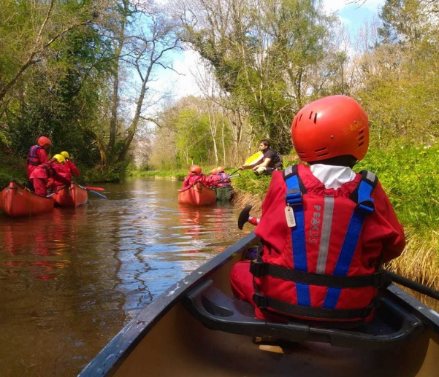
The post holder will contribute to the school’s objectives by:
- Enactment of Health and Safety requirements and initiatives as directed.
- Ensuring compliance with Data Protection legislation.
- At all times operating within the school’s Equal Opportunities framework.
- Commitments and contribution to improving standards for pupils as appropriate.
- Contributing to the maintenance of a caring and stimulating environment for pupils.
- Undertake regular Child Protection training at a level commensurate with the role
- Undertake regular training on SEND issue at a level commensurate with the role.

Conditions of service
Governed by the National Agreement on Teachers’ Pay and Conditions.
Special conditions of service
Because of the nature of the post candidates are not entitled to withhold information regarding convictions by virtue of the Rehabilitation of Offenders Act 1974 (Exemptions) Order 1975 as amended. Candidates are required to give details of any convictions on their application form and are expected to disclose such information at the appointed interview.
Because this post allows substantial access to children, candidates are required to comply with departmental procedures in relation to Police checks. If candidates are successful in their application, prior to taking up post, they will be required to give written permission to the Department to ascertain details from the City of London Police regarding any convictions against them and as appropriate the nature of such convictions.
Equal Opportunity
The post holder will be expected to carry out all duties in the context of and in compliance with the school’s Equality Policy.

Person Specification
Assessed by: A- Application form, I- Interview, R- Reference
Desirable
Essential
Knowledge and qualifications
Teaching qualification recognised by the DFE | / |  | A
Higher degree |  | / | A
Evidence of leadership training and/or qualification e.g. NPQH |  | / | A
Experience
Senior management experience as assistant head, Deputy Head teacher or senior teacher | / |  | AIR
Experience of teaching in both Key Stage 1/EYFS and Key Stage 2 |  | / | AIR
Safeguarding children and a commitment to its importance | / |  | AIR
Track record of successful leadership | / |  | AIR
Working successfully as a member of a team | / |  | AIR
Setting benchmarks, monitoring and evaluating the quality of teaching and learning. | / |  | AIR
Planning, determining and organising major curriculum areas | / |  | AIR
Budget management and financial responsibilities |  | / | AIR
Knowledge, skills and competencies
Familiarity with the national policy framework and current educational legislation and initiatives | / |  | AIR
Commitment to equality | / |  | AIR
Familiarity with SIMS management system and proficiencies with a variety of software and IT |  | / | AI
Excellent understanding of behaviour management and promote impeccable standards of behaviour with all children | / |  | AIR
Personal characteristics
Inspirational teacher and leader capable of working collaboratively. | / |  | AIR
Reflective practitioner, not afraid to challenge the status quo, making sound and timely decisions based on good judgement | / |  | AIR
Ability to motive and inspire pupils, other staff and stakeholders | / |  | AIR
Ability to work under pressure and with competing priorities | / |  | AIR
Models well-enforced high standards across the school community | / |  | AIR
Ability to be discreet and adhere to confidentiality |  |  | AIR

Thank you for taking the time to read this pack. We look forward to receiving your application. Please do give us a call or send me an email to find out more about this exciting opportunity at our great school.
Alexandra Allan

