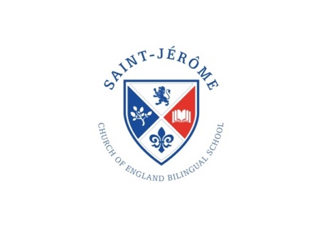
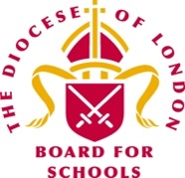
St. Jérôme Church of England
Bilingual Primary School
Headteacher: Revd. Daniel Norris MBA NPQH

Person Specification

Date Reviewed: November 2021

- JOB TITLE: School Governance Information Manager

- GRADE: SO1 – NJC23 £30,585 FTE. Approx 195 hours a year, hourly rate £16.29

- SCHOOL: St. Jérôme Church of England Bilingual Primary School

- RESPONSIBLE TO: The Governing Body of the School

- CONTACTS The post holder is required to develop and maintain the following contacts within the context of the job.

- CLOSING DATE Monday 6th December at 5.00pm

- INTERVIEW DATE Week commencing Monday 13th December

- START DATE January 2022

PERSON SPECIFICATION

School Governance Information Manager (SGIM)

Skills, knowledge and aptitudes Essential Desirable
The applicant should be able to evidence and/or demonstrate the following…
Excellent listening, speaking, writing skills and a good level of numeracy | E
Sound experience in minuting meetings and/or note taking | E
Knowledge and experience of writing agendas and accurate concise minutes | E
Excellent ICT skills including MS Word, MS Excel, MS Powerpoint, and use of email, internet and google drive | E
Organising their time and working to deadlines | E
Organising meetings and co-ordinating people | E
Excellent record keeping, information retrieval, research and dissemination of data/documentation | E
Confident speaking skills, especially in front of groups, and able to articulate well in clear English | E
Skills in developing and maintaining professional working relationships with internal and external contacts |  | D
Knowledge of school governing body procedures for academis and Church of England Schools |  | D
Knowledge of educational legislation, guidance and legal requirements |  | D
Knowledge of the roles and responsibilities of the governing body |  | D
Knowledge of equal opportunities and human rights legislation |  | D
Knowledge of safeguarding children |  | D
Knowledge of data protection legislation |  | D
Qualifications and training
The applicant should be able to demonstrate…
Professional business or administration qualifications and/or equivalent experience | E
Be able to demonstrate a willingness to attend appropriate training | E
Have already attended, or make a commitment to attend, the National Training Programmes for Clerks or equivalent training available | E
Experience
Be able to produce evidence of…
Having attended relevant personal and/or professional development | E
Excellent customer care skills and being able to work with people from a diverse range of backgrounds | E
Taking initiative and demonstrating self-motivation | E
Being a clear communicator and managing information effectively | E
Working and developing as a member of a team | E
Personal attributes
Be a person of integrity who is willing to work within and uphold the school’s Christian vision. | E
Be able to maintain absolute confidentiality and be sensitive | E
Be able to remain impartial | E
Have a flexible approach to working hours | E
Be understanding to the needs of others | E
Have an openness to learning and change | E
Have a positive attitude to personal development and training | E
Be able to confidently address groups of people and individuals | E
Have excellent interpersonal skills | E
Have an eye for written detail | E
Be confident in dealing with people in contentious, complex and sensitive circumstances | E
The applicant must:
Be able to work at a time convenient to the governing body, as detailed in the job  description | E
Be confident about working on their own, and working from home when not required for  duties in a school | E
Be able to travel to meetings and be punctual | E
Be available to be contacted during school term time, and ideally by mobile telephone | E
Have own secure access to a PC, printer and internet facilities | E

A willingness to support and be part of the wider life of the school would be a distinct advantage as would be an interest and passion to support the Christian vision and bilingual nature of our school.

Our School Vision

An aspirational, multilingual, multicultural education community that empowers everyone: to grow and flourish, to gain in knowledge, wisdom and skills and to translate the love of God for all people into words and actions.

