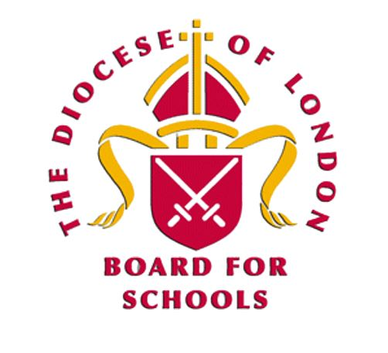
Year Group 4: Autumn B
Lesson 2: What do you think the word ‘peace’ means

Task: Exploring what is meant by internal and external peace.

Working in groups of three.

Cut up the statements.

Place the statements in the venn diagram where you think they best fit.

Add any additional statement of your own to the venn diagram.

Swap with another group.

- What do you notice?
- Are the statements placed in the same place as yours?

Return to your venn diagram.

- Do you wish to move any of your statements having now looked at another group’s work?

Statements

Peace means being calm.

Peace means no violence.

Peace means having no worries or burdens.

Peace is about justice.

Peace means no conflict.

Peace means being free from anxiety.

Peace is about fairness.

Peace is about feeling complete and content.

Peace is living without greed.

Peace means living without war.

Peace is about harmony.

Peace is about justice.

Peace is about fairness.

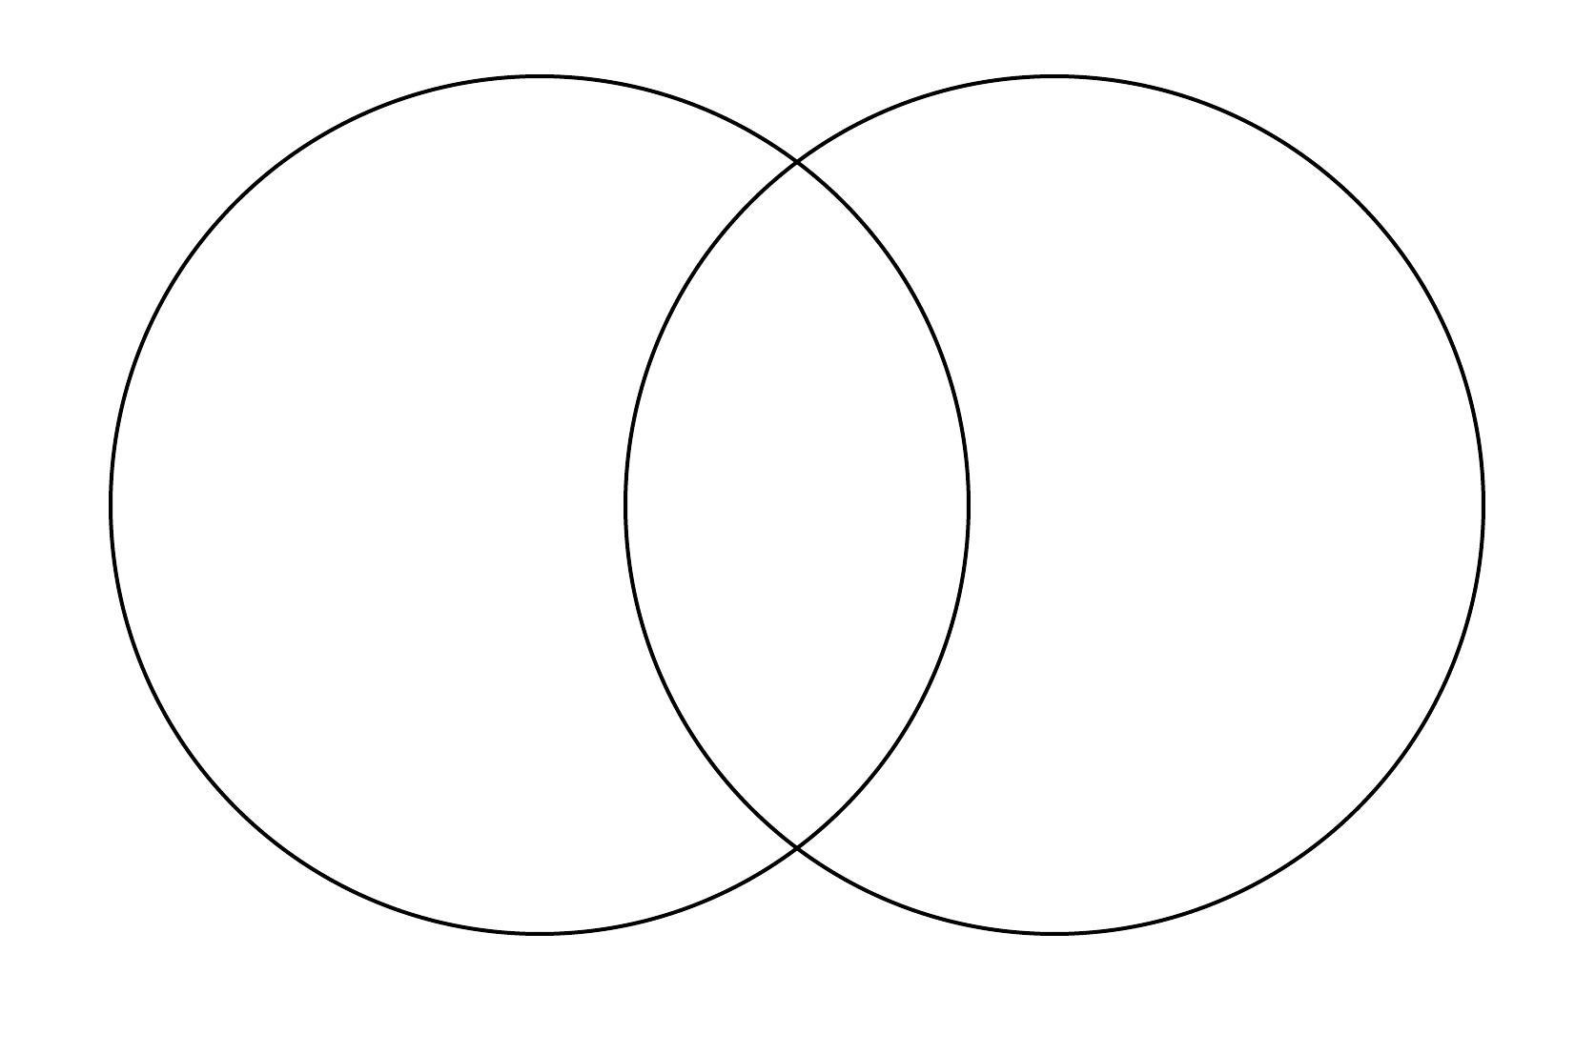
External peace
Inner peace

