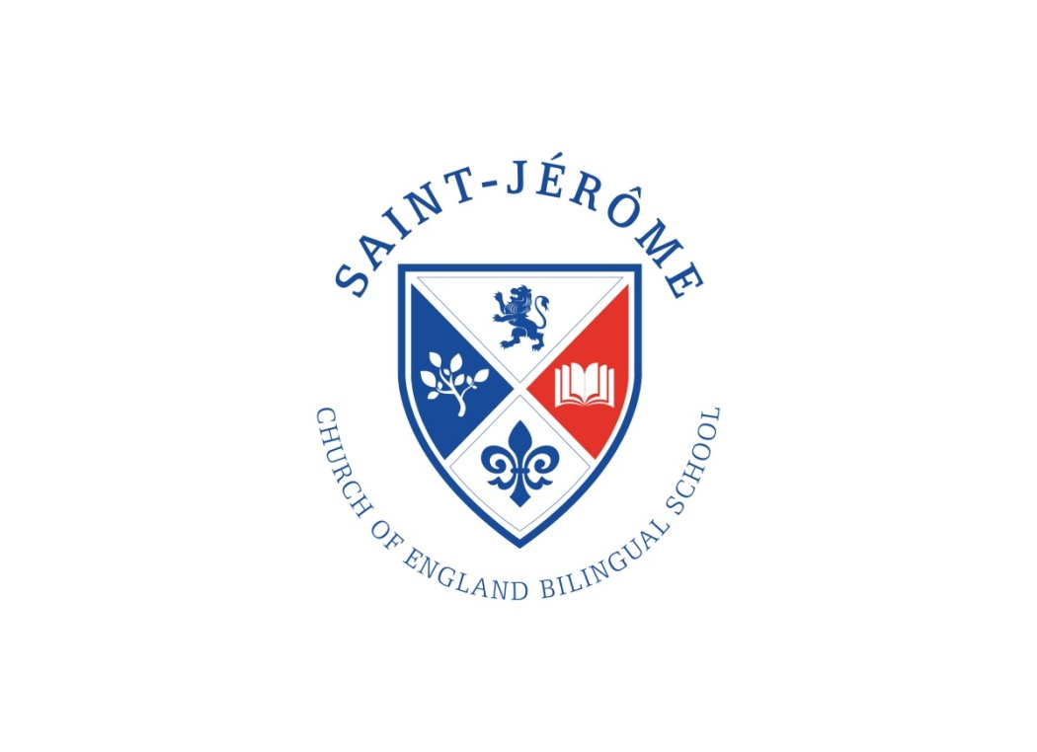
St Jérôme Church of England Bilingual School

Job Description – Office Manager

We have a vacancy for an Office Manager at our busy school office.
The successful candidate will be required to work 37 hours per week for 39 weeks (term time only plus one week).

Monday – Thursday 8.30 am – 5 pm
Friday 8.30 am – 4.30 pm

Directly reporting to our School Business Manager and supporting and leading our Administration Assistant, we are seeking a candidate who can display the highest standards of accuracy, presentation, professionalism, care and discretion at all times.

Responsibilities include but are not limited to:

- Fully support the school’s commitment to the safeguarding and welfare of children
- Provide a friendly, caring, professional and efficient first point of contact to all pupils, parents, staff, professionals and visitors to our school
- Fully manage and administer all matters relating to pupil admissions and leavers including Reception intake and in year admissions plus attendance at the Admissions Committee annual meeting
- Manage the HR function to include all matters relating to advertising posts, coordinating interviews, informing applicants of interview panel decisions and completing recruitment processes
- Fully manage and administer our school’s MIS to the highest standard including adding new pupils
- Fully manage and administer all matters relating to Data Protection ensuring the school is fully compliant including record keeping and training of staff in liaison with the Data Protection Officer.
- Complete the school census and workforce census
- Act as point of contact for individual music lessons via liaison with Harrow Music Service and families and to administer communication and payment
- Maintain and administer all matters relating to safeguarding including processing DBS applications, safer recruitment, safeguarding training and maintaining the Single Central Register
- Oversee all matters relating to attendance including first day calling and ensuring the correct codes are recorded in the class registers and absences authorised as completed by our Administrative Assistant
- Be fully conversant with, facilitate and monitor ParentPay and assist users
- Coordinate school trips and events as directed by the teaching staff and senior leaders
- Fully manage transition to KS3 of Year 6 pupils
- Produce and respond to all correspondence including communication via email, text and regular enewsletter
- Maintain accurate and up to date communication systems with all stakeholders
- Contribute to the marketing and promotion of the school and effectively support the Christian and bilingual ethos
- Keep up to date with educational changes that impact administration duties
- Plan, develop, organise and monitor support systems and procedures
- Contribute to the development of administration policies and procedures
- Provide support, advice and guidance on administrative issues to the Senior Leadership Team and Governing Body
- Embrace the whole school community joining in and facilitating organisation of events such as parents’ evenings, school fayres, sports events etc.
- Be a point of contact and liaison for the school’s PTFA
- Any other reasonable request at the discretion of our School Business Manager

This job description may be adapted from time to time at the discretion of our Senior Leadership Team.

Person Specification – Office Manager

- Previous experience of working in a school office and have knowledge of school administration policies and procedures
- Working knowledge of school Admissions
- Ability to maintain an effective administrative environment and clerical systems whilst adhering to school policies and protocols
- Exceptional communication skills both oral and written plus an excellent telephone manner
- Must be articulate, well-presented and supportive of the school’s Christian ethos and bilingualism
- Be welcoming and responsive to all visitors at all times
- Proven interpersonal skills and an ability to forge effectual professional relationships with all stakeholders of the school
- Uncompromising attention to detail and ability to create a high standard of work
- Be reliable, dependable and have the ability to work with absolute discretion
- Ability to operate all software packages such as Parentpay, word, excel, PPT, Mac computers and the school’s MIS and other educational software packages
- Be able to demonstrate flexibility and adaptability
- Ability to prioritise, plan, organise work and anticipate issues before they arise
- Be able to work as part of a team and individually as needs dictate
- To support and work in conjunction with the School Business Manager and Administration Assistant to create and maintain an outstanding school administration team
- Commitment to equal opportunities
- Knowledge of HR procedures is desirable, plus an ability to liaise with the Schools HR provider and staff to administer HR matters
- Possess GCSE (or equivalent) Maths and English minimum grade C
- Will be required to participate in training and other learning activities as directed by the Senior Leadership Team

St Jérôme Church of England Bilingual School opened to pupils for the first time in September 2016 and as such is able to offer the successful candidate many opportunities to develop professionally as the school grows and establishes a new community in the centre of Harrow. We are able to offer an outstanding working environment with up to date technology and systems.

The Governing Body supports ongoing professional development for all staff and if desired will support the successful candidate to undertake training and learning. Members of staff are able to contribute to the Harrow LGPS and receive additional wellbeing benefits.

