Appendix Lesson 4: John 15: 1. “I am the true vine.”

For a Christian, who remains connected to Jesus who is the vine, what sort of ‘fruit’ do think they would bear in their lives? Discuss in pairs and then choose the six most important ones from your list to write in the fruit.
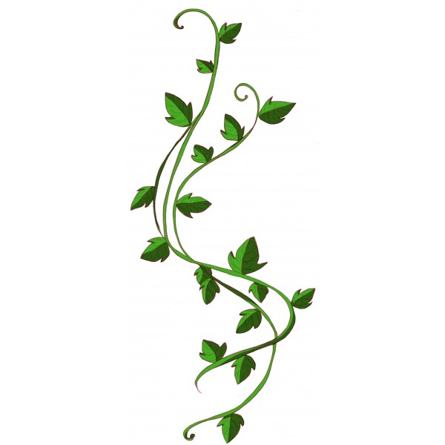
Write your list of ‘fruit’ a Christian might bear if they remain connected to the vine.
Why do you think the six you have chosen are the most important ‘fruit’ to bear for a Christian?
Jesus
Jesus

My vine and the ‘fruit’ which I hope to bear from being connected to it.

What things make up your vine? List them on the vine. What sort of ‘fruit’ do you hope to bear from remaining connected to your vine? What are your top six ‘fruits’ that you would like to bear? Write them in the fruit.
Write your list of ‘fruit’ you would hope to bear because you have remained connected to your vine.
Why are the six you have chosen the most important fruit to bear for you?

