Appendix Lesson 1: Diamond nine

Preparation: Cut up the statements.

What ingredients do we need in life that will sustain and nourish us?

Do you think everyone needs the same ingredients or do you think it is dependent upon circumstances? (Provide pupils with another context to consider, being mindful of their own context and life experiences.) Eg – Refugee, living in poverty in a developing country, living with significant wealth.

Here are nine statements. Put them into a diamond nine shape with the ones you think are most important at the top.

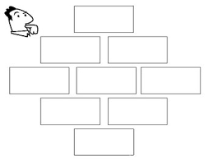
water
Faith in God
shelter
friends
family
new car

food
money
love

