**Appendix Lesson 4b:**

When can a Muslim eat during Ramadan? **Tick = Yes. Cross = No**

 

Can a Muslim eat now?

Can a Muslim eat now?

tick or cross

 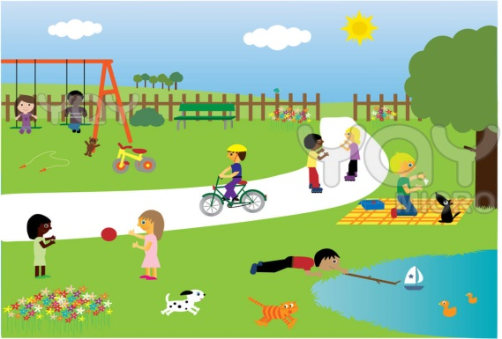

Can a Muslim eat now?

Can a Muslim eat now?

 

Can a Muslim eat now?

Can a Muslim eat now?