Year group: 3

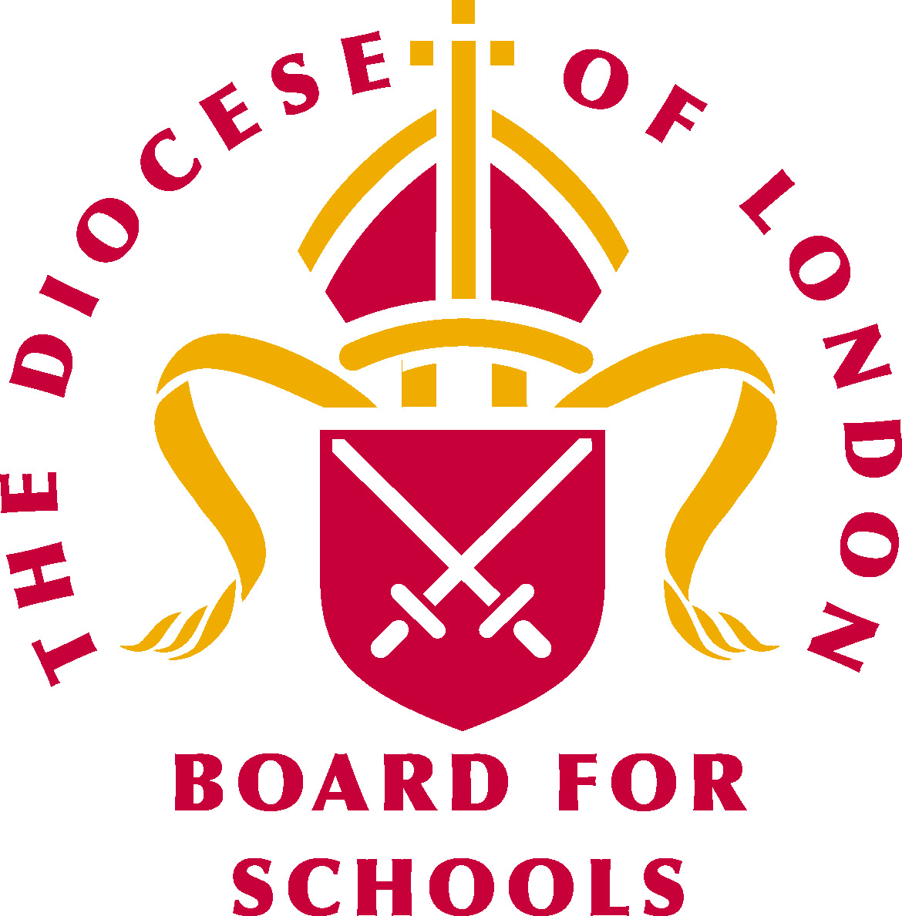Big question: What does it mean to be Jewish?
Religious vocabulary:
- Promise: An assurance that someone will do something.
- Covenant: A formal agreement made between two people.
See background knowledge for teachers:
- Abraham
- Moses
- Shema
- Mezuzah
- Passover
- Pesach
- Plague
- Israelite
- Egyptians

What a child needs to know and remember by the end of the unit:
- To know and remember what a promise/covenant is.
- To understand the significant of the Shema (Affirmation of the Jewish faith)
- To know and remember what the significance of the Passover is for Jewish people.
- To know and remember the importance of the seder meal for Jewish people.
- To know and remember the importance of the ten commandments for Jewish people.
Core concept:
Beliefs, values and commitment
Sensitivities:

Be mindful of pupils’ cultural backgrounds and beliefs.

What a child should be able to do: (Assessment)
Beliefs, teachings and sources of wisdom and authority:
- I can retell a religious story and say what special book it comes from. (WT)
- I can describe what a Jewish person might learn from a sacred text and what it might
mean. (Exp)
- I can make links between the beliefs and teachings in the sacred texts and show how they
are connected to believers’ lives. (GD)
Questions of values and commitments:
- I can begin to express my own ideas and opinions and understand that there may be more
than one answer. (WT)
- I can link things that are important to me and other people with the way they think and
behave. (Exp)
- I can confidently ask questions about the moral decisions I make and suggest what might
happen as a result of different decisions, including those made with reference to my own beliefs/values. (GD)

Weekly questions:
Week 1: What is a promise/covenant?
Week 2: What is the significance of the Shema?
Week 3: What is the significance of Passover for Jewish people?
Week 4: What is the importance of the seder meal for Jewish people?
Week 5: What is the importance of the ten commandments for Jewish people?
Week 6: What have I learnt about what it means to be Jewish?

Background knowledge for teachers:

The Abrahamic covenant: (Extract from BBC Bitesize)
The covenant between Abraham and God consisted of three separate parts:
- the promised land
- the promise of the descendants
- the promise of blessing and redemption
Abraham was the founder of Judaism and was the first to make a covenant with God.

The promised land:
The first part of the covenant is known as the promised land and can be found in Genesis 12:1, where Abraham is called by God to leave Ur and go to a place known as Canaan. The land of Canaan then became known as Israel. Israel was named after Abraham's grandson and is often referred to as the promised land because God promised to give the land to the descendants of Abraham.

The promise of the descendants:
The second part of the covenant is known as the promise of the descendants and can be found in Genesis 12:2. This is where God promised Abraham that he would make a great nation out of him – I will increase your numbers very, very much, and I will make you into nations.... This is when God changed Abram’s name to Abraham meaning ‘father of many nations.’

The promise of blessing and redemption:
The third and last part of the Abrahamic covenant is known as the promise of blessing and redemption. It can be found in Genesis 12:1-3, where God promises to bless Abraham and all of his descendants. As part of this last covenant, God asked Abraham to remove his foreskin and the foreskin of all Jewish boys after him. This process is known as circumcision and is a sign of the Abrahamic covenant.

The covenant:

The covenant between God and Jews is the basis for the idea of the Jews as the chosen people. The Jewish covenant continues to be an important part of the Jewish religion today.

The Mosaic covenant:

Who is Moses?
Moses is regarded as an important prophet in Judaism. Jews believe that he too made an important covenant with God. It is believed that Moses is the only person to have ever witnessed God face to face. Moses delivered the words of God and received miracles sent by God. Jews believe that God acted through Moses.

Freeing the Israelites from slavery:
Many of the stories about Moses are important to the Jewish people, especially the story where he led the Israelites out of slavery to the promised land. This important story is concerned with a time when Jewish people were living in slavery in Egypt. God called Moses to rescue these people, but at first the pharaoh refused to let them leave Egypt. As a result, God sent ten plagues to the Egyptian people. Eventually the pharaoh let the Israelites go, but then sent his army after them. God parted the Red Sea to let the Jews through and help them escape, but then brought the sea back down on the Egyptian army. Jews celebrate this story each year during Pesach.
Who am I to go to the pharaoh?” said Moses to God. “And how can I possibly get the Israelites out of Egypt?”

“Because I will be with you” replied God...Exodus 3:11-15

The commandments:
It is also believed that after Moses had led the Israelites out of Egypt, he took them through the desert and disappeared up a mountain. Jews believe that this is when God revealed to Moses the 613 commandments that Jews are expected to follow. They included the ten commandments. Many Jews also believe that Moses was given the Oral Torah, which was passed down by word of mouth to help people interpret the written Torah.

The Shema:
A Mezuzah hangs from the door of a Jewish home.

The Shema is regarded by many Jews as the most important prayer in Judaism. This is because it reminds them of the key principle of the faith - there is only one God. This is a monotheistic principle. This part of the Shema is taken from the Torah: Hear O Israel, the Lord our God, the Lord is One. (Deuteronomy 6:4).
The Shema also places emphasis on the covenant that God made with the Jewish people, the need to follow the mitzvot and the importance of loving God.
Many Jews say the Shema three times a day: in the morning, in the evening and before they go to sleep.

The Mezuzah:

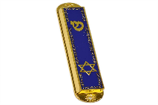
In many Jewish homes, the first two paragraphs of the Shema are written on a scroll and placed inside a mezuzah, which is nailed to a doorpost or gate. By touching the mezuzah every time, they enter their home, Jews show their faith and love to God.

Passover:

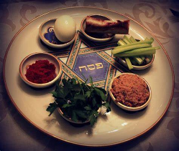

Passover is one of the most important religious festivals in the Jewish calendar. Jews celebrate the Feast of Passover (Pesach in Hebrew) to commemorate the liberation of the Children of Israel who were led out of Egypt by Moses.
Jews have celebrated Passover since about 1300 BC, following the rules laid down by God in Exodus 13.

The story of Passover is told in the Book of Exodus:

The Children of Israel had been slaves in Egypt for 210 years. God promised he would release them from slavery, but not before Pharaoh had refused their release and God had visited ten plagues on Egypt to demonstrate his power. (Exodus 3: 19-20)

The first nine plagues were:

- The plague of blood: God turned the water of the River Nile into blood so that the fish died and the water stank. All the water in Egypt was turned into blood.
- The plague of frogs: Egypt was overrun with frogs - there were frogs in the beds, frogs in the ovens, and frogs jumping on the people.
- The plague of lice: Dust was turned into lice which crawled on people and animals. (The Bible calls this The Plague of Gnats, but in Judaism the accepted translation of the Hebrew word Kinim is lice).
- The plague of flies: Swarms of flies arrived in Egypt and poured into Pharaoh's palace, the houses of his officials, and all over the land. (The Hebrew word here is orov meaning mixture and in Jewish tradition this refers to a mixture of wild animals.)
- The plague on livestock: All animals belonging to the Egyptians died - horses, donkeys, camels, cattle, sheep and goats.
- The plague of boils: Festering boils broke out on the Egyptian people and their livestock.
- The plague of hail: The worst hailstorm ever to hit Egypt struck, beating down crops growing in the fields and even killing people and animals caught in it.
- The plague of locusts: A swarm of locusts settled in Egypt and devoured anything left growing after the hail.
- The plague of darkness: Egypt became totally dark for three days.

The plagues only affected the Egyptians - the Israelites were unaffected.

The escape from Egypt:

The tenth plague - the plague on the firstborn

An avenging angel would go from house to house killing every first-born son. Israelite children would not be killed and thus God would show that they were his chosen people. So that the angel would know which houses were Israelite homes, the Children of Israel were to follow very specific instructions:

- Each household was to take an unblemished, male lamb, look after it, and slaughter it at twilight four days later.
- Blood from the lamb was to be brushed on the door frames. This would tell the avenging angel that it was an Israelite home and to 'pass over'.
- Then the families were to roast the lamb and eat it with bitter herbs and unleavened bread. Every bit of the lamb had to be eaten and any remaining bones burned.
The Israelites were to perform this ritual dressed for a journey.

The avenging angel arrives:

At midnight every Egyptian firstborn - from the firstborn of Pharaoh to the firstborn of the prisoner in his cell - and even of the livestock - was struck down by the angel. The Egyptians were terrified and demanded Pharaoh banish the Israelites there and then.

Pharaoh frees the Israelites:

Pharaoh summoned Moses and ordered him to get his people out of Egypt immediately. The Egyptians were so glad to see the back of the Israelites that they gave them silver and gold and other valuables to encourage them to go. The Israelites took their unleavened dough with them - they hadn't had time to add the yeast - and lived on this for the first few days of their Exodus.

Passover today:

Celebrations:
Every year, Jews celebrate the feast of Passover to commemorate the liberation of the Children of Israel, as commanded by God in Exodus 13. The celebrations last for seven or eight days, depending on where you live.
In Israel:

Passover lasts seven days - the first and seventh days are observed as full days of rest (yom tov), and the middle five as intermediate holidays (hol ha-moed).

Outside Israel:

Passover lasts eight days and the first two and last two days are observed as full days of rest.

The Torah says to celebrate Passover for seven days, but Jews in the Diaspora lived too far away from Israel to receive word as to when to begin their observances and an additional day of celebration was added to be on the safe side.

Preparations:
Before celebrations can begin, the house must be cleaned from top to bottom to remove any traces of chametz (leaven) from the home. This commemorates the Jews leaving Egypt who did not have time to let their bread rise, but also symbolises removing 'puffiness' (arrogance, pride) from their souls. The day before Passover begins there is a ritual search for chametz in every home. The children usually join in with great enthusiasm. A Jewish person may not eat chametz or derive benefit from it during Passover. They may not even own it or feed it to animals. Any chametz in a Jewish person’s possession, or utensils used to prepare food with chametz, have to be temporarily 'sold' to non-Jews. They can be bought back after the holiday.
The Seder and the Haggadah:
The fast of the firstborn:
The day before Passover begins the fast of the firstborn is observed. All first born males fast on this day to celebrate their escape from the plague of the first born.
Seder meal:
The highlight of Passover observance takes place on the first two nights, when friends and family gather together for ritual seder meals. Seder means 'order' and the ceremonies are arranged in a specific order. Special plates and cutlery are used which are kept exclusively for Passover.
The Haggadah is a book which tells in fourteen steps the story of the Jewish experience in Egypt and of the Exodus and revelation of God. As the story of each of the ten plagues is read out a drop of wine is spilt to remind Jews that their liberation was tinged with sadness at the suffering of the Egyptians.
The four questions:
The Haggadah also contains songs, blessings, psalms and four questions. These four questions are:
Why do we eat unleavened bread? Unleavened bread or matzo is eaten to remember the Exodus when the Israelites fled Egypt with their dough to which they had not yet added yeast.
Why do we eat bitter herbs? Bitter herbs, usually horseradish, are included in the meal to represent the bitterness of slavery.
Why do we dip our food in liquid? At the beginning of the meal a piece of potato is dipped in salt water to recall the tears the Jews shed as slaves.
Why do we eat in a reclining position? In ancient times, people who were free reclined on sofas while they ate. Today cushions are placed on chairs to symbolise freedom and relaxation, in contrast to slavery.
Usually, the youngest person present will ask the questions and the father will respond. The paradox of this is that these four questions should be asked spontaneously, but celebrations cannot happen unless they are asked!
Children:
Children are central to Passover proceedings and symbolise the continuity of the Jewish people. Customs are designed to hold their attention. There's the hunt for the afikomen, where a piece of matzoh is hidden which children have to find and hold 'ransom' until a reward is given.
The Passover meal:
The components:
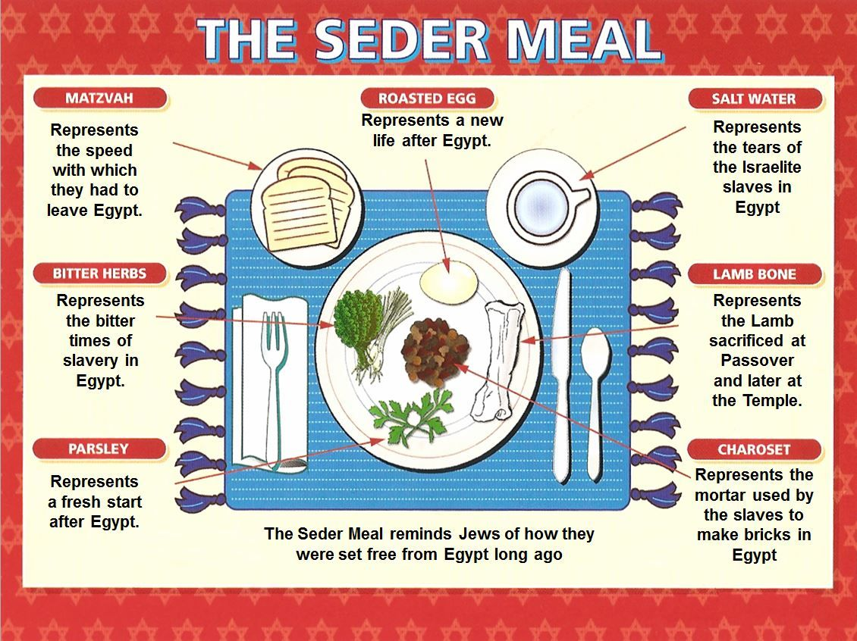
Each of the components of the meal is symbolic. The food is eaten in ritual order and its meaning and symbolism is discussed.
Matzo: (unleavened bread) which is eaten symbolically three times during the meal. Matzah is one of the most iconic elements of Passover. During the Exodus from Egypt, the Jews fled so quickly that there was no time to waste waiting for bread to rise Instead, they ate unleavened matzah in their desperate escape from slavery. What was once an act of necessity is now celebrated in triumphant, everlasting joy. Jews choose to eat matzah in honour of their ancestors, and to celebrate their freedom. This special unleavened bread is kept on a separate matzah tray.

Bitter herbs: Maror and chazeret are bitter herbs, such as romaine lettuce, endives, or horseradish, which are eaten to remind us of the bitter lives of the Jewish slaves in Egypt and of the frightening journey of Exodus. The maror is eaten near the end of the Seder after the washing of the hands. It is eaten along or as a sandwich with matzah.

Charoset: Charoset is a sweet-tasting mixture of apples, cinnamon, wine, and nuts. Charoset is symbolic of the mortar that the Jewish slaves used when being forced to build Egyptian storehouses. The Hebrew word Charoset comes from the word cheres meaning clay. The bitter maror is dipped into the charoset before being consumed. When tasted together, the participants remember the struggle of the Jewish slaves, and pay homage to their hardships. The bitterness of the maror tells the tale of a life of strife, while the sweet-tasting charoset invokes the very building blocks of a slave's daily existence.

Karpas: Karpas is a vegetable of parsley, celery or potatoes, which is dipped into salted water. It should be allowed to drip off, to represent the tears shed by the Jews during their enslavement by the Egyptians. The plain, bitter taste of this food also reinforces the brutal life of the Jewish slaves, which was fraught with scarcity and pain. The participants at the Passover Seder meal taste the pain of their ancestors.

Zeroah: Zeroah is the only meat included on the Passover Seder plate. Usually, zeroah is a shank bone of meat or poultry. For vegetarians, the Pesach sacrifice can be represented by a beet. Before the Jews left Egypt, in order to protect their houses from the tenth plague against the Egyptians, Jews smeared lamb's blood on their doorposts. The angel of death, seeing the blood, would pass over those houses.

Beitzah: Beitzah is an egg which has been roasted to symbolise an ancient Jerusalem sacrifice - the Korban Chagigah. The Chagigah was a meat sacrifice, yet on the Seder Plate it is represented by an egg for two reasons. The egg is symbolic of mourning and represents sadness after the temple's destruction and in knowing that no sacrifices could be offered there. The first temple was destroyed by the Babylonians in about 586 BCE and the second temple was destroyed by the Romans in 70 CE. Another meaning behind the Beitzah is that it celebrates Spring, renewal, and rejuvenation. It is not eaten as part of the Seder, but many people dip it in saltwater and eat it as a first course of the Passover meal.

Symbolism of Passover:
Passover is also called the festival of freedom and is a celebration of freedom, not just in Biblical times, but its importance to the individual today and throughout history. Jewish people believe freedom to be one of the basic human rights. Readings about contemporary slavery or oppression to show solidarity with the oppressed may be included in some traditions (although not in Orthodox Jewish households).
Jews living under oppression often use Passover to express their own desire for freedom.
The ten commandments:

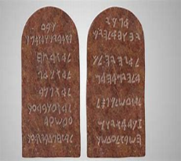

The covenant at Sinai:

The Torah teaches Jews about the covenant God made with all Jewish people at Mount Sinai. God gave Moses a set of ten laws that they should follow in order to please him. God told Moses that if these rules were not followed, God would punish people who disobeyed them. Today these laws are known as the ten commandments.
The ten commandments are found in the book of Exodus. They are:
Do not have any other gods.
Do not make or worship idols.
Do not disrespect or misuse God’s name.
Remember the Sabbath and keep it holy.
Honour your mother and father.
Do not commit murder.
Do not commit adultery.
Do not steal.
Do not tell lies
Do not be envious of others.
Exodus 20:1–15
The ten commandments were given to Moses by God for all Jewish people to follow. They form part of the covenant made at Mount Sinai.

Moses: Jews believe that Moses was a very important prophet as he was chosen by God to pass on these laws to all of the Jewish people. It is believed that God gave the laws to Moses verbally before they were inscribed on stone.

Importance of the ten commandments today:

The ten commandments still hold great significance for Jews today for many reasons:

- They are a guide for Jewish living today.
- Following the ten commandments is part of the covenant made at Mount Sinai, which applies to all Jewish people.
- God will judge Jews on how well they have observed these commandments.
- Following the commandments helps Jews to become better people today.
- The commandments help Jews to treat other people with respect.
- The commandments guide Jews to love and worship God effectively.

Lesson 1: What is a promise/covenant?

Intentions:  To give pupils opportunities to: | - Know what a promise and covenant is and to know the difference between the two.  - Know the significance of Abraham to the Jewish faith.  - Know and understand the significance of the story of Abraham and Isaac.  Key religious vocabulary: Promise, covenant, Abraham.
Implementation:  Outlining how to introduce the religious content in the classroom and create learning opportunities from it. | Introduction:  Prior knowledge gathering:  Key question:  - What can you recall from prior learning about the Jewish faith?  Pupils to brainstorm in small groups.  Teachers could provide pupils with a ‘talking tub’ of artefacts and photos to aid discussion. (See appendix lesson 1)  Main teaching input: (Investigate and explore)  Introduce the big question for the unit: What does it mean to be Jewish?  Introduce this week’s question: What is a promise/covenant?  Pupils to discuss what they think a promise is and what they think a covenant is. Do they know the difference?  Pupils to discuss when they have made promises and when they have had promises made to them?  Teachers to explain the difference between a promise and a covenant. See background knowledge for teachers.  Teachers to explain the importance of the covenant God makes with His people. See background knowledge for teachers.  Key question:  - Who is Abraham?  - Why is Abraham so significant to the Jewish faith?  Watch the following clip:  The story of Abraham and Isaac  https://www.youtube.com/watch?v=i3c3gTwW-ME  Key questions:  - What did God promise Abraham?  - What did Abraham have to do in return?  - How do you think Abraham felt when God asked him to sacrifice his son?  - What did Abraham learn about God?  - What do you think we can learn from Abraham?  - How easy do you find it to trust others?  Main activity: (Evaluate and communicate)  In three’s, role play a scenario where a promise has been made and broken. Pupils are encouraged to reflect on how each party feels when the promise is broken and how the situation can be best resolved.  Plenary: (Reflect and express)  Key questions:  - Why is it important to try and keep promises?  - Why is it sometimes hard to keep them?
Resources: | - The story of Abraham and Isaac.  https://www.youtube.com/watch?v=i3c3gTwW-ME  - Appendix lesson 1.
Sensitivities: | - Be mindful of pupils who find it difficult to trust others.
Impact:  What do you notice as a teacher?  What do pupils say? | In this box, note down anything that you heard a pupil say that would provide evidence towards their progress in RE.  Note down anything significant an additional adult has noticed.  Note down anything significant that happened in the lesson that will have an impact on the next lesson.

Lesson 2: What is the significance of the Shema?

Intentions:  To give pupils opportunities to: | - Know the Jewish faith believes in One God.  - Know what the Shema is and its significance in Judaism.  - Know how the Shema underpins the relationship which the Jewish people have with God.  - Express their own ideas and opinions.  - Link things that are important to them and other people with the way they think and behave.  Key religious vocabulary: Shema, mezuzah.
Implementation:  Outlining how to introduce the religious content in the classroom and create learning opportunities from it. | Introduction:  Recap on previous week’s learning.  Key knowledge checking:  - To know what a promise and covenant is and to know the difference.  - To know the significance of Abraham to the Jewish faith.  Key question:  - If I walked into your flat/house, what would I see that would give me clues about you and your family?  Whole class discussion.  Main teaching input: (Investigate and explore)  Introduce this week’s question: What is the significance of the Shema?  Explain the Mezuzah and Shema. See background knowledge for teachers.  Watch the following clip:  The Shema - KS2 Religious Education - BBC Bitesize  Biblical text analysis: Deuteronomy 6: 4 – 9  Behind the text: Why was it written? Discipline: Theology  - What do you think the author (often thought to be Moses) was trying to tell his people?  Within the text: What does the text mean? Are there any words that need explaining? Discipline: Philosophy  - What is the meaning of this text?  In front of the text: This is concerned with the relationship between the text and the reader. Discipline: Human and social science  - How do you think this key text demonstrates the relationship which the Jewish people have with God?  Main activity: (Evaluate and communicate)  Pupils to create their own affirmation of their faith or belief system and make their own equivalent of a mezuzah to put it in. These are then placed around the class door.  Things for pupils to consider:  - If they are a practising member of a faith community – what for them, are the key things about their faith that they live by ie love thy neighbour, treat everyone equally, worship one God.  Alternative:  - What agreement do they want to and think is important to make about how to treat others?  - What agreement do they want to and think is important to make about how to take care of the world?  - Are there any other values they wish to put into an agreement that they believe would help them to live a fulfilling life?  Plenary: (Reflect and express)  Key question:  - If we were to write a class agreement for us all to work towards keeping, what would we want to have in it?  Together pupils discuss and decide on an agreement they can all work to keep. This can be put in a class mezuzah and placed above the class door.  Recap on the meaning of the Shema for the Jewish community and the significance of the Mezuzah in helping them to remember what is being asked of them.  Recap on what a covenant is – an agreement between two parties.  Key questions:  - Who are you making your agreement with – you and God? You and your fellow human beings? You and your family? You and your class friends?  - Do you think trust is important when making an agreement?  Pupils reflect on the importance of the agreement being between two parties and therefore are encouraged to share this with the ‘other’ party whoever that might be.  Pupils decide on how they are going to hold each other to account with their class agreement. Classes could agree when they will review their agreement and reflect on how well they are keeping to it – this could take place during a class circle time.
Resources: | - The Shema - KS2 Religious Education - BBC Bitesize
Sensitivities: | - Be aware of pupils that do not come from a faith background but still hold values and beliefs that are important to them.
Impact:  What do you notice as a teacher?  What do pupils say? | In this box, note down anything that you heard a pupil say that would provide evidence towards their progress in RE.  Note down anything significant an additional adult has noticed.  Note down anything significant that happened in the lesson that will have an impact on the next lesson.

Lesson 3: What is the significant of Passover for Jewish people?

To note: Lesson 3 and 4 are connected. The importance of this lesson is to ensure pupils understand who Moses was, his role in leading the Israelites to freedom and how this is linked to the festival of Passover.

Intentions:  To give pupils opportunities to: | - To know how God rescued His people from the Egyptians.  - To know the significance of Passover for Jewish people.  - Make links between the beliefs and teachings found in a sacred text and how they connect to a believer’s life.  - Express their own ideas and opinions.  - Ask questions about the moral decisions people have to make.  Key religious vocabulary: Passover, Pesach, Moses, Israelites, Egyptians, plague.
Implementation:  Outlining how to introduce the religious content in the classroom and create learning opportunities from it. | Introduction:  Recap on previous week’s learning.  Key knowledge checking:  - To know the Jewish faith believes in One God.  - To know what the Shema is and its significance in Judaism.  - To know how the Shema underpins the relationship which the Jewish people have with God.  Key question:  - Why do you think it is important to celebrate festivals? (Pupils are encouraged to pull on their prior knowledge of Judaism taught in K.S 1 – Jewish people celebrate and keep the festivals to remember the past.)  Main teaching input: (Investigate and explore)  Introduce this week’s question: What is the significance of Passover for Jewish people?  Explain that Passover (Pesach) is a significant festival celebrated around the time of the Christian celebration of Easter. See background knowledge for teachers.  To understand the story of Passover, pupils need to understand who Moses was. (Putting things in context.)  Key question:  - What do you already know about Moses?  Watch the following clips:  Moses as a baby – Exodus 1 – 2  https://www.youtube.com/watch?v=vf-4x4iefQE  Recount the story of Moses. Exodus chapter 6 – 12.  The ten plagues of Egypt.  https://www.bbc.co.uk/bitesize/clips/zbsb9j6  Main activity: (Evaluate and communicate)  - Sequence the story of the Passover through animation.  OR: Pupils to complete a piece of reflective writing based on one of the questions listed in the plenary section. The question can either be directed by the teacher or pupils can be given the choice of which question to answer.  Plenary: (Reflect and express)  Key questions:  - How do you think God felt doing this to the Egyptians?  - Why do you think this was important for God to rescue his people in this way?  - How do you think the Israelites (Jewish people) felt when they knew they were free?  - Does everyone in our world live with freedom today? What do you think?  - Do you feel free? If so, how would you describe freedom? Have you ever felt not free? How did that feel?  - Consider the difficult decisions you have to make. What/who influences you in making those decisions?  - What do you think the significance of Passover is for Jewish people?  - What do you think is the most important thing to remember from this story is? Can you explain your answer?  Possible ways of exploring the above questions if used as part of a plenary session:  - Circle time  - Silent conversations  - Independent written responses on thought bubbles
Resources: | - Moses as a baby  https://www.youtube.com/watch?v=vf-4x4iefQE  - The ten plagues of Egypt.  https://www.bbc.co.uk/bitesize/clips/zbsb9j6
Sensitivities: | - Be mindful of pupils who may be refugees or who have had to flee from difficult situations/circumstances.
Impact:  What do you notice as a teacher?  What do pupils say? | In this box, note down anything that you heard a pupil say that would provide evidence towards their progress in RE.  Note down anything significant an additional adult has noticed.  Note down anything significant that happened in the lesson that will have an impact on the next lesson.

Lesson 4: What is the importance of the seder meal for Jewish people?

To note: Allow 1.5 hours for this lesson.
Intentions:  To give pupils opportunities to: | - Know how the seder meal teaches the Jewish community the meaning of Passover.  - Know what each of the foods symbolise.  - Know why it is important to remember and celebrate.  Key religious vocabulary: Seder, Passover, Pesah.
Implementation:  Outlining how to introduce the religious content in the classroom and create learning opportunities from it. | Introduction:  Recap on previous week’s learning.  Key knowledge checking:  - To know how God rescued His people from the Egyptians.  - To know the significance of Passover for Jewish people.  Key questions:  - What events do you remember and celebrate?  - Why do you think it is important to remember?  Explain the importance of looking back and remembering. (Make links with other festivals that the school might celebrate as a community – Christmas, Easter and pupils might celebrate at home; Eid, Diwali.)  Explain the significance of remembering difficult times as well and how this can help us in our lives.  Recap the story of Moses from the previous week’s lesson. What can pupils remember? How does the story link with the festival of Passover?  The ten plagues of Egypt.  https://www.bbc.co.uk/bitesize/clips/zbsb9j6  Main teaching input: (Investigate and explore)  Introduce this week’s question: What is the importance of the seder meal for Jewish people?  Explain to pupils the significance of the seder meal.  Watch the following clips, pausing between each one to check for understanding:  Introduction to the seder meal  https://www.bbc.co.uk/programmes/p01147yd  Symbolism of each of the special foods eaten at the seder meal  https://www.bbc.co.uk/programmes/p0114w71  What happens at the seder meal?  https://www.bbc.co.uk/programmes/p011426q  Main activity: (Evaluate and communicate)  Explain that Passover (Pesach) is a reminder to the Jewish people that God rescued them from the hands of the Egyptians and led them to freedom.  Prepare and re-enact out the seder meal, explaining each aspect along the way.  Task: Explanation of the seder plate. (See appendix lesson 4)  Key question:  - If you were going to add an additional item to the seder plate, what would it be and what would it symbolise?  Plenary: (Reflect and express)  Circle time:  Key questions:  - Why is it important for Jewish people to celebrate the Passover and remember the story behind it each year?  - By remembering and celebrating, how do you think it might help a Jewish person to be stronger in their faith?  - How might the celebration give hope to those who are not free today?  - What joyful times can you remember from your life and how have those times helped make you the person that you are?
Resources: | - The ten plagues of Egypt.  https://www.bbc.co.uk/bitesize/clips/zbsb9j6  - Introduction to the seder meal.  https://www.bbc.co.uk/programmes/p01147yd  - Symbolism of each of the special foods eaten at the seder meal.  https://www.bbc.co.uk/programmes/p0114w71  - What happens at the seder meal?  https://www.bbc.co.uk/programmes/p011426q  - Appendix lesson 4.
Sensitivities:
Impact:  What do you notice as a teacher?  What do pupils say? | In this box, note down anything that you heard a pupil say that would provide evidence towards their progress in RE.  Note down anything significant an additional adult has noticed.  Note down anything significant that happened in the lesson that will have an impact on the next lesson.

Lesson 5: What is the importance of the ten commandments for Jewish people?

Intentions:  To give pupils opportunities to: | - Know the importance of the ten commandments to the Jewish faith.  - Express their own ideas and options and understand that there may be more than one answer.  - Make links between what is important to them with the the way they think and behave.  Key religious vocabulary: Moses, Mount Sinai, ten commandments.
Implementation:  Outlining how to introduce the religious content in the classroom and create learning opportunities from it. | Introduction:  Recap on previous week’s learning.  Key knowledge checking:  - To know how the seder meal teaches the Jewish community the meaning of Passover.  - To know what each of the foods symbolise.  - To know why it is important to remember and celebrate.  Key questions:  - Do you think rules are important?  - Where do you see rules?  Main teaching input: (Investigate and explore)  Introduce this week’s question: What is the importance of the ten commandments for Jewish people?  Show the pupils a selection of paintings of Moses on Mount Sinai with the tablets of stones. (See appendix lesson 5)  Key questions:  - What do you notice?  - Who do you think this could be?  - What questions do you have related to this painting?  Make note of the questions pupils come up with to refer back to later.  Recap the Exodus story first introduced in lesson 3. Explain that the Israelites were in exile (give meaning) and were wandering in the desert. God needed to give them guidelines for living. He took Moses up a mountain (Sinai) to give him His special rules for His people.  Watch the following clip:  Moses in the wilderness  https://www.youtube.com/watch?v=ogfVBP35U-U  Explain the meaning of the ten commandments and why they were important.  Main activity: (Evaluate and communicate)  In groups of three:  Pupils are given the ten commandments to discuss why they think each one is so important to the Jewish people. Teachers to address any misconceptions  Key question:  - For a Jewish person which commandment do you think is the most important and why?  - For a Jewish person which would be the five most important do you think?  Snowball the groups:  Two groups share their responses with each other.  Each group writes five commandments from their perspective that they think would help society to live well together now. Pupils need to be able to explain why they have come up with the five commandments they have.  Two groups share their responses with each other.  As a group of six, they need to decide on the five commandments they are going to keep.  Plenary: (Reflect and express)  Each group of six to share their five commandments, giving clear explanations for their choice.
Resources: | - Moses in the wilderness  https://www.youtube.com/watch?v=ogfVBP35U-U  - Appendix lesson 5.  - Copies of the ten commandments for each trio.
Sensitivities:
Impact:  What do you notice as a teacher?  What do pupils say? | In this box, note down anything that you heard a pupil say that would provide evidence towards their progress in RE.  Note down anything significant an additional adult has noticed.  Note down anything significant that happened in the lesson that will have an impact on the next lesson.

Lesson 6: What have I learnt about what it means to be Jewish?

Intentions:  To give pupils opportunities to: | - Recap on prior learning.  - Reflect and answer the big question.  - Retell religious stories.  - Describe what a Jewish person might learn from a sacred text and what it might mean.  - Make links between the beliefs and teaching with a believers’ life.  - Ask questions.  Key religious vocabulary: Revisit all religious vocabulary from previous lessons.
Implementation:  Outlining how to introduce the religious content in the classroom and create learning opportunities from it. | Introduction:  Recap on previous week’s learning.  Key knowledge checking:  - Know the roots and significance of the ten commandments.  Assessment opportunity:  Return to the unit’s big question: What does it mean to be Jewish?  In groups of 3:  Each group is given a talking tub. (See appendix lesson 6)  Task 1: (Model for children what you are expecting them to do.)  Step 1:  - Pupils are given the opportunity to talk about each object/photo in the box. What can they remember from the unit of learning? Pupils are encouraged throughout to use religious vocabulary in their talk and conversation.  Step 2:  - On strips of paper, pupils write down what they believe the key knowledge is for each item using appropriate religious vocabulary.  Step 3:  - On a different coloured strip of paper, pupils write down any links/connections they can make/see between the items. Eg: What is the link between the seder plate and the story of Moses? What is the link between the photo of Moses up the mountain and the tablets of stone?  Step 4:  - On speech bubbles, pupils write down any questions they still have related to the big question?  To note: Throughout the activity, the teacher moves around the groups, taking note of what pupils are saying and addressing any misconceptions that may arise.  Task 2: Children complete personal reflection sheet. (See appendix lesson 6a)
Resources: | - Talking tub  - Appendix lesson 6 and 6a
Sensitivities:
Impact:  What do you notice as a teacher?  What do pupils say? | In this box, note down anything that you heard a pupil say that would provide evidence towards their progress in RE.  Note down anything significant an additional adult has noticed.  Note down anything significant that happened in the lesson that will have an impact on the next lesson.

