Lesson 4:
Crosses from around the world. Information for teachers.
Some examples
The aim is to get the pupils to look at a range of different crosses and to explore their meaning, recognising that each cross has a slightly different focus attached to its design.
The task the pupils have been asked to do is to design a cross that expresses the meaning of Easter.
Further reading and examples can be found in the following publication: A – cross the world. An exploration of forty representations of the cross from the world-wide Christian Church. Martyn Payne and Betty Pedley.
Cross | Meaning
Ethiopian cross  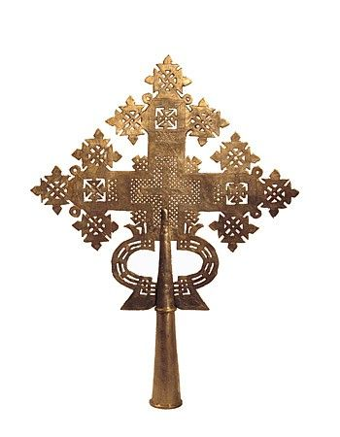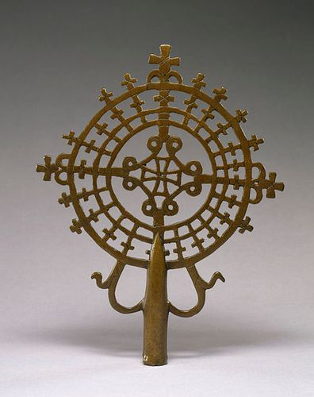 | The basic Ethiopian cross takes the form of a circle with the cross set inside it. Some Ethiopian crosses are designed in rhombus shapes and have vegetable motifs, which are linked to the narrative of the garden of Eden and the tree of life. There is sometimes a square tablet, which may contain words or occasionally a picture, at the base of some of these crosses. Triangles, details of flowers and various zigzag patterns are also very common in different makes of this cross.  Often the designs are complex and colourful, reflecting the craftsman’s desire to indicate that, for believers, the cross is a symbol of vibrancy and life and not just a place of death.  Extract from A - cross the world
Eygptian cross  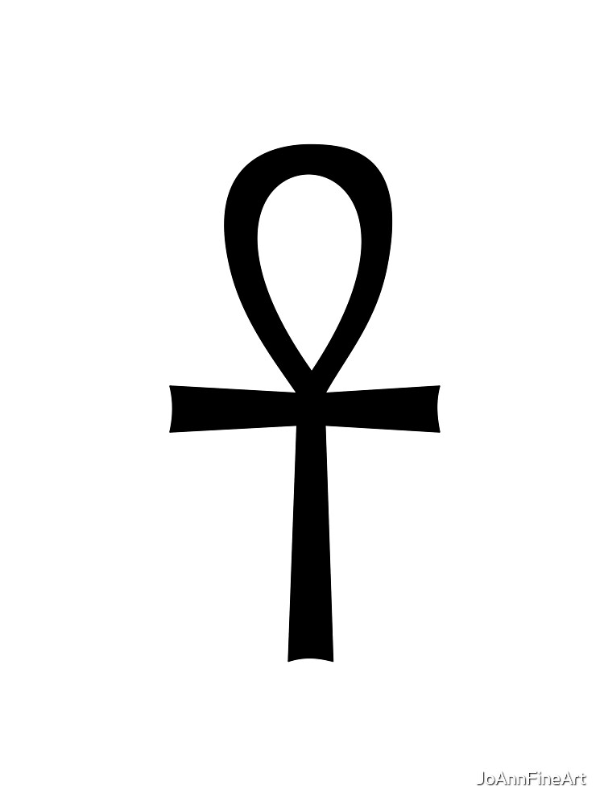 | The ankh symbol—sometimes referred to as the key of life or the key of the Nile — is representative of eternal life in Ancient Egypt. Created by Africans long ago, the ankh is said to be the first--or original--cross.  - The Egyptian cross, also known as Ankh, was originally an Egyptian hieroglyph used to represent the word “life”. By extension, this cross became primarily a symbol of life.  - This cross was also placed on the lips of dead kings, bearing in mind that according to the mentality of ancient Egypt, death did not mean the end, but was merely a transition to the afterlife, to eternal life.  - As is usual with many symbols of religious or spiritual origin, there is no single meaning for this symbol. Throughout history, this symbol and its variations have been used by different cultures and religions that have given it different meanings.  - Among the Egyptians, it was mainly a symbol of life or immortality. In this sense, it also had a certain relationship with death and the rites associated with death. The symbol  - of the Ankh has also been interpreted as a symbol of balance between opposing forces, for example, between masculinity and femininity. It can also represent joy, energy, and fertility.
The Jerusalem cross  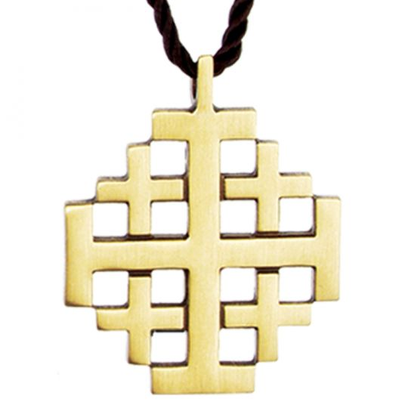 | The Jerusalem cross is believed to represent several things. Historians note that the four crosses surrounding the large centre cross represent the four Gospels of Matthew, Mark, Luke, and John. The four crosses also are believed to represent the four corners of the earth, in which Jesus desired His word to be proclaimed by His disciples. The large cross symbolises Christ.  Other historians believe that the five crosses together symbolise the five wounds Jesus suffered on the cross. The four small crosses represent the four wounds of Jesus’ hands and feet, while the large cross signifies Jesus’ pierced heart.
South Indian cross – created in 1997  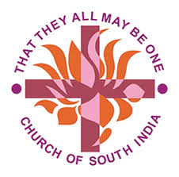 | The united church of South India adopted a very distinctive cross as one of its symbols. The basic cross is red and represents Jesus’ death for the forgiveness of sins. Superimposed on the cross in this design is the lotus flower. This a cultural image that denotes the holiness of God. The lotus grows out of the mud, and in a similar way, our lives, thought surrounded by the mud of all that spoils our world, can blossom into something beautiful because of Jesus’ sacrifice. The lotus is an eastern symbol of God’s closeness. In the design it is saffron in colour.  Around this cross are set words from John 17:21 part of Jesus’ prayer that his followers would ‘be one’. This unity is to be a witness to the world that Jesus was sent by God and that what he says is true. In many ways the Church of South India has set the Christian world an example of obedience to this prayer, which has been an important fact in its growing life and witness.  Extract from A - cross the world

