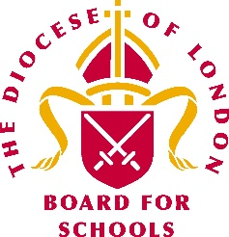 | London Diocesan Board for Schools  SIAMS Update  November 2020

Although as a Diocese we have no definitive news, we thought it would be helpful to provide you with an update of what we understand the current position to be:

- The requirement to have a section 48 inspection every five years remains disapplied and so SIAMS will not restart until that disapplication is lifted by DfE. This should be when Ofsted restart inspections. We understand that Ofsted still publicly intends to restart inspections in January but are keeping this under review as they monitor the changing situation.

- SIAMS inspections will not recommence until it is safe to do so and until it is valuable to do so. We understand that this could be January or April or even September.

- Unlike Ofsted, SIAMS does not have the legal basis to do an interim visit (such as section 8) so when we do restart full inspections will be undertaken.

- We already have 500 plus schools around the country that have passed the 5 year legal limit, should it drift until the end of this year it will around 1500 schools. Therefore, a catch up timescale will need to be negotiated with the DfE.

- As we understand it, the speed, and potential order of scheduling will be decided by the outcome of those negotiations. This in turn will depend on when we are able to start re-inspecting.

We are confident that when inspections do recommence, inspectors will be very mindful of the significant pressures on school leaders during these particularly challenging times.

We will keep you informed of any developments via our weekly bulletin. In the meantime, we would like to remind schools of the centrality of the school’s Christian vision within the SIAMS inspection schedule. Inspectors will be keen to unpack how school leaders and governors use their school’s Christian vison as the filter through which both operational and strategic decisions are made, so this is perhaps something you could begin to explore with your LDBS link adviser.

Jayne Pavlou
November 2020

