Inclusion
When Jesus reached the spot, he looked up and said to him, “Zacchaeus, come down immediately. I must stay at your house today.”
Luke 19: 5
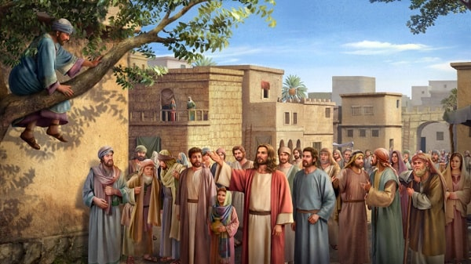
Equipment:
- Pens/pencils
- Paper
- Bowl

Instructions:

- I invite you to think about the things that you would like to ask God to forgive you for.
You may have said some unkind words.
You may have fallen out with a friend.
You may have not listened.
You may have not included someone in your game.
You may have had some unkind thoughts.

- Now, taking your piece of paper, I invite you to write or draw those things on your paper.
- Fold your paper up so no one can see what you have written or drawn.

Reflection: Begin by watching the clip below.

Zacchaeus

EYFS:

Zacchaeus Bible Songs For Children

Talk time:

- What do you think Zacchaeus might be thinking?
- What do you think Jesus might be thinking?
- Look at the crowds faces. What do you think they are thinking when they hear Jesus inviting himself to Zacchaeus’ house?
- If you were in that crowd that day, I wonder what you would be thinking and feeling.

Tax collectors were not liked. Zacchaeus was one of them. He had lots of money but not many friends. When he heard that Jesus was in town, he was desperate to see him. Because he was short, he ran ahead of the crowd and climbed a sycamore-fig tree to be sure that when Jesus arrived, he would be able to see him.

When Jesus saw Zacchaeus, immediately he called him down from the tree. Zacchaeus came down at once and he was welcomed by Jesus.

The crowd were not happy. They did not like the fact that Jesus welcomed Zacchaeus and went to his home. The crowd viewed Zacchaeus as a sinner and cheat and pushed him away.

Jesus did the exact opposite to the crowd. He welcomed and included Zacchaeus. He accepted Zacchaeus for who he was.

Zacchaeus wanted to see Jesus and having met with him, he repented, received forgiveness and changed. He gave back what he had taken and gave half his possessions to the poor.
Time to be still and quiet:

In the silence of your own home, look again at the picture and ask yourself these questions:

- How good are you at including and accepting everyone?
- Are you ready to turn to God and allow him to forgive you so that you can start again?

Take the piece of paper that you have written or drawn the things you would like to ask God to forgive you for, and tear it into pieces, placing the pieces in the bowl you have in the middle of your circle.

Remember when we ask God to forgive us, we know that he always does and we can let go of the things we have asked forgiveness for.

I invite you to say this prayer: God, forgive me for the times I have hurt others. Forgive me for the times I have not included people in my games. Forgive me for the things that are written on my paper. Help me to live the way you want me to live, showing kindness and love to everyone. Amen.

