Journeys
Moving on

One of them, named Cleopas asked him, “Are you only a visitor to Jerusalem and do not know the things that have happened there in these days?”
Luke 24: 18

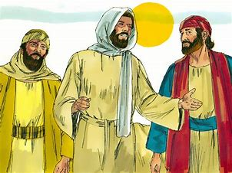
“It is true! The Lord has risen and has appeared to Simon.”
Luke 24: 34
Equipment:
- Pens/pencils/colouring pencils/scissors/glue
- Collage materials
- Paper

Instructions:

Option 1:

Design a poster that has three sections to it:
- My memories.
- People you would like to thank for helping you this past year.
- Things you are most looking forward to about next year and things you might be worried about.

Option 2:

Create a college/painting/drawing entitled: Journey

In it include symbols that represent:
- Memories
- Thankfulness
- Hopes and dreams

Reflection: Begin by watching the clip below.

The road to Emmaus

EYFS, K.S 1 and Year 3 and 4

https://www.youtube.com/watch?v=K3QkZsKLU2o

Year 5 and 6

The appearance of Christ on the road to Emmaus

https://www.youtube.com/watch?v=dmmTWQn95xQ

Many people think about life as a journey. In the story you have just heard, the disciples had an opportunity to reflect on all that had happened so far as they travelled along the road. They thought about the things they had learned, significant events they had experienced and people they had met, helped and supported along the way.

They also had a moment of realisation as they sat at the table. A moment of change had come, that was to have an impact on their life’s journey. They were becoming ready to move onto a new adventure. They had an opportunity not only to look back, but to look forward.

In the silence of your own home, I invite you to reflect on this year. Looking at your poster or piece of art might help you with this.

I wonder….

- What your favourite memories have been?
- How have you perhaps changed this year?
- Who has helped you on this journey? Who would you most like to thank?
- What most excites you about your future journey?
- What are you perhaps a little anxious about?
- What would you like to do next year that you haven’t been able to do this year?
- What wisdom will you take with you into next year?

I invite you to say this prayer: Dear God, thank you for this year. Thank you for being with me in the ups and downs. Thank you (name the people that you would like to thank) who have helped me when I have needed help, listened to me when I have needed to talk and reassured me when I have felt anxious or afraid. Keep me safe this summer holiday and give me the confidence to enjoy and embrace the next stage of my life journey. Amen.

