Good News
“Therefore, go and make disciples of all nations, baptising them in the name of the Father and of the Son and of the Holy Spirit.”

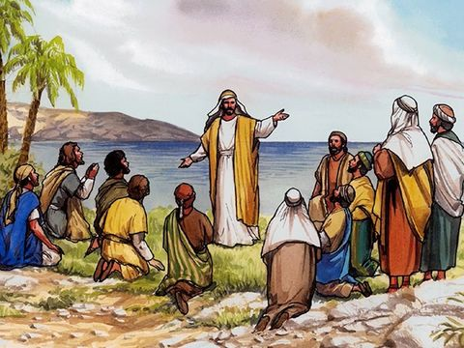
Equipment:

- Pens/pencils
- Paper

Instructions:

- If you had one message to give to the world right now, what would it be?
- Design a poster for your front window with your message on it. Think carefully about your message. Does it bring hope? Does it bring comfort? Is it a reassuring message? Does it call people to action in some way or another?

Reflection: Begin by looking at the picture below:

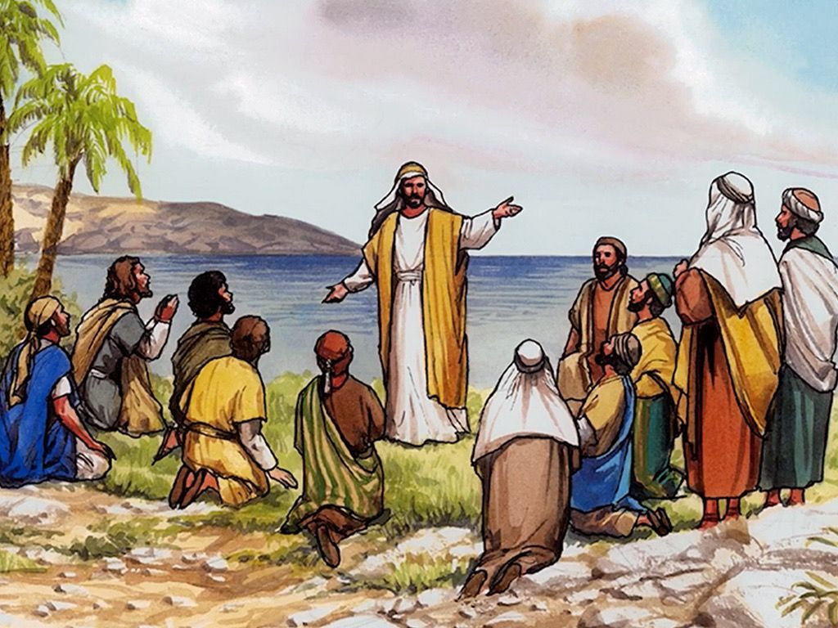
- What do you see?
- Who do you think is speaking?
- Where do you think the people are?
- What do you think the crowd are thinking?
- What questions do you have?

This is a picture of Jesus’ final instruction to his disciples before he returns to Heaven. He is telling them to go and make disciples of all nations, baptising them in the name of the Father and the Son and the Holy Spirit. He also asks them to tell others about his teachings. Jesus reassures them, that he will be with them always.

When you receive Good News, what do you do with that news? I would imagine many of you go and tell someone else about it so that they can share in your joy and happiness.

How good are we at sharing with others what we know about God? How good are we at sharing God’s love with others through our kind words and actions?

The messages you have written today are also important messages to share with others.

Remember you have a voice. Your words and actions make a difference.

Time to be still and quiet:

Share with your family your message for the world today. Put it up in a window for others to see.

I invite you to say this prayer: Dear God, thank you that we have the freedom to share with others our message for the world today. Help us to show God’s love to others through our words and actions. Amen.

