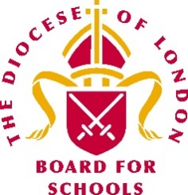 | London Diocesan Board for Schools  Wider opening of schools during the coronavirus outbreak – clergy visits to schools

May 2020

We hope that this advice will answer the questions which schools may have as they begin to open to more children.

After consultation with the Chair of the Board and the Bishop of London we are of the view that clergy visits can take place provided that the school sees them as a helpful part of their operation as they bring back more children.

Points to note when planning for clergy visits:

- Clergy presence in school must be subject to the same degree of risk assessment and briefing as for other staff
- Clergy visits should be by invitation from the headteacher or school leaders, for example to support collective worship or to support staff or children
- Clergy should not just drop in to schools
- Clergy governors may need to visit for specific reasons, especially chairs
- Schools should be aware that some clergy are either shielding themselves or have extremely clinically vulnerable people at home and so not all will be able to respond to an invitation or feel able to do so

Please contact your link adviser or HR adviser as appropriate with any further queries.

