Seeing
“Stop doubting and believe.” Thomas said to him, “My Lord and my God!”
John 20: 27 - 28

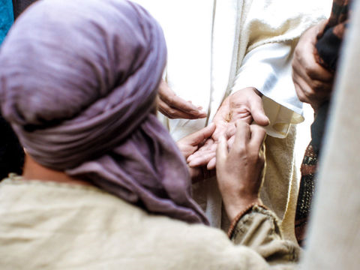

After Jesus had risen from the dead, he appeared to his disciples on more than one occasion. In this picture we see Thomas seeing Jesus for himself.
Equipment:

- Promise card
- Pens/colouring pencils

Instructions:

- Place the bowl in the centre of your circle.
- Give each person a paper rock.

Reflection: Begin by watching this clip of the story of doubting Thomas

Thomas The Doubting Disciple

Many people today call the disciple Thomas ‘doubting Thomas.’ This is because when the other disciples came and told him that Jesus had risen from the dead, Thomas did not believe and insisted on having to see Jesus for himself. Even though we can’t see Jesus /God, we know he is with us. We know he love us. We know this because we often experience God’s love through other people’s love and we often experience God’s kindness through other people’s actions towards us. It is like the wind. We can’t see it, but we know it is there because we can feel it. We know God is present because, if we believe and trust in what we know and have learnt about God, we will feel very often a sense of calm and peace.

Time to be still and quiet:

Take a promise card. On it write an act of kindness that you could do in your home this week to show others an example of God’s and your love for them. Eg: Helping tidy your room. Playing a game with your brother or sister. Reading a story to your younger brother or sister. Helping wash or dry up after a meal. Remembering to say thank you and please when someone helps you.

When you are ready, place your promise card in a place where you will see it every day to help remind you of what you need to do.
I invite you to say this prayer: Dear God, help me to show God’s love and presence through my act of kindness this week.

My promise card

My act of kindness this week is…….

