Possible questions to ask in RE lessons or to provide as next steps to help develop skills in the subject.
Progression of skills in RE:
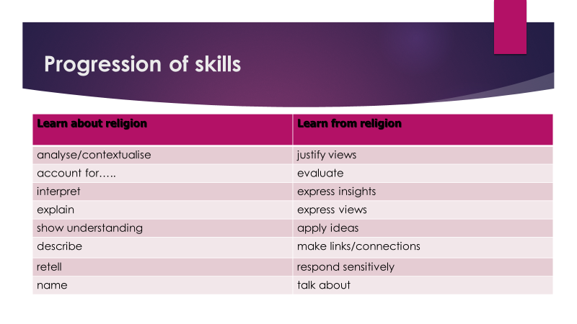
- Name: Can you name the characters in the story?
Can you use the correct name for this ceremony?
Can you name this artefact?

- Talk: Tell me about your family
Tell me about something special that has happened to you
Tell me about this place of worship. What makes its special?

- Retell: Can you retell the story?
Can you retell another story we have learnt?
Can you retell the part of the story when…..
Can you retell me the things that happen when…… a Christian gets baptised, when a person gets married.
Can you tell me what happens at….. (name a key religious festival)

- Respond sensitively: How can you show kindness?
How can you be a good friend like Jesus?
How would you show respect if you were visiting a place of worship?
How do you show respect for creation?

- Describe: Describe how Muslims pray?
Describe what happens at (name a key festival)
Can you describe what it feels like to make a commitment?
Can you describe what it means to be a Christian/Jewish person/ Sikh etc
Can you describe the different ways people might pray?
Describe how ……felt in this parable?
Describe the emotions of Judas, Peter and Mary Magdalene in relation to Jesus’ death.

- Make links/connections: Can you make a link with another religion or worldview?
How does…..link with your own understanding of what it means to be equal?
What happens in your family that is very similar?
What is the link between a shepherd and Jesus calling himself the ‘Good Shepherd?’
What is the link between karma and how Hindus practice their life?
What is the link between Passover and the concept of remembering?

- Show understanding: Do you think all Christians/Jewish people/Muslims
practice in this way?
What makes a mosque different to a church?
Are all sacred books viewed in the same way by believers?
What makes the Qur’an different from the Bible?
Why is Guru Nanak so significant for Sikhs?

- Apply ideas: How does the concept of incarnation apply to your own understanding of the
God?
Is it always possible to forgive?
How do you apply the idea of loving your neighbour to your own life?
What does equality mean to you?
What do you think heaven is like?
How does reincarnation link with your own understanding of what happens at death?

- Explain: Can you explain what it means to be a Sikh/Buddhist?
Explain the significance of Easter for a believer
Does having hope make a difference to how you live this life? Explain your view with examples.
Explain your understanding of reincarnation
Explain what the purpose of the miracles were in understanding who Jesus is.

- Express views: What do you think?
What makes you think in this way?
What has influenced your response?
What in your opinion is faith?
Justify your views giving examples

- Interpret: What is your understanding of this piece of Art/music/text?
How do believers express themselves in worship – why is there a range of expressions?
Why do people see things differently? What factors influence how a believer or non-believer reads a piece of scripture?

- Express insight: From your own knowledge and research, what is your view?
How have you come to this decision?
What has influenced your answer to this big question?
Is your view the same as your partner’s? What makes them similar and what makes them different?

