Easter briefing paper
Key website to support the teaching of Holy Week and Easter: REquest.org.uk.
Background knowledge for teachers:

Core concept: Salvation

The meaning of salvation:

Jesus’ death and resurrection effect the rescue or salvation of humans. He opens the way back to God. Through Jesus, sin is dealt with, forgiveness offered, and the relationship between God and humans is restored.

Background knowledge for teachers:  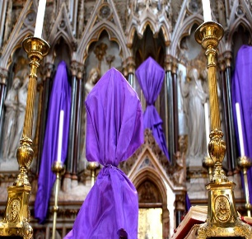  Passiontide:  Passiontide begins two weeks before Easter. It is when Christians begin to focus much more closely on the passion(suffering) and death of Christ.  The Sunday before Palm Sunday, the fifth Sunday of Lent, is known as Pasion Sunday in the Anglican Church. | How the Church and Christians remember today:  Christians begin to spiritually prepare themselves for the events of Holy week.  Customs/Rituals of the Church:  - Many churches will ensure that crosses, crucifixes, statues and images are covered up with simple purple cloth. This is a symbolism of anticipating Christ’s suffering.

Background knowledge for teachers:  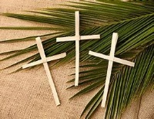  Palm Sunday:  Holy week begins with Palm Sunday. On this day the focus is on the triumphal entry of Jesus into Jerusalem. Jesus sends two of his disciples ahead to the village of Bethphage to look for an unbroken colt. They brought the colt to Jesus and placed their cloaks on his back. As Jesus sat on the young donkey, he slowly made his humble entrance into Jerusalem. People welcomed Jesus in the traditional way of honouring a worthy person, by throwing down their cloaks and waving palm branches.  The crowds that went ahead of him and those that followed shouted, "Hosanna to the Son of David! Blessed is he who comes in the name of the Lord! Hosanna in the highest heaven!" (Matthew 21:9, NIV)  The shouts of "Hosanna" meant "save now," and the palm branches symbolised goodness and victory. | How the Church and Christians remember today:  Palm Sunday is the sixth Sunday of Lent and last Sunday before Easter. Worshipers commemorate Jesus Christ's triumphal entry into Jerusalem.  On this day, Christians also remember Christ’s sacrificial death on the cross, praise God for the gift of salvation, and look expectantly to the Lord’s second coming.  Customs/Rituals of the Church:  - Palm crosses are distributed to the congregation.  - The passion narrative is read out – this is the Gospel account of the last week of Jesus’ life, ending with his death on the cross.  - Congregations will process carrying and waving palm branches.  - Traditional hymns will be sung that speak of the account.  - Palm crosses are blessed and worshippers will then take them home as a reminder of their Faith. The crosses are burned at the start of Lent the next year to provide the ash for Ash Wednesday.

Background for teachers:  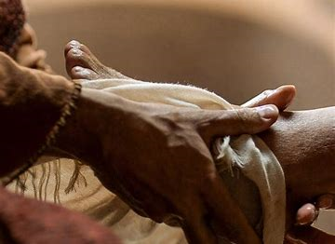  Maundy Thursday: The Last Supper  Whilst Maundy Thursday was the night on which the Lord’s Supper was first celebrated, there is a deeper meaning. The actual Latin word from which "maundy" is derived means "command." The central theme of that first Lord’s Supper was one of humble service. Jesus washed the feet of the disciples and commanded that the disciples do the same for each other. Jesus taught that he came not to be served but to serve, to share the hospitality of God and the intimacy of breaking bread together. | How the Church and Christians remember today:  It is from Jesus’ instruction: And he took bread, gave thanks and broke it, and gave it to them, saying, “This is my body given for you; do this in remembrance of me.” (Luke 22: v19) that the Church celebrates the Eucharist/Mass in some churches daily, in others, every Sunday.  Customs/Rituals of the Church:  - The Eucharist will be celebrated in churches.  - In many churches, the priest will wash the feet of twelve people to commemorate Jesus’ washing the feet of his disciples.  - In some churches, foot washing is made available to all.  - In many churches, the service will end with the altar and sanctuary being stripped and left empty.  - In many churches, the service ends with a ‘prayer watch’ ‘prayer vigil’ to remember that Jesus asked his disciples to remain with him and pray, following the Last Supper. Whilst done communally, it is a time of personal prayer and adoration.  The consecration of holy oil:  In the Roman Catholic and Anglican Church, Maundy Thursday is usually the day on which the supply of anointing oil to be used in ceremonies during the year is consecrated. This is done at a special Chrism Mass.  Did you know?  In England it is traditional for the King or Queen to give out Maundy money to some of their people, often to elderly people who are in need or who have offered service to their community. This is a small bag of silver coins that have been specially made for the occasion. The tradition of giving Maundy money began in 1662 when the reigning Monarch stopped the practice of washing the feet of some of his people and decided to give money to the poor instead.
Background for teachers:  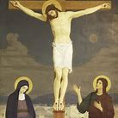  Good Friday:  Good Friday is the Friday before Easter Day. Good Friday was the day when Jesus stood trial before the Priests and later a Roman Governor called Pilate. Although Pilate could not find any wrong in Jesus, he was still sentenced to death by crucifixion. Later that day after having been beaten and mocked, Jesus was crucified. He died in the afternoon. His body was taken from the cross and put into a guarded tomb. | How the Church and Christians remember today:  Good Friday is a day when Christians remember what Jesus did for the whole of humanity. It is the day that Christians remember God allowing Jesus, his perfect son, to take the world’s sin, onto Himself. Christians believe that when Jesus died, he took the punishment for all of their individual sins. It is because of God’s offering of Himself that humanity can be restored. God's mercy and grace make salvation possible. The gift of eternal life through Jesus Christ is made available.  Customs/Rituals of the Church:  - Good Friday is a day of mourning in church. During special Good Friday services Christians meditate on Jesus' suffering and death on the cross, and what this means for their faith.  - In some countries, there are special Good Friday processions, or re-enactments of the Crucifixion.  - The main service on Good Friday takes place between midday and 3pm. In many churches it takes the form of a meditation based on the seven last words of Jesus on the cross, with hymns, prayers, and short sermons.  - It is the most sombre day in the Christian Calendar.  - The Eucharist is not celebrated on this day, but some churches will offer worshippers the host (body of Christ) consecrated from the night before.

Background for teachers:  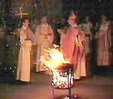  Holy Saturday:  Holy Saturday is the Saturday after Good Friday which is often, wrongly, called Easter Saturday. Some traditions observe Holy Saturday as a day of fasting, reflecting the quiet Jewish Sabbath and Christ’s rest in the tomb. The somewhat hopeless feelings of Good Friday and Holy Saturday is a reminder of the scriptural promise: "Weeping may linger for the night, but joy comes with the morning" (Psalm 30:5 NRSV), Easter morning! | How the Church and Christians remember today:  Holy Saturday is the day Christians wait and watch,  hopeful and confident that Christ will return.  Customs/Rituals of the Church:  - The Easter vigil service is the first Easter service, and takes place on the night of Holy Saturday.  - The service traditionally begins outside the church. Worshippers gather around a fire. From this fire, the Easter (often known as paschal) candle is lit.  - The service begins with words like these:  Dear brothers and sisters in Christ,  on this most holy night,  when our Lord Jesus Christ passed from death to life,  the Church invites her children throughout the world  to come together in vigil and prayer.  This is the Passover of the Lord.  We remember his death and resurrection  by hearing his word and celebrating his mysteries,  confident that we shall share his victory over death  and live with him for ever in God. Traditional Easter vigil liturgy  - After readings and prayers, the paschal candle is lit from the fire using a taper, while a prayer like the one below is said:  May the light of Christ, rising in glory, banish all darkness from our hearts and mind.’  - The lit candle is now a symbol of Christ, risen as the light of the world, and comes into the midst of the people.  - After being lit outside, the candle is carried into the church, which is in darkness. After more prayers and readings, the candles held by the congregation, are lit from the paschal candle.  - The readings at the service tell of the creation of humanity, how humanity fell from grace, and was repeatedly rescued by God. The readings remind people of God's promise to be with them always.  - Christians are given the opportunity to renew their baptismal vows at this service. It is also an opportunity for people to be baptised.
Background for teachers:  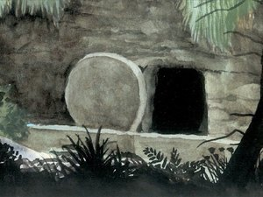  Easter Sunday:  Easter is the most significant Christian festival, remembering and celebrating the salvation offered through Jesus.  On Easter Sunday, the women on visiting Jesus’ tomb, found the stone had been moved, and his body gone. The Gospels recall the resurrection accounts slightly differently, presenting different details and perspectives but all presented as eye-witness reports. Jesus appears to the women and his disciples on a number of different occasions. He first appears in the garden. He appears on the road to Emmaus. He appears among them while they were still talking about the events of the day. He appears again to his disciples by the Sea of Tiberias during the miraculous catch of fish.  On Easter Sunday, hope comes. The disciples cannot believe it at first and are not able to believe until they encounter the living Christ. | How the Church and Christians remember today:  Easter is a time when Christians are reminded of God’s salvation. Jesus was resurrected, brought back to life. He appeared to the women and his disciples and ascended into heaven to be with his Father. For many Christians, this provides a sense of hope, that even in the midst of darkness and despair, God is a God of unconditional love, a God who forgives and through Jesus Christ, offers eternal life.  Customs/Rituals of the Church:  - Churches will often be filled with flowers and colour.  - Special hymns and songs will be sung.  - The Eucharist/Mass will be celebrated.  - ‘Alleluia’ will reappear in the liturgy.  - Easter Sunday marks the end of Lent.

