By the end of this unit, pupils should be able to:
Level 3

Attainment target 1
use a developing religious vocabulary to describe some key features of religions, recognising similarities and differences; make links between beliefs and sources, including religious stories and sacred texts;
begin to identify the impact religion has on believers’ lives; describe some forms of religious expression.

Attainment target 2
identify what influences them, making links between aspects of their own and others’ experiences;
ask important questions about religion and beliefs, making links between their own and others’ responses; make links between values and commitments, and their own attitudes and behaviour.

Level 4

Attainment target 1
use a developing religious vocabulary to describe and show understanding of sources, practices, beliefs, ideas, feelings and experience; make links between them, and describe some similarities and differences both within and between religions;
describe the impact of religion on people’s lives;
suggest meanings for a range of forms of religious expression.

Attainment target 2
raise, and suggest answers to, questions of identity, belonging, meaning, purpose, truth, values and commitments; apply their ideas to their own and other people’s lives;
describe what inspires and influences themselves and others.

What this unit contains |  | Through this unit pupils will consider the implications of rules and responsibilities for belonging to communities and, in particular, of belonging to a faith community. Children will consider rules in religions and other sources of authority.  This unit contains work on rules, laws and responsibilities in society and in Judaism, Christianity and Islam.
Where the unit fits and how it builds upon previous learning |  | This will be taught as the first, primary school, element of a bridging unit, preceding work to be completed in secondary schools at the beginning of Year 7. It focuses on elements from the local Agreed Syllabus on rules and responsibilities and should be completed by all pupils leaving Year 6. Through this unit, pupils will focus on key questions: What is a rule? Why do we have rules? Who makes the rules? Where are they found? When are rules / laws difficult to follow? What rules or guidelines for living do we have? What are our responsibilities?  This unit contains six sequenced themes which can be taught throughout the Summer Term or in a more intense block in the final weeks of the term. The themes must be taught in the order shown to ensure coherence, continuity and progression.
Extension activities – gifted and talented pupils |  | ⇒  ⇒  ⇒ | Discuss / consider ‘Are all rules written down or are some unwritten?’  How and why is story a good means of expressing beliefs/values and passing them on to others? Are any of the beliefs / values in Judaism and Islam expressed in Christianity?
Vocabulary  environment responsibilities morality respect writings  Bible Qur’an authority | sacred issues rule law religion  consequences Christianity Judaism |  | Islam obedience community society rights responsibility secular creator | creation choice decision value creed  commitment fair  unfair | Cross-Curricular Links  PSHE – Circle Time. Personal lifestyle/choice. Personal Health  Music – Writing Songs, raps etc.  SMSC / Citizenship – Rules, laws, government, community, leisure activities, and topical events.  Geography – Environmental issues, global citizenship.  Literacy – Stories, creeds, poetry and newspaper articles. Drama, speaking and listening.  Art and Design – Banners, murals.  ICT – Internet research – topical issues, presentation of work.  PE – Invent games for playground, rules, etc.  Science – Natural world, recycling, materials.
Theme 1. Rules, Rules, Rules!

Learning objectives | A T 1 | A T 2 | Suggested teaching activities | Skills | Sensitivities, points to note, resources
Pupils should:  - consider some key  questions in relation  to rules;  - relate the breaking of rules to a local topical issue. |  | ✔  ✔  ✔  ✔  ✔ | Class discussion - What is a rule and where do we find rules?  Then in pairs discuss the rules members of the class have kept  so far today (could be noted on post-it notes). Feedback.  Group activity  Give pupils different key questions about rules. When they have discussed and generated answers, report to class.  Place group choices in a class display; note and discuss  different group choices. As a class examine case study/studies of a particular issue/s e.g. drunk driving, theft, or school issues like parking on zigzag lines.  In groups either: role play different characters in the scenario; hot seat as characters or prepare a ‘News Flash’ report.  Discuss feelings of characters involved and how they are  affected. Relate to key questions.  Plenary:  Feed back and discuss. From discussion, highlight some feelings/quotes from characters (could be displayed as stimulus for rest of unit of work). Consider the following Key Questions: What is the result of rule breaking? Who does it hurt? How are our lives affected? | Listening  Sharing  Considering  Collaboration  Empathy  Communication Causality Generalisation Evaluation | Resources  Sheet of Key Questions –  resource sheet.  Rules written on cards or A3  sheet. Each set of rules for a  group could be on different coloured card.  Post-it notes.  Notes for Teachers:  Please be aware that there will be differences in some  unwritten rules e.g. some households may allow swearing, others not, etc.  Information about a topical  issue, e.g. Newspaper articles, Television/radio report BBC News website: www.bbc.co.uk/news  Backgrounds of pupils need to be borne in mind when selecting case study.

Theme 2. The Traditional Jewish/Christian/Creation Story

Learning objectives | A T 1 | A T 2 | Suggested teaching activities | Skills | Sensitivities, points to note, resources
Pupils should:  - know the story of God, the Creator, as told in Genesis;  - consider the following Key Questions:  - What happens if rules aren’t followed?  - Are there punishments?  - When are rules difficult to follow?  - understand why this story is important to Jews/Christians;  - consider the consequences of actions. | ✔  ✔  ✔  ✔ | ✔  ✔  ✔  ✔ | Recap Key Questions on rules and the consequences of rule breaking. Ask pupils to consider these ideas when watching the Judeo/Christian Creation story. Watch video and/or look at Christian Creation story in Bibles. In pairs discuss:  ⇒ Have the characters broken any rules?  ⇒ Who made the rules?  ⇒ How did the rule maker react?  ⇒ Do you think the rule breakers were treated fairly?  ⇒ Do you think Eve/Adam realised the consequences of breaking the rules?  ⇒ What does this story teach followers of the religion?  Feedback to the class and, as a class, discuss:  ⇒ How could rules be difficult to follow for the people in story and for followers of a religion? Why is this story important to Jews and Christians? Draw out particular ideas on the consequences caused by the rule–breaking in the Creation and in lives.  In pairs, consider/discuss quotes from the story of Creation in ‘Testament’. Feedback ideas.  Plenary:  Listen to song ‘In the Beginning’ from ‘Children of Eden’; reflect on the words used and how they relate to the theme and our lives. (If CD is unavailable some other reflective music can be played and the words read out).  Set homework as preparation for next lesson. | Homework Think of a time when you have broken rules – did you realise the consequences? | Resources  Video – ‘Testament’ (BBC) and/or ‘Testament’ the Animated Bible, adapted by Sally Humble- Johnson ISBN 0- 7522-1041-6  ‘Testament’ Teachers’ notes. ‘Creation and the Flood’ or Video ‘Quest: Creation Stories 1 Christianity’.  From pupils’ Book – Creation Stories Anthology (published by Channel 4 Learning)  Testament quotation sheet (Teachers may want to select different quotes appropriate to the ability of the children)  ‘In the Beginning’ words from CD of ‘Children of Eden’ by Stephen Schwartz www.musicalschwartz.com/child ren-of-eden.htm  Broken rules and consequences sheet

Theme 3. A Modern Jewish/Christian Creation Story

Learning objectives | A T 1 | A T 2 | Suggested teaching activities | Skills | Sensitivities, points to note, resources
Pupils should:  - know a different  version of the  Genesis Creation  story;  - realise that there are  consequences if  rules are broken;  - use art to interpret  religious ideas;  - understand how  rules affect  Jewish/Christian  lives;  - understand that  everyone is  responsible for  taking care of the  world and the  consequences of not  caring. | ✔  ✔  ✔  ✔ | ✔  ✔  ✔  ✔ | Discuss the consequences of rule breaking from end of last  lesson.  Introduce the idea of a modern version of the Jewish/Christian  Creation story. The pupils will need to consider the consequences  of rule breaking in the story.  Read ‘The Blessing Seed’ around the class or to the class. Explore  similarities/differences between this book and video/Bible version  from last lesson.  Using quotes from ‘The Blessing Seed’ either alone or in small  groups:  a) Create a piece of artwork to reflect the quote.  or  b) Refer back to lesson one and ‘The Blessing Seed’. Decide ‘How  do Jews/Christians live in The World by The Ten Commandments?’  and ‘How should Jews or Christians treat the world?’  Plenary:  Agree on a small project that could, in some way, help the  environment, e.g. can recycling, picking up litter, care of  playground equipment. Write class set of rules, list of  responsibilities and consequences of not keeping the rules. | Speaking  Listening  Sharing  Considering  Collaboration  Communication  Causality  Evaluation  Application  Reflection  Interpolation  Making informal  Decisions | Resources  ‘The Blessing Seed’ by Caitlin  Mathews, Barefoot Book  ISBN 1-901223-70-1  Quotes on cards or sheets.  Art materials

Theme 4. Guidelines for Living in Islam

Learning objectives | A T 1 | A T 2 | Suggested teaching activities | Skills | Sensitivities, points to note, resources
Pupils should:  Consider the following  Key Questions:  - Why is this story  important to Muslims?  - What values does it teach?  - How could Muslims put these beliefs/values into  practice in their daily lives? | ✔  ✔  ✔  ✔  ✔ | ✔  ✔  ✔  ✔ | As a class read, tell, listen or watch on video a version of one  selected Islamic story, ensuring that children understand it is a  Muslim story. Explain that the Hadith is a record of the statements  and actions of the Prophet Muhammad (pbuh) and these are a  second source of Islamic law after the Qur’an.  Discuss  What is the message in the story? (The story might convey the importance of the prophet Muhammad (pbuh), how you should  treat others, how you should treat living creatures.) Why do you think the story is important to Muslims? How could Muslims put these beliefs/values into practice in their daily lives?  Give small groups of children the story of the crying camel. (One or two different stories may be used for this activity.)  Pupils should share the story in their groups and identify the values or behaviour taught through this particular story.  Feedback to the class and discuss the values identified in the  stories and the implications for daily life of living according to these  teachings. Are there similarities between this story and the first  story shared in the lesson?  Read some of the Qur’an quotes and discuss what the class can  learn about Muslim behaviour from these rules. | Comparison  Application  Reflection  Communication  Interpretation  Evaluation  Making  informed decisions. | Resources  Possible Islamic stories:  The Prophet and the Old  Woman. {‘Pathways of Belief’:  Islam Programme 1 – Allah,  Creator and Provider.}  Video/DVD and resource pack: (BBC Active)  The story of the Crying Camel  Qur’an quotes  Sugar, Paper, Pens

Theme 5. Creeds

Learning objectives | A T 1 | A T 2 | Suggested teaching activities | Skills | Sensitivities, points to note, resources
Pupils should:  Consider the following  Key Questions:  - How do people  communicate their  values, rules and responsibilities?  - What is a ‘creed’?  - Who are they for?  - Why do they need  them?  - How are they used?  - Who created them?  - What are our  beliefs/ values/ principles for living? | ✔  ✔ | ✔  ✔ | Look at examples of secular ‘creeds’ or statements of belief e.g.  school mission statement, Brockley Community Poem, ‘Sunscreen  Rap – Everybody’s Free’ by Baz Luhrmann. Highlight these on  sheets.  Examine examples of religious ‘creeds’ or statements of belief  (e.g. The Apostles’ Creed, The Nicene Creed, the Shahadah  (Islam), the Shema (Judaism), and the Dalai Lama’s Instructions  for Life in the New Millennium (Buddhism). What messages/values do these convey? Highlight these.  Compare/contrast secular and religious ‘creeds’/value statements.  What do they have in common? How/when are they used? In what  form are they expressed? e.g. hymn, statement, on cards,  posters/banners.  Pupils should now devise their beliefs/values/principles for living life, e.g. personal, care and treatment of others, the natural world  within which we live. This could be done over a week by writing their beliefs/values/principles on strips of cards for an interactive  wall display, to be used as a resource for lesson six.  Children may wish to draw upon their personal/family’s religious beliefs. | Reflection  Expression  Application  Interpretation  Comparing/  Contrasting  Speaking/  Listening  Collaborative small group  work | Resources  Examples of secular  creeds/statements of beliefs  – enlarged copies of materials  attached to this unit or found  on greetings cards or on CDs.  Highlighter pens.  Examples of religious  creeds/statements of belief;  enlarged copies of materials  attached to this unit  Strips of card  Blutack

Learning objectives | A T 1 | A T 2 | Suggested teaching activities | Skills | Sensitivities, points to note, resources
Pupils should:  Consider and find  answers to the following  Key Questions:  - What are our beliefs/values/principl es for living?  - How can we express them/get our message across to others? |  | ✔  ✔  ✔  ✔  ✔ | Review and update beliefs / values / principles posted on display  board during the week.  Discuss: how could these beliefs/values/principles be expressed?  Identify different forms of expression: statements, poems, songs,  raps, murals, banners, dance and drama.  In small groups, pupils plan and design their shared ‘creed’/value statement for sharing with others. (These could be used as part of their Leavers’ Assembly and their leaving gift to each other and the school.)  One quote from each ‘creed’ could be put together to form a class/Year 6 ‘creed’ which could be depicted in a large class mural or other 2-dimensional form. This could finally be cut into pieces as a jigsaw with enough pieces for members of the class to each take  one with them at the end of the year along with a copy of the  complete creed. This will enable them to know how all the  separate bits including their own joined together will make the  unique statement from their class/year group.  A selection of creeds could be made into bookmarks or other items  and shared with the school community.  Pupils should take individual copies of their creed to their  secondary school, to be shared as ‘Part Two’ of this Bridging Unit.  Discuss and complete evaluation of unit. | Reflection  Expression  Application  Communication  Developing  confidence  Collaboration Discussion Working in a range of groups  Contributing to  the class effort. | Resources  Examples of poems, songs,  raps, banners, with a  message.  Sugar paper for brainstorming.  Equipment as required Evaluation sheet
Theme 6. Our Creed for Life

Key Questions

What is a rule?

Why do we have rules? Who makes the rules? Where are they found?
Where do these rules come from? When are rules/laws difficult to follow? How do the rules affect their lives?
What are our responsibilities?
Who are rules for? Can rules be changed?
Are rules the same everywhere?

Do the rules from other places always match each other? If not, what difficulties arise?

Are rules always written down? If not, how do we know they exist?

What happens if they are not followed? (e.g. Punishments)
What rules or guidelines for living do we have? What special rules do religious people follow?

Rules and Responsibilities in the Jewish/Christian Creation Story
These are quotations taken from “Testament - The Animated Bible” (BBC). Read each quote carefully and think what each one means in relation to rules and responsibilities.

Consider the actions, thoughts and feelings of the different characters involved, the consequences in the story and what the Creation Story says to Jews and Christians.

The garden of Eden was a perfect world, in which even the tiger was their friend.

‘It is the tree of all knowledge, evil as well as good,’ God said.
‘Bite into that fruit and on that day death will begin to hunt you down.’

‘Will you pick some fruit for us?’ he asked. ‘No,’ she said.
‘No?’ The serpent’s eyes clouded with surprise. ‘But . . . doesn’t it make your mouth water?’

Now the serpent’s eyes widened in astonishment.
‘If God forbids this or that, Eden is no better than a prison.’ ‘Oh no,’ Eve protested, ‘We are free.’

Rules and Responsibilities in the Jewish/Christian Creation Story
(Continued)
‘If we eat the fruit we will die . . .’ Eve said uncertainly. She could feel the invisible cloak of temptation wrapping around her . . . As the serpent continued to wheedle, Eve found herself drawn towards the forbidden tree.

Red juice trickled through her fingers like blood.

Suddenly she felt horribly alone . . . she could not bear this feeling of loneliness. This was Eve . . . his Eve . . . but she seemed different, distant, unreachable.
The moment he had eaten, the fruit rotted in his hand . . . then he shivered. For the first time ever, Adam felt shame.

He had no name for this sickening feeling in his stomach, this scorching of his skin, but he did know that Eve and he were no longer the perfect creatures that God had made. They were spoiled. For ever.

Eve groaned. ‘Something has gone,’ she cried. ‘Something I knew.’
‘That,’ said God, ‘is a pain that you – and your children – will ever shed. The pain you now feel is the mirror of mine.’

Rules and Responsibilities in the Jewish/Christian Creation Story
(Continued)
‘I made you a world,’ God said to Adam and Eve. ‘Now make your own.’
Adam and Eve looked at one another in despair. They had already made their world . . . ‘Will you curse me when it has no purpose?’ asked God. ‘No beauty?’
Tears sprang to their eyes. They knew the difference between beauty and ugliness now, between good and evil, innocence and guilt. If they strived, strived all the days of their lives, could they create perfection with their own hands? Could they ever lose their shame?

Adam and Eve hung their heads. Oh, what had they done?

‘There is consolation . . . ’ God encouraged, ‘ . . . in all that lies unused in your hearts. There will always be a memory of a memory. And there will be a way back.’

He kept his promise, He gave them what they, in their freedom, had chosen. Cruelty and death.

For the first time, Adam and Eve experienced fear. The fabulous garden was suddenly filled with danger. The animals had become menacing, the sun burned too hot, the smell of death was in the air. Adam and Eve had spoiled God’s

Rules and Responsibilities in the Jewish/Christian Creation Story
(Continued)

perfect creation. Thorns sprang up, beast turned against beast, disease floated in on the wind. Frightened and ashamed, Adam and Eve seemed to stand alone against the world.
He sighed. ‘You have eaten of the fruit. My single commandment - and you have broken it.’ ‘The serpent reasoned with me,’ Eve protested. ‘He made me listen.’
‘We had no arguments,’ accused Adam.

‘I did not give you the burden of understanding, only of obedience.’

‘The fruit had no power, no magic. It was the commandment that was important.’

‘And because the commandment was so easy to keep, the punishment was made so hard to bear.’ ‘True freedom always has restraints.’
‘Will this world ever be home for us?’
‘We are always drawn to home, but you have heard the story. Home must be in heaven now, not anywhere on earth.’

Rules and Responsibilities in the Traditional Jewish / Christian Creation Story

A time when I broke a rule | The consequences
The first rule ever broken according to  the Jewish and Christian Creation Story | The consequences

In The Beginning

This step is once again our first We set our feet upon a virgin land
We hold the promise of the earth in our hands

No flood from heaven comes again No deluge will destroy and purify
We hold the fate of man and men in our hands

Now at this dawn so green and glad I pray that we may long remember
How lovely was the world we had in the beginning

Of all the gifts we have received
One is most precious and most terrible The will in each of us is free
It’s in our hands
And if some day we hear a voice
If he should speak again, our silent father If he will tell us is the choice
Is in our hands
Our hands can choose to drop the knife Our hearts can choose to stop the hating For every moment of our life
Is the beginning

There is no journey gone so far
So far we cannot stop and change direction No doom is written in the stars
It’s in our hands

We cannot know what will occur
Just make our journey worth the taking And pray we’re wiser than we were
In the beginning, it’s the beginning NOW WE BEGIN

From ‘Children of Eden’ by Stephen Schwartz

Quotations from ‘The Blessing Seed’

“You have a special duty. You will care for everything on Earth. Your special gift is to learn and to care.”

“The women listened to the song of ‘The Tree of Life’. It sang a song of
laughter, a song of tears, a song of beginning and a song of coming home.”

“The four paths are called The Path of Wonder, The Path of Emptiness, The Path of Making and The Path of Coming Home.”

“When you look after the Earth, when you defend the helpless, when you speak for those that have no voice, when you enjoy and respect my creation, then you will be most like me”.

Story of the Crying Camel
It was very hot and the people in Madinah were trying to keep cool. There were many beautiful gardens in the city with tall, shady trees. People came to the gardens to sit there to talk and enjoy cool, refreshing drinks. Prophet Muhammad (pbuh) was walking in one of the gardens. He greeted the people he knew as he walked along. But while he was walking, Muhammad (pbuh) heard a very strange noise that sounded a bit like someone crying and sobbing really loudly. Someone was obviously very sad.

As he came closer to the noise, Muhammad (pbuh) could see it was not a person making the sounds; it was a very sad camel. Muhammad (pbuh) felt very sorry for the camel. He could see why it was so sad. It was tied to a post, in the full sunshine where it was very hot.
The camel looked very thirsty. Tears were running down its cheeks and it had been crying for a long time so its fur was very wet.
Strangely no one else seemed to notice the camel’s cries.

Muhammad (pbuh) stroked the camel and talked to it. Slowly it became calmer and soon the sobs stopped and the camel snorted with pleasure. The tears stopped running down its cheeks. Muhammad (pbuh) became angry. He searched the area asking, “Who owns this camel?” At last a voice said, “I do,” and a man stepped out from under the shade of the biggest tree in the garden. Muhammad (pbuh) looked at the man. He was not hot or thirsty. He was also not thinking about his camel.

Muhammad (pbuh) spoke to him quietly and as he spoke, the man’s head began to hang down. He realised what he had done. Muhammad (pbuh) reminded him that the camel was one of Allah’s creatures. It would work hard for the man, carrying heavy loads and travelling to places far away. The man had a responsibility to care for the camel in return for its hard work.

The owner felt very ashamed. From that day on he looked after his animals with great care, and always made sure they had enough to eat and drink and the camel never cried again.

Qur’an Quotes About How To Behave

Qur’an 61:14
People who believe – be helpers of Allah. Do good and give the good news

Qur’an 33:41
People who believe – remember Allah very often

Qur’an 49:11
People who believe – one group should not laugh and make fun of others . . . or give one another bad nicknames.

Qur’an 4:36
Pray to Allah . . . do good to your parents, family, people who need help, neighbours who are near . . .

Qur’an 5:8
People who believe . . . do not be unfair to people even if you don’t like them

Qur’an 20:130
. . . be patient and always praise Allah, before the sun rises and before it sets

Qur’an Quotes (Continued)

Qur’an 8:61
If people you have been fighting with want to make up then you should also make up and trust in Allah

Qur’an 9:71
People who believe look after one another, men and women. They encourage what is right and stop what is wrong. They pray regularly, give to charity and obey Allah and His messenger

Qur’an 7:31
Children of Adam – wear your best clothes every time and place when you pray.
Eat and drink but do not waste from being greedy. Allah does not like people who waste.

Brockley Community Poem

(Displayed in Shardeloes Road, Brockley)

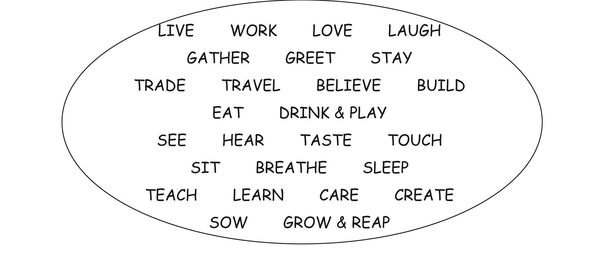

Everybody’s Free (to wear sunscreen) Mix
Song Lyrics: Lee Perry

Ladies and gentleman of the Class of ’97.

If I could offer you only one tip for the future, sunscreen would be it. The long-term benefits of sunscreen have been proven by scientists, whereas the rest of my advice has no basis more reliable than my own meandering experience. I will dispense this advice now.

Enjoy the power and beauty of your youth. Oh, never mind. You will not understand the power and beauty of your youth until they’ve faded. But trust me, in 20 years, you’ll look back at photos of yourself and recall in a way you can’t grasp now how much possibility lay before you and how fabulous you really looked. You are not as fat as you imagine.

Don’t worry about the future. Or worry, but know that worrying is as effective as trying to solve an algebra equation by chewing bubble gum. The real troubles in your life are apt to be things that never crossed your worried mind, the kind that blindside you at 4pm on some idle Tuesday.

Do one thing every day that scares you. Sing.

Everybody’s Free (to wear sunscreen) Mix (Continued)
Don’t be reckless with other people’s hearts. Don’t put up with people who are reckless with yours. Floss.

Don’t waste your time on jealously. Sometimes you’re ahead, sometimes you’re behind. The race is
long and, in the end, it’s only with yourself.

Remember compliments you receive. Forget the insults. If you succeed in doing this, tell me how. Keep your old love letters. Throw away your old bank statements.
Stretch.

Don’t feel guilty if you don’t know what you want to do with your life. The most interesting people I
know didn’t know at 22 what they wanted to do with their lives. Some of the most interesting
40-year-olds I know still don’t.

The Optimist Creed

To be so strong that nothing can disturb your peace
of mind.
To forget the mistakes of the past and press on to the
greater achievements of the future.
To talk health, happiness and prosperity to every
person you meet.
To wear a cheer countenance At all times and give
every loving creature you meet a smile.
To make all your friends feel there is something in
them.
To give so much time to the improvement of yourself
That you have no time to criticise others.
To look at the sunny side of everything and make
your optimism come true.

To think only of the best, to work only for the best and to expect only the best.
To be too large for worry,
Too noble for anger, Too strong for fear,
And too happy to permit the presence of trouble.
To be just as enthusiastic about the success of
others as you are about your own.

Teen Creed

Choose only a date,
Who will make a good mate.
Don’t let your parents down
They brought you up.
Be master of your habits,
Or they will master you.
Be humble enough to obey,
You may give orders someday.
Don’t be a show off when you drive,
Drive with safety and arrive.
Choose companions with care,
You become what they are.
Don’t let the crowd pressure you.
Stand for something or You’ll fall for anything.
Guard your thoughts,
What you think you are
Author unknown

If!
If you can keep your head when all about you Are losing theirs and blaming it on you;
If you can trust yourself when all men doubt you, But make allowance for their doubting too;
If you can wait and not be tired of waiting, Or being lied about, don’t deal in lies,
Or being hated don’t give way to hating,
And yet don’t look too good, nor talk too wise.

If you can dream - and not make your dreams your master,
If you can think - and not make thoughts your aim, If you can meet with Triumph and Disaster,
And treat those two imposters just the same; If you can bear to hear the truth you’ve spoken Twisted by knaves to make a trap for fools,
Or watch the things you gave your life to broken, And stoop and build ‘em up with worn out tools.

If you can make one heap of all your winnings And risk it on one turn of pitch-and-toss,
And lose, and start again at your beginnings And never breathe a word about your loss;
If you can force your heart and nerve and sinew To serve your turn long after they are gone, And so hold on when there is nothing in you Except the Will which says to them “Hold on!”

If you can talk with crowds and keep your virtue, Or walk with Kings - nor lose the common touch, If neither foes nor loving friends can hurt you,
If all men count with you, but none too much; If you can fill the unforgiving minute,
With sixty seconds worth of distance run. Yours is the earth and everything that’s in it, And - which is more - you’ll be a Man, my son.

By Rudyard Kipling

You Can Do It

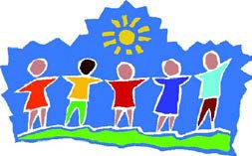

Yes! – you will succeed – Never think any other way,
Just set your goals and follow them Every single day!
And if ever there are setbacks Or things do not go right,
Keep those longed for hopes and dreams Always in your sight.
For the secret of success

Is determination in every way, For then those not so distant stars
You’re sure to grasp one day!

Author unknown

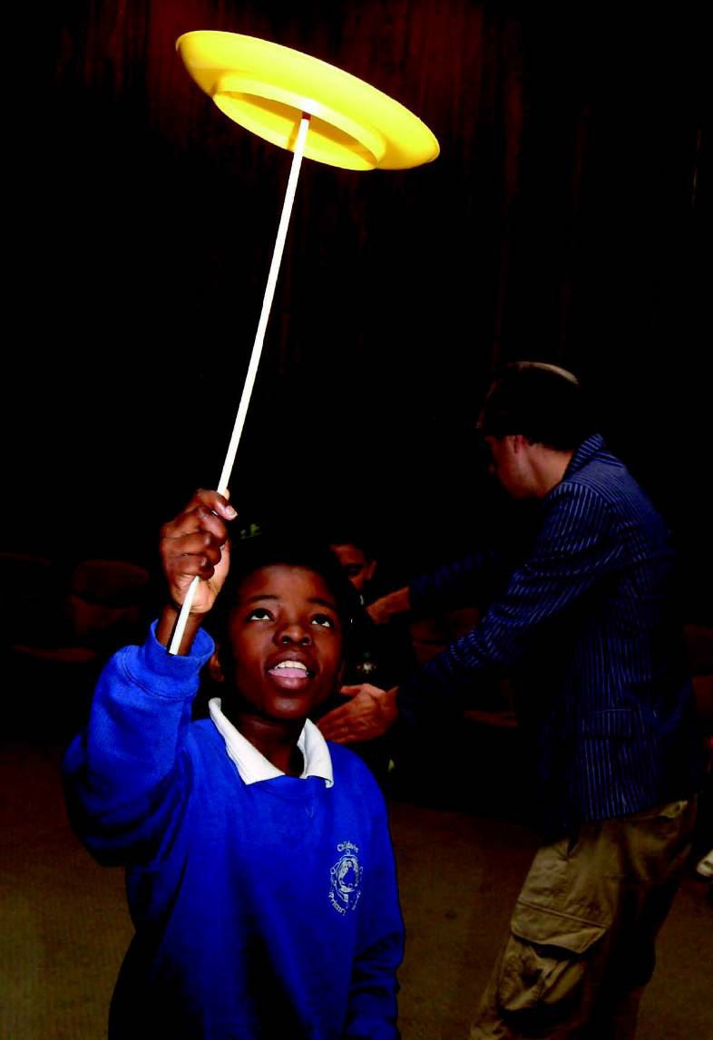
Follow Your Dreams

Follow your dreams Wherever they lead, Don’t be distracted
By less worthy needs…

Shelter them, nourish them, Help them to grow.
Let your heart hold them Down deep where dreams go.

Follow your dreams, Pursue them with haste: Life is too precious,
Too fleeting to waste…

Be faithful, be loyal, Then all your life through, The dreams that you follow
Will keep coming true.

By Larry Chengges

Believe in Yourself
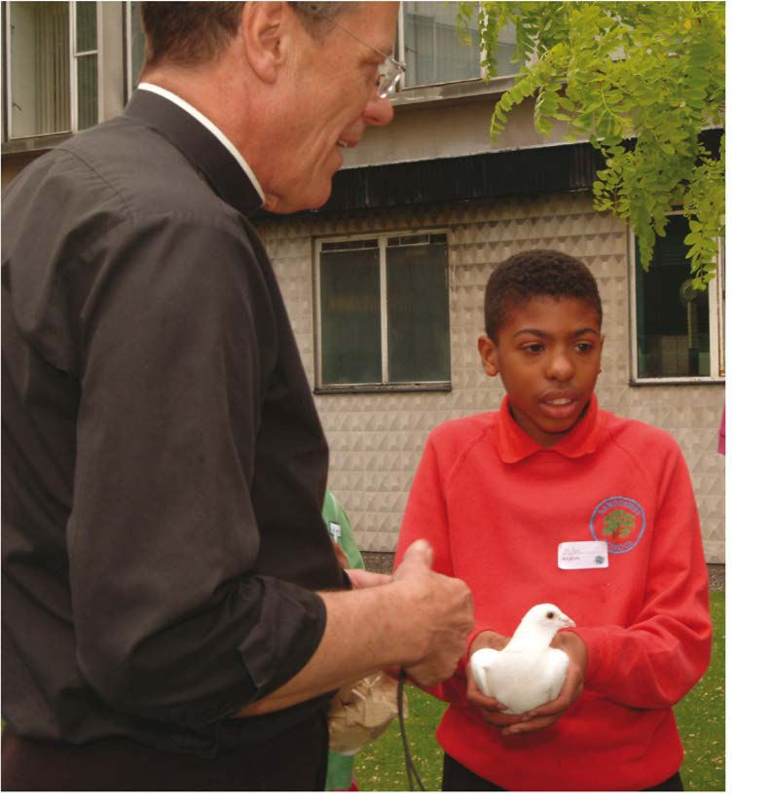
Believe in yourself And know that it’s true – There is absolutely nothing
That you cannot do! First of all learn to love And to yourself be true,
For then you’ll come to realise All that lies in you!
Reach for the distant stars – They are within your grasp And you shall find a happiness
That throughout your life will last Each star is waiting out there Shining just for you,
So remember this every day In all you say and do.
And, never allow a negative thought To creep into your mind,
For your every longed for dream You then are sure to find
Author unknown

Believe in Yourself
Believe in yourself In the power you have
To control your own life Day by day . . .

Believe in the strength That you have deep inside, And your faith will help Show you the way . . .

Believe in tomorrow And what it will bring,
Let a hopeful heart carry you Through . . .

For things will work out If you trust and believe There’s no limit
To what you can do!
Author unknown

Reach For Your Goals
Whatever the goal we’re pursuing, No matter how rugged the climb,
We’re certain to get there by trying our best, And taking one day at a time.

“Forever” is hard to imagine, “The future” may seem far away –
But every new dawn brings a wonderful chance To do what we can on that day.

As you reach for the goals You would like to achieve,
May you find all the strength you will need To meet every challenge one step at a time Until the day you proudly succeed!

Author unknown

Life’s Little Instructions
Sing in the shower. Treat everyone you meet like you want to be treated. Watch a sunrise at least once a year. Leave the toilet seat in the down position. Never refuse home made brownies. Strive for excellence, not perfection. Plant a tree on your birthday. Learn 3 clean jokes. Return borrowed vehicles with the gas tank full. Compliment 3 people everyday. Never waste an opportunity to tell someone you love them. Leave everything a little better than you found it. Keep it simple. Think big thoughts but relish small pleasures. Become the most positive and enthusiastic person you know. Floss your teeth. Ask for a raise when you feel you’ve earned it. Be forgiving of yourself and others. Over tip waitresses. Say “thank you” a lot. Say “please” a lot.

Avoid negative people. Buy whatever kids are selling on card tables in their front yards. Wear polished shoes. Remember other people’s birthdays. Commit yourself to constant improvement. Carry jump leads in your boot. Have a firm handshake. Send lots of Valentine cards and sign them, “Someone who thinks you’re terrific.” Look people in the eye. Be the first to say “hello”. Use the good silver. Return all things you borrow. Make new friends but cherish the old ones. Keep secrets. Sing in a choir. Plant flowers every Spring. Have a dog. Always accept an outstretched hand. Stop blaming others: take responsibility for every area of your life. Wave at kids on school buses. Be there when people need you. Feed a stranger’s expired parking meter. Don’t expect life to be fair. Never underestimate the power of love. Drink champagne for no reason at all. Live your life as an exclamation, not an explanation. Don’t be afraid to say, “I made a mistake.” Don’t be afraid to say, “I don’t know.” Compliment even small improvements. Keep your promises (no matter what). Marry only for love.
Rekindle old friendships. Count your blessings. Call your mother. adapted from an original by H. Jackson Brown, Jr published by Portal Publications Ltd

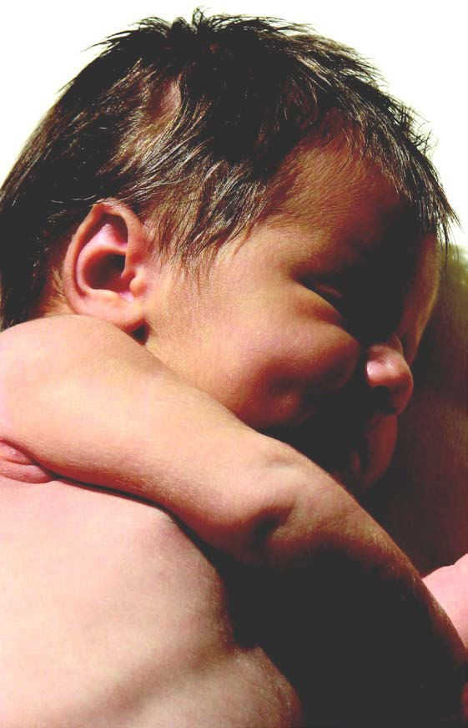

Advice to My Child on Growing Up in Life . . .
You are unique, my child . . .
a wonderful addition to life for there is no one else like you.

You are important . . . believe it . . . know it . . .

Search your heart and be willing to try new things . . .
Don’t be afraid to be different . . .
follow your feelings and be proud . . . be happy . . .

Reflect your feelings, your hopes and your dreams . . . you have much to contribute
and other people can learn from you.
Take your time . . . and please, don’t hurry.

You must reach out and help others to grow . . . for the more you give, the more you receive.

Your time on earth is a measure of progress, year by year . . . for each year will present new and different opportunities . . .

Enjoy what is beautiful in life, my child, and try to achieve the highest goals in life . . .
to love, to care, to give, to share.

By Larry S Chengges

Children Learn What They Live

If a child lives with criticism
he learns to condemn.
If a child lives with hostility,
she learns to fight.
If a child lives with ridicule,
he learns to be shy.
If a child lives with shame,
she learns to feel guilty.
If a child lives with tolerance,
he learns to be patient.
If a child lives with encouragement,
she learns confidence.
If a child lives with praise,
he learns to appreciate.
If a child lives with fairness,
she learns justice.
If a child lives with security,
he learns to have faith.
If a child lives with approval,
she learns to like herself.
If a child lives with acceptance, and friendship
they learn to find LOVE in the world.

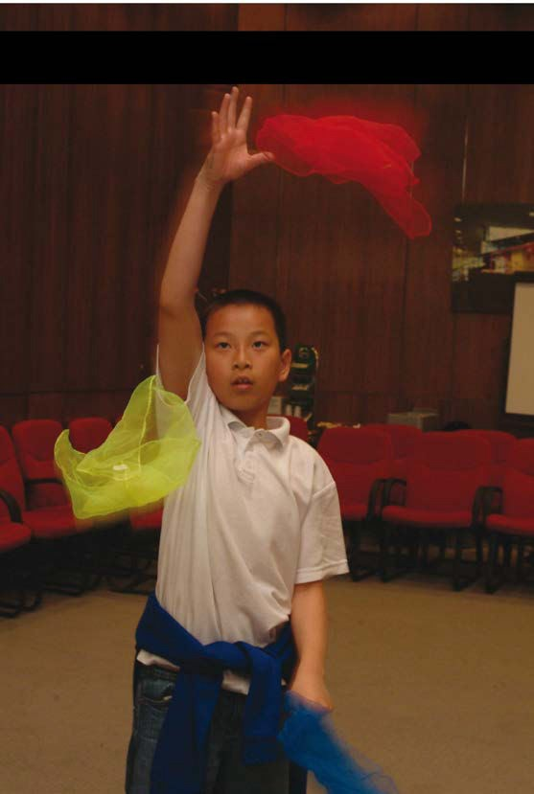
Tapestry of Life
And I shall weave the canvas of your life And let you choose the silks.
Choose your colours well, to match the gifts I‘ve chosen
Pick them well, to suit the cloth that I have woven.
Choose the brighter colours, to lift the natural grey. To heighten and to lift the spirit on the dullest day.
Choose them for the softness of their touch, and in doing such
Let them be in harmony: as the life you lead.
Choose them to be strong, not tough or harsh like flax or tweed.
Work them with love, all blending.
Gently and caressing they will need no mending

No regrets of colours chosen; Nor the tapestry I’ve woven.

by Lynn New

The World is our Classroom

I’ve learned that . . .
I’ve learned that most of the things I worry about never happen. Age 64
I’ve learned that every great achievement was once considered impossible. Age 47
I’ve learned that you can’t hide a piece of broccoli in a glass of milk. Age 7
I’ve learned that if there were no problems there would be no opportunities. Age 19
I’ve learned that it doesn’t cost anything to be nice. Age 66 I’ve learned that the important thing is not what others think of me but what I think of me. Age 38 I’ve learned that even the simplest task can be meaningful if I do it in the right spirit. Age 72 I’ve learned that in every face-to-face encounter, regardless of how brief we leave something behind. Age 45 I’ve learned that whenever I decide something with kindness, I usually make the right decision. Age 66 I’ve learned that if you spread the peas out on your plate, it looks like you ate more. Age 6 I’ve learned that regardless of colour or age, we all need the same amounts of love. Age 37 I’ve learned that education, experience and memories are 3 things that no one can take away from
you. Age 67
I’ve learned that hotel mattresses are better on the side away from the phone. Age 50

The World is our Classroom (Continued)
I’ve learned that the simple things are often the most satisfying. Age 63 I’ve learned that if you want to cheer yourself up you should try cheering up someone else. Age 13 I’ve learned that successful living is like playing a violin - it must be practised daily. Age 70 I’ve learned that if you laugh and drink soda pop at the same time, it will come out of your nose. Age 7 I’ve learned that a sunroof is worth the extra cost. Age 29
I’ve learned that optimists live longer than pessimists. That’s why I’m an optimist. Age 8 I’ve learned that happiness is like perfume, you can’t give it away without getting a little on yourself.
I’ve learned that when someone hurts your feelings, it’s unimportant unless you persist in
remembering it. Age 68
I’ve learned that there’s no elevator to success. You have to take the stairs. Age 48
I’ve learned that if you smile at people, they will almost always smile back. Age 81
I’ve learned that homemade Toll House cookies should be eaten while still warm. Age 29 I’ve learned that we grow only when we push ourselves beyond what we already know. Age 53 I’ve learned never to underestimate the potential and power of the human spirit. Age 82
I’ve learned that everyone has something to teach. Age 51
H. Jackson Brown JR. Entries taken from book “Live and Learn and Pass It On” by H. Jackson Brown JR

Live and Learn and Pass it On

People age 5 - 95 share what they’ve learned about life, love and other good stuff . . .
Age 52 - I’ve learned that I should make the little decisions with my head and the big decisions with my heart.
Age 46 - I’ve learned that you can get by on charm for about 15 minutes. After that, you’d better know something. Age 78 - I’ve learned that to love and be loved is the greatest joy in the world.
Age 14 - I’ve learned that lying in the green grass of an empty field makes you feel so good.
Age 51 - I’ve learned that you shouldn’t expect life’s very best if you’re not giving it your very best. Age 95 - I’ve learned that deciding whom you marry is the most important decision you’ll ever make. Age 54 - I’ve learned that you can’t hug your kids too much.
Age 60 - I’ve learned that if you depend on others to make you happy, you’ll be endlessly disappointed. Age 37 - I’ve learned that children are the best teachers of creativity, persistence and unconditional love. Age 81 - I’ve learned that you should keep your promises no matter what.
Age 51 - I’ve learned that you should fill your life with experience, not excuses. Age 16 - I’ve learned that you can never have too many friends.
Age 51 - I’ve learned that we are responsible for what we do, no matter how we feel.
Age 64 - I’ve learned that if you wait until all conditions are perfect before you act, you’ll never act.

Live and Learn and Pass it On (Continued)
Age 5 - I’ve learned that goldfish don’t like jelly.
Age 54 - I’ve learned that I cannot expect others to solve problems. Age 50 - I’ve learned that if you care, it shows.
Age 72 - I’ve learned that it’s just as important to forget a wrong, as it is to remember a kindness. Age 26 - I’ve learned that love will break your heart, but it’s worth it
Age 39 - I’ve learned that you should treasure your children for what they are, not for what you want them to be. Age 9 - I’ve learned that you can be in love with 4 girls at the same time.
Age 85 - I’ve learned that it’s never too late to improve yourself.
Age 14 - I’ve learned that a good feeling gets even better when it’s shared.
Age 51 - I’ve learned that if love isn’t taught in the home, it’s difficult to learn it anywhere else. Age 45 - I’ve learned that it’s better not to wait for a crisis to discover what’s important in your life.
Age 20 - I’ve learned that trust is the single most important factor in both personal and professional relationships. Age 51 - I’ve learned that you shouldn’t do anything that wouldn’t make your mother proud.
Age 92 - I’ve learned that I still have a lot to learn.

Christian Creeds – The Apostles’ Creed
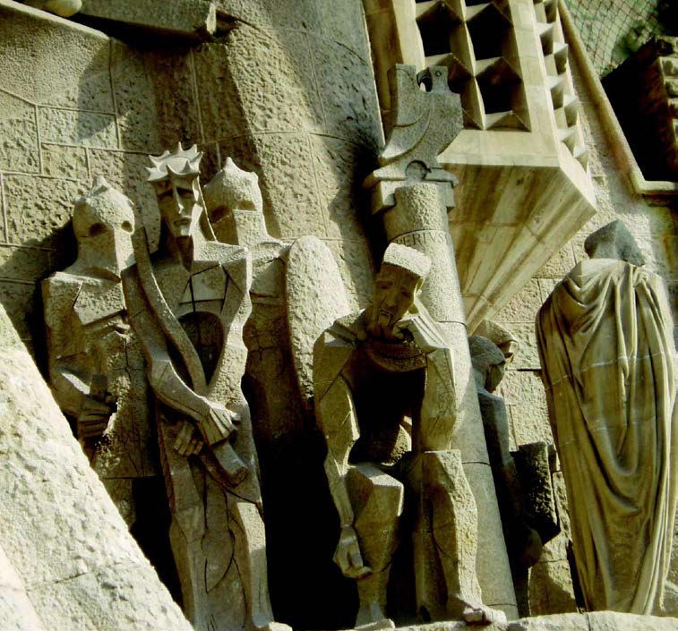
I believe in God the Father Almighty, Creator of heaven and earth.

I believe in Jesus Christ, his only Son, our Lord, who was conceived by the Holy Spirit,
born of the Virgin Mary, suffered under Pontius Pilate,
was crucified, died and was buried; he descended to the dead.
On the third day he rose again; He ascended into Heaven,
He is seated at the right hand of the Father,
and he will come to judge the living and the dead.

I believe in the Holy Spirit, The Holy Catholic Church, The communion of saints, The forgiveness of sins,
The resurrection of the body,
And the life everlasting. Amen.

Christian Creeds – The Nicene Creed

We believe in one God, the Father, the Almighty,
maker of Heaven and earth, of all that is,
seen and unseen.

We believe in one Lord, Jesus Christ, the only son of God,
eternally begotten of the Father, God from God, light from light, true God from true God,
begotten, not made, of one being with the Father; through him all things were made.

From us and our salvation he came down from Heaven, Was incarnate of the Holy Spirit and was made man.
For our sake he was crucified under Pontius Pilate; He suffered death and was buried.
On the third day he rose again
In accordance with the scriptures;
He ascended into Heaven
And is seated at the right hand of the Father.
He will come again in glory to judge the living and the dead And his kingdom will have no end.

We believe in the Holy Spirit, The Lord, the giver of life,
Who proceeds from the Father and the Son
He is worshipped and glorified, who has spoken through the prophets.

We believe in one holy and apostolic Church.
We acknowledge one baptism for the forgiveness of sins. We look for the resurrection of the dead
And the life of the world to come. Amen.

A Jewish Statement of Belief

The Shema
(abridged version for young children)
Listen Israel, the Lord is our G-d, the Lord is one.
Let the name of His magnificent kingdom be blessed forever and ever.
You shall love the Lord your G-d with all your heart, with all your soul and with everything you have. Let these words which I command you today, be on your heart.
Teach them carefully to your children.
Speak of them when you are sitting at home and when you are travelling. When you go to bed and when you get up. Tie them on your arm as a sign and place as a sign between your eyes.
Write them on the doorposts of your house and on your gateposts.

Deuteronomy 6: 4-9

A Muslim Statement of Belief

The Shahadah
“There is no God except Allah and Muhammad (pbuh) is the messenger of Allah”

Instructions for Life in the New Millennium from the Dalai Lama
•Take into account that great love and great achievements involve great risk.
•When you lose, don’t lose the lesson.
•Follow the three Rs: Respect for self, Respect for others, Responsibility for all your actions.
•Remember that not getting what you want is sometimes a wonderful stroke of luck.
•Learn the rules so that you know how to break them properly.
•Don’t let a little dispute injure a great friendship.
•When you realise you’ve made a mistake, take immediate steps to correct it.
•Spend some time alone every day.
•Open your arms to change, but don’t let go of your values.
•Remember that silence is sometimes the best answer.
•Live a good honourable life. Then when you get older and think back, you’ll be able to enjoy it a second time.
•A loving atmosphere in your home is the foundation for your life.
•In disagreements with loved ones, deal only with the current situation. Don’t bring up the past.
•Share your knowledge. It’s a way to achieve immortality.
•Be gentle with the earth.
•Once a year, go someplace you’ve never been before.
•Remember that the best relationship is one in which your love for each other exceeds your need for each other.
•Judge your success by what you had to give up in order to get it.
•Approach love and cooking with reckless abandon.

